UNIT OVERVIEW: Biological Molecules
ENQUIRY: What are organisms and what are they made of?

Unit intention: The cells of all living organisms are composed of biological molecules. Proteins, carbohydrates and lipids are three of the key groups of biological macromolecules that are essential for life. Students will have studied these molecules at GCSE but this will be the first time that they will study the structure of these macromolecules and gain a better understanding of their functions in living organisms and cells.
Success criteria: |  |  | X
2.1.1 Cell structure Learning Checklist I can:  Describe and explain the properties of water and key inorganic ions that are involved in biological processes  Explain the concept of monomers and polymers and the importance of condensation and hydrolysis reactions in a range of biological molecules  The ring structure and properties of glucose as an example of a hexose monosaccharide and the structure of ribose as an example of a pentose monosaccharide.  I can compare and contrast the structure and properties of starch, glycogen and cellulose molecules.  I can explain the synthesis and breakdown of dipeptides and polypeptides, by the formation and breakage of peptide bond  I can compare the structure and function of globular proteins including a conjugated protein  I can describe and explain the synthesis and breakdown of triglycerides by the formation (esterification) and breakage of ester bonds between fatty acids and glycerol |  | 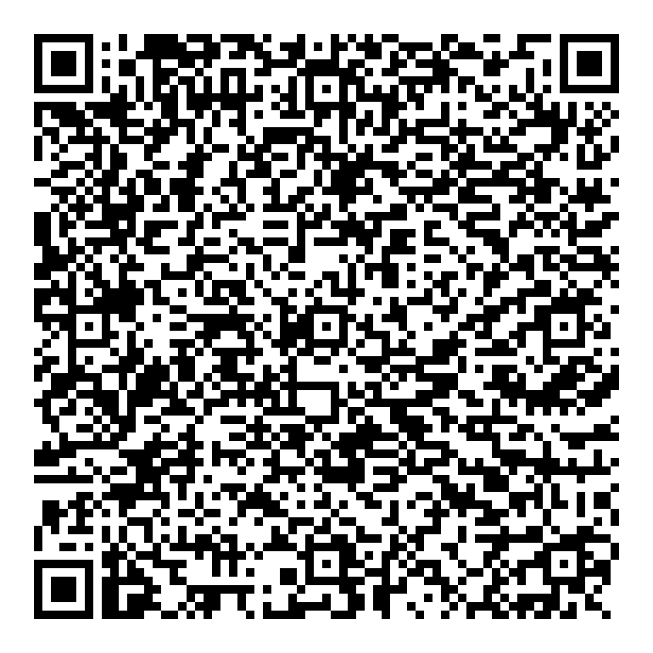
Unit summative and formative assessment details:
Weekly Seneca, factual re-call
Extended writing
Practical Research
End of unit test
Home Learning (What and how often):
Home Learning (What and how often):
Homework once a week (flip learning and Seneca)
Revisit class content (make notes)
Research activities for practical
Topic Sequence  - Water and Inorganic ions  - Monomers and Polymers  - Carbohydrates  - Lipids  - Proteins  - Biochemical Test for Molecules  - Separating Molecules | Recommended reading:  HPA Recommended biological dictionary  https://alevelnotes.com/notes/biology/biological-molecules/biological-molecules  http://brilliantbiologystudent.weebly.com/biuret-test-for-protein.html  https://jcp.bmj.com/content/jclinpath/25/10/892.full.pdf  Places to visit:  Centre of the cell

Success criteria – Have you met them? Show your evidence in the boxes below.
1.

2.

3.

4.
5.
6.
How will you improve your work?

End of Unit EVALUATION

