UNIT OVERVIEW: Cell Structure
ENQUIRY: How have microscopes contributed to our understanding of living organisms?

Unit intention: Every living organism is made up of one or more cells, therefore understanding the structure and function of the cell is a fundamental concept in the study of biology. Since Robert Hooke coined the phrase ‘cells’ in 1665, careful observation using microscopes has revealed details of cell structure and ultrastructure and provided evidence to support hypotheses regarding the roles of cells and their organelles. Students will have studied cells structure at GCSE but this will be the first time that they would have studied many of the organelles in the cell and gain a better understanding of their functions and interrelationship between the organelles in the cells.

Success criteria: |  |  | X
2.1.1 Cell structure Learning Checklist
I can evaluate the use of microscopy to observe and investigate different types of cell and cell structure in a range of eukaryotic organisms
I can comparison of light microscopes, TEMs, SEMs and laser scanning confocal microscopes.
I can describe ultrastructure of eukaryotic cells and the functions of the different cellular components
I can explain the interrelationship between the organelles involved in the production and secretion of proteins.
I can describe the similarities and differences in the structure and ultrastructure of prokaryotic and eukaryotic cells.

Unit summative and formative assessment details:
Weekly Seneca, factual re-call
MCQ
Extended writing
Practical Research
End of unit test
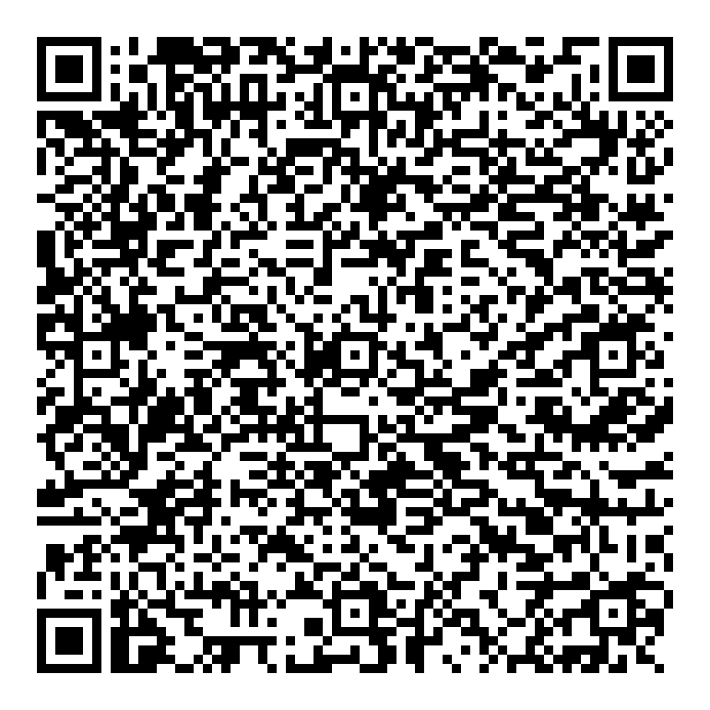
Home Learning (What and how often):
Home Learning (What and how often):
Homework once a week (flip learning and Seneca)
Revisit class content (make notes)
Research activities for practical
Topic Sequence  - How microscopes work  - Using microscopes  - Cells and organelles  - Organelles working together  - Prokaryotic cells  Stretch and challenge | Recommended reading:  HPA Recommended biological dictionary: https://www.sciencephoto.com/dennis-kunkel-microscopy-collection  https://www.stem.org.uk/big-cture/resource-collection  www.microscopy-uk.org.uk/  www.pbrc.hawaii.edu/bemf/microangelo  www.cellsalive.com  Places to visit:  Centre of the cell
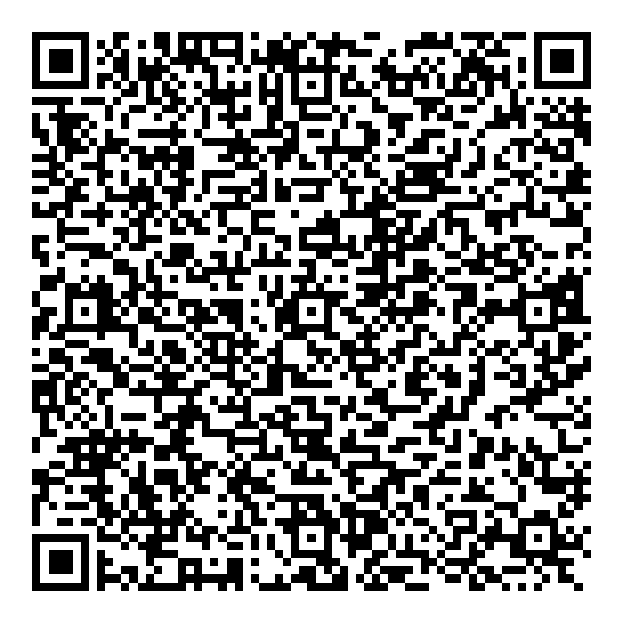
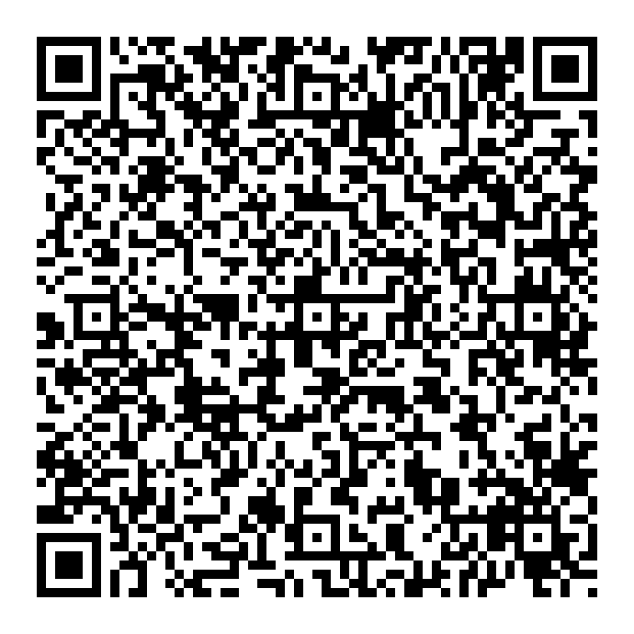
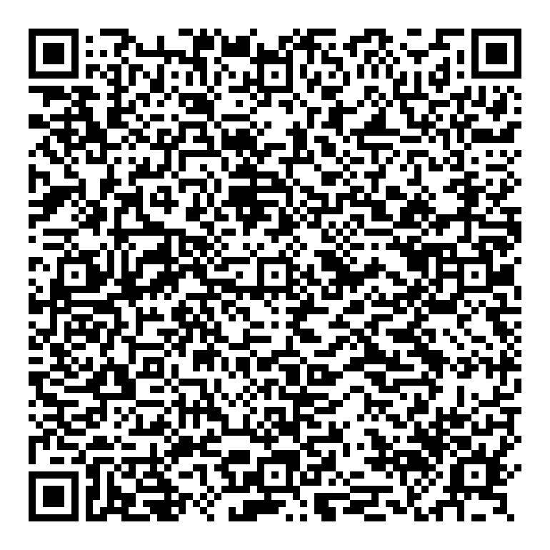
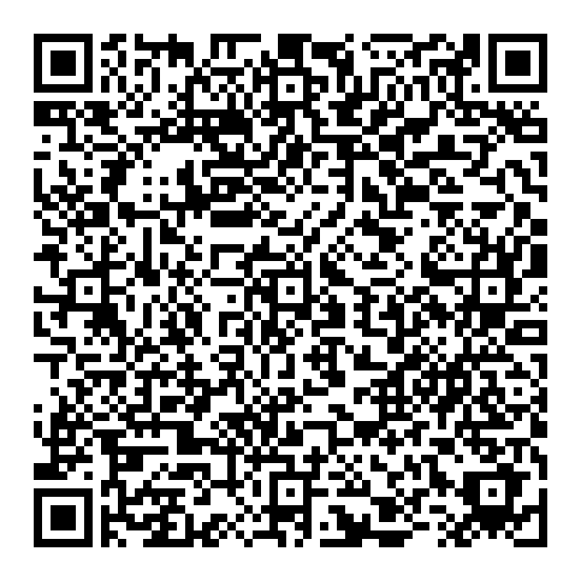
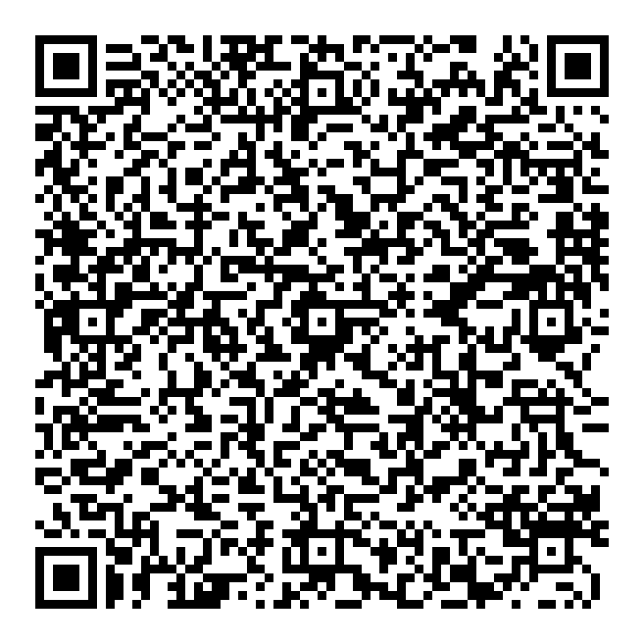
Success criteria – Have you met them? Show your evidence in the boxes below.
1.

2.

3.

4.
5.
6.
How will you improve your work?

End of Unit EVALUATION

