ENQUIRY: Would the mother country have survived without her children?
Unit intention: We will explore the ways in which Britain experience World War Two, both at home and abroad. We will delve into the importance of colonial support and the development of “Britishness” as an identity.
Second Order Concept- Significance
Key Concepts: Government, Conflict, Ideologies (Imperialism/Nationalism/Fascism/Liberalism), Empire
Success criteria |  | ✓ | X
- I can understand a ‘mother country’ is.
- I can describe how countries within the West Indies contributed.
- I can describe the role of the Indian Sepoys along this journey,
- I can evaluate commonwealth support.
- I can analyse how significant Britain’s support system was in winning the second world war.
Unit summative and formative assessment details:
Students will answer the enquiry question with an extended writing task

Would the mother country have survived without her children?

Student will answer extended writing piece on this.

Home Learning (What and how often:)
Meanwhile/elsewhere
Topic Sequence  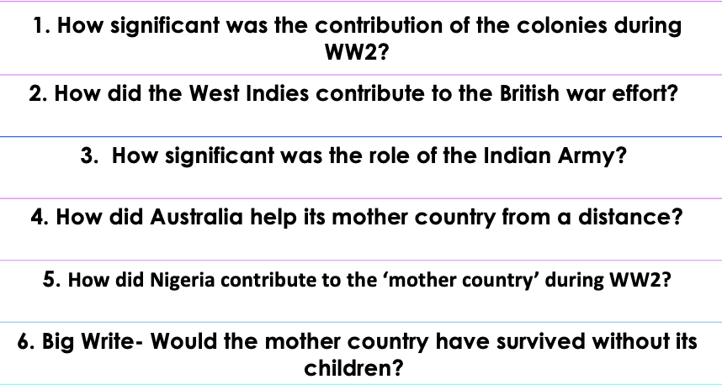 | Recommended reading to support Home Learning:  https://www.nytimes.com/2020/09/01/magazine/the-forgotten-colonial-forces-of-world-war-ii.html  https://www.bbc.co.uk/bitesize/topics/zk94jxs/articles/zgjff82  Recommended places to visit with your family:  Imperial War Museum  National Army Museum  Black British Archives

Success criteria – Have you met them? Show your evidence in the boxes below.
End of Unit EVALUATION
1.

2.
3.

4.
5.
How will you improve your work?

