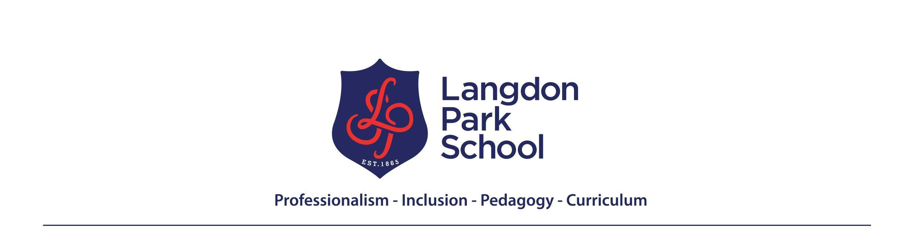

In the mathematics faculty we aim to inspire the mathematician in every student, developing fluency and confidence in using mathematics to reason and solve problems. We also aim to develop an appreciation of the beauty and humanity of mathematics and of its historical development and wider social relevance. We seek to do this without placing limits on the attainment of any student and while developing universal human values including anti-racism and challenging sexism, homophobia and other forms of discrimination.
Year 9 Learning Journey
Autumn
Term1 – Introduction to Ratio and Similarity How do we know whether two drinks of squash are the same strength if they have different volumes? What shapes can be made by using three overlapping triangles? | Term 2 –Geometric Reasoning 2 and Percentages with a Calculator When is a line not a line? Are credit cards a rip-off?
INTRODUCTION TO RATIO  - Introducing key ideas of ratio  - Developing fluency in choosing most useful representation for a particular problem  - What is a unitary ratio and how can we use it?  - Working with more complex ratio problems  SIMILARITY  - What changes and what does not when you enlarge a shape without distorting the image?  - What is a scale factor?  - Which internal ratios do not change in similar shapes?  - Solving problems using similarity  - Similarity and congruence - what’s the difference? | GEOMETRIC REASONING 2  - Recap of basic angles  - Translating lines or shapes  - Rotating lines or shapes  - Reflecting lines or shapes  - Enlarging shapes  - Applying a combination of transformations  - Describing a combination of transformations  PERCENTAGES WITH A CALCULATOR  - What is percentage change?  - Why decimal multipliers are key to working with percentages  - Using a calculator efficiently  - Percentages of amounts  - Percentage increases and decrease  - Reverse percentages  - Repeated percentage change and interest
Spring
Term 3 - Circles & Graphs and Linear Functions - Were the Ancient Greeks correct when they believed that the circle was the perfect shape? Is a graph a picture? | Term 4 - Pythagoras - How can you tell if there’s a right angle just by measuring lengths?
CIRCLES  - Parts of a circle  - Drawing circles accurately  - All about PI  - Finding the circumference- and finding radius or diameter given circumference  - Finding the area- and finding radius or diameter given area  - Working with compound shapes involving circles and parts of circles  - Problems involving circles  GRAPHS AND LINEAR FUNCTIONS  - What is a graph?  - What is a linear function and what does it graph look like?  - The algebra of linear functions and graphs  - Gradient and intercept  - What is the significance of where the graphs of two linear functions intersect?  - Modelling problems with linear functions and graphs.  - Real life graphs - distance-time; conversion  - Other kinds of graphs | PYTHAGORAS’ THEOREM  - Right angled triangles and squares on the sides  - Pythagoras’ theorem  - Using Pythagoras’ theorem  - Proving Pythagoras’ theorem as an example of mathematical reasoning  - Extending Pythagoras theorem - it works with any similar shapes drawn on the sides, link to similarity and ratio  - Pythagoras theorem in 3 D  - Who was Pythagoras?
Summer
Term 5 - Averages and Spread Does your postcode affect your average wage? | Term 6 – Representing and Interpreting Data and Introduction to Probability Are all graphs useful? What’s the probability of winning the lottery?
AVERAGES AND SPREAD  - Ways of representing data- tallies, bar and vertical line charts, pie charts, two way tables  - Using one number to represent lots  - Different types of average - mode, median and mean  - Strengths and weaknesses of different averages  - Solving problems using averages  - Why variation and spread matter - and why averages are not enough  - Range and other ways to measure variation and spread  - Applying averages and spread to analyse real data  - The use and abuse of statistics | REPRESENTING AND INTERPRETING DATA  - Representing data in pie charts, line graphs and scatter diagrams  - How can we interpret different charts?  - How can we compare charts?  - Explore real data sets - including using technology and digital sources  INTRODUCTION TO PROBABILITY  - What is chance and uncertainty?  - Assigning numbers on chance- probability  - Probability and fractions and ratio  - Calculating simple probabilities
Recommended reading/videos:  Pythagoras: https://link.springer.com/article/10.1057/jt.2009.16  Thinking Mathematically - book by Mason, Burton and Stacey  The story of PI: https://www.gresham.ac.uk/lectures-and-events/the-story-of-pi  Are averages typical: https://www.gresham.ac.uk/lectures-and-events/are-averages-typical | Places to visit:  Bank of England museum: www.bankofengland.co.uk - free but need to pre-book, lots of interesting maths stuff!  Winton maths gallery science museum: www.sciencemuseum.org.uk free gallery with lots of maths  Legoland: www.legoland.co.uk not free but as well as fun lots of maths related workshops once you’re there  Royal Observatory Greenwich: www.rmg.co.uk again not free but lots of great maths stuff to see and interact with  Bletchley Park: www.bletchleypark.org - short (30min) train ride from Euston but a great day out where you see the origins of modern computing and algorithms and lots of maths.

