**Course facilitators:**

* **Pip Pinhorn**
* **Julie Morgan**

# Children’s Group workers:

* **Natasha & Afia + others**

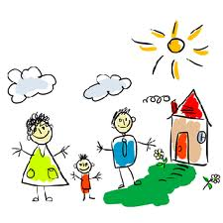

Both **Pip & Julie** are parents and have many years’ experience of supportive work with families and young children, both individually and in groups.

The Children’s Group staff are

all parents and are qualified

Early Years Practitioners

***“I’d like to refer a parent to the next Mellow Parenting course. Mum attended SFSC course in the past but difficult issues from her childhood were not addressed; she needs an intergenerational focus.”***

**LBTH Professional**

If you would like to join this course please contact:

**Pip or Julie**

**020 7987 7399**

**Email:**

[**info@toyhouse.org.uk**](mailto:info@toyhouse.org.uk)

This course will be for Mums & their pre school child & held at

**The Toyhouse Centre**

92 St. Paul’s Way, E3 4AL

**On a Thursday**

Running every week from late Autumn through to the spring

(during term time)

**For 14 sessions**

**Between 9.30am – 2.30pm**

***Due to C-19 pandemic, it might be necessary to adapt aspects of the course delivery to run safely within the current guidelines***

|  |  |
| --- | --- |
|  |  |

***“Thank you - it’s helped me set & keep to boundaries with my child, something my own Mum didn’t do with me; so I hope in the future it helps other mums”.***

***Parent***

MP10 INFO 4 PARENTS13072022/MP.DOCx

**Information for parents**



**Mellow Parenting**

**Course**

MCj04361630000[1]

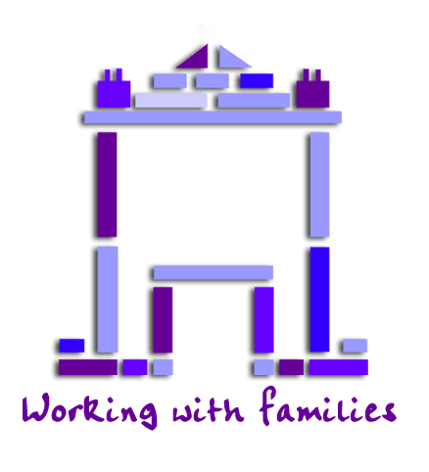

**Toyhouse**

**The Toyhouse Centre**

**92 St. Paul’s Way**

**London E3 4AL**

[**www.toyhouse.org.uk**](http://www.toyhouse.org.uk)

**info@toyhouse.org.uk**

*Toyhouse is a local charity independent from, but working in partnership with, The London Borough of Tower Hamlets*

**What is Mellow Parenting**

**Mellow Parents Course helps parents** who, for one reason or another, struggle with the challenges of parenting

* For parents and their Children under five years
* We will meet one day a week for 14 weeks.
* There will be a maxium of 8 parents in the group.
* The course is free of charge & includes a shared light lunch
* Each day will be divided into 3 parts:

1. **Personal Group**

You will join a group of parents with whom you can discuss the links between your own experiences in childhood

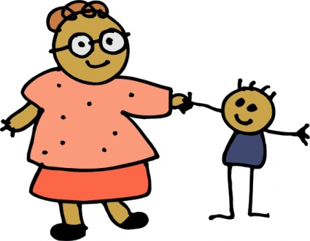

and your experience now of being a parent.

1. **Activity & lunch altogether**

All parents& facilitators involved in the group will prepare & eat a healthy light lunch together with their children. After lunch, we will all take part in group activities, during which we will support you to play together with your child.

1. **Parents’ workshop**

In this session, you will get the chance to watch films of interactions between parents and their children, learning about positive parenting. Usually you will be given tasks to **“Have a Go”** at home, to practise new activities or skills that you have learned about on the course. During the afternoon group session, you will have the opportunity to discuss your ‘Have a Go’, successes from what you’ve learned. You will also be encouraged to try new solutions to your parenting challenges.

**Other information**

Use of video……



We will take a videocam film of you and your children in your home, before the course starts. Most people do not like to be filmed but we have found it is a great way to look back on you and your children. ALL parents are hesitant about the filming & then end up pleased with it!

The film will belong to **YOU** and you will be able to watch it all with staff before choosing a small clip to share in the group.

Most people are usually surprised at how much is going on between parents and children when they get the chance to see it on film!