***Les nombres en français :***

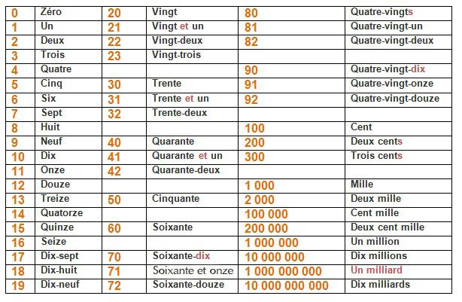

**ACTIVITY:** Les couleurs

**Translate the following colours into English.**

Rouge = _________________

Jaune = ____________________

Vert= _________________

bleu = __________________

noir = ___________________

gris = __________________

orange = ____________________

marron = ___________________

rose = __________________

violet = _________________

**Score = /10**

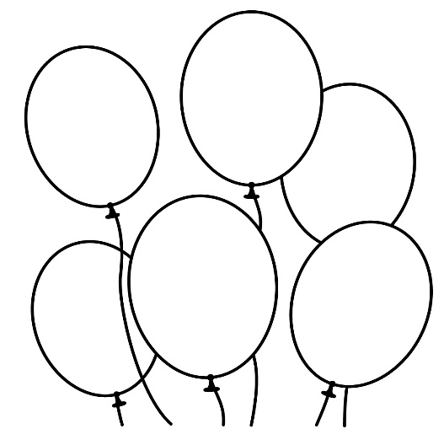[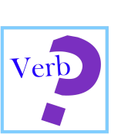](https://www.google.co.uk/url?sa=i&rct=j&q=&esrc=s&source=images&cd=&cad=rja&uact=8&ved=0ahUKEwi08NLY0p3NAhXkDsAKHQ0zB_cQjRwIBw&url=https://www.tes.com/lessons/cL74ZQIJYP5a6w/verbs&psig=AFQjCNHnAlDeyGoxuINl1fDGORfbZrfpwA&ust=1465654512215022)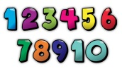

77

**ACTIVITY 4:** Les Verbes

**Match up the infinitives below**

|  |  |
| --- | --- |
| 1. **aller =h** | 1. to live |
| 1. avoir | 1. to eat |
| 1. être | 1. to hate |
| 1. faire | 1. to have |
| 1. aimer | 1. to call |
| 1. jouer | 1. to write |
| 1. boire | 1. to be able to |
| 1. vouloir | 1. to go |
| 1. pouvoir | 1. to want |
| 1. vivre | 1. to be |
| 1. manger | 1. to drink |
| 1. écrire | 1. to play |
| 1. appeler | 1. to do |
| 1. détester | 1. to like |

**Score = /14**

**ACTIVITY 3:** Common vocabulary

**How many can you translate into English?**

1. Comment t’appelles-tu ? –
2. Je m’appelle -
3. Merci –
4. De rien -
5. S’il vous plait –
6. A plus tard–
7. Au revoir –
8. Oui -
9. J’habite à Southampton –
10. J’ai 12 ans. –
11. Avec –
12. Bonjour –

**Score = /12**

**ACTIVITY 1:** Les nombres

**Unscramble the letters to spell a number in French.(1-40)**

e.g. qnutarae = quarante (40)

ozne = _________________

vgint = ____________________

idx-nuef = _________________

trtnee = __________________

soaintxe = ___________________

dzoue = __________________

qturae = ____________________

qzuine = ___________________

duex = __________________

sziee = _________________

idx-pset = _________________

vgint-ciqn = ____________________

**Score = /12**

**ACTIVITY 2:** Les nombres et les couleurs

**Colour in each of the balloons with the correct colour!**

dix-huit = rouge

cinquante-six= rose

quatre-vingt-neuf= jaune

quatre-vingt-quatorze= vert

soixante-dix-neuf = bleu

quarante-deux = orange

**Score = /12**

42

56

18

89

94