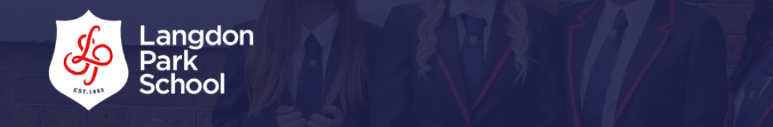
ICT Department



KS3 HL Workbook

Use internet/TeachICT.com to help you complete the activities.
Name & Form: ______________________________________
Teacher: ____________________________________________

Check MILK/Email your teacher if you do not have Teach ICT.com login details.

Data and Information

1 Which of the items below would be data (d) and which information (i)?

6 £12.50
Anne 1234567
17.9km 38a

2 Give an example of information that is:-

- text
- number
- graphic

3 Which software uses each of these icons:-







4 Match the file extensions to the file type:-

word processing .xls
spreadsheet .jpg
photo .doc
picture .ppt
presentation .bmp

Word Processing

1. The boxes show text before and after formatting.

List 5 ways in which the text has been formatted.
Menu
Starters
Prawn Cocktail
Soup of the Day
Main Courses
Pasta
Steak and Chips
Chicken Curry
Desserts
Ice Cream and Jelly
Cheesecake

Menu
Starters
Prawn Cocktail
Soup of the Day

Main Courses
Pasta
Steak and Chips
Chicken Curry

Desserts
Ice Cream and Jelly
Cheesecake

2. Describe what we mean by the term ‘Text Alignment’

3. Copy the icons below and name which type of alignment they are used for.

4. Match the picture to the correct type of page orientation

Portrait
Landscape

5. What is meant by the term hard copy ?

Word Processing

1 State two types of document you might create on a word processor.

2 Match the words to their definition:

Word wrap take out text a place it somewhere else
Header create an identical piece of text
Footer find a word and change it to another one
Margin found at bottom of every page
Cut & Paste automatically go on to next line if need to
Copy & Paste space between text and edge of page
Search & Replace pictures to add to a document
Word count found at top of every page
Clip art how many words are in my story

- Does a spelling mistake show a red or a green line?

4 State whether the font, size or style has been changed

PC Passport PC Passport
PC Passport PC Passport
PC Passport PC Passport
PC Passport PC Passport

5 Describe other ways in which the appearance of text could be altered

Graphics

1 What is a graphic?

2. State two ways to acquire a graphic.

3. Match the type of graphic file to a use

JPEG animations
BMP photographs
GIF paint documents

4. Which of the file types mentioned above allows you to alter a graphic at pixel level?

5. Which of these three types is a very big file?

6. Which of these file types can only use 256 colours?

7. Which of these three types does not lose quality when compressed?

8. List two uses for each of the following types of graphics software:
  - Draw
  - Paint

Graphics

1. Which statements describe a paint document and which a draw document?

  - Can’t overlap shapes without deleting part of previous
  - Uses vectors (lines and shapes) to create graphics
  - Files created are very large

2. Describe one advantage that a draw document has over a paint document.

3. Describe one advantage that a paint document has over a draw document.

4. Draw three tools that might expect to find in any graphics package and explain what they do.

5. List five ways the following shape has been altered.

Spreadsheets

1. Copy and label the diagram below using the word provided.

dsheets 1 Layout
Row, Column, Cell, Column Heading,
Row Heading

Spreadsheets 1 Layout

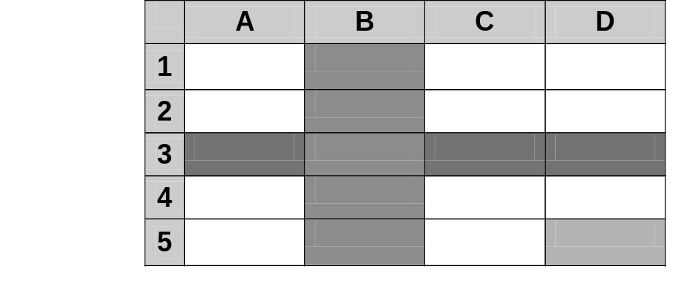
1
2
3
4
5

2. Using the words in the box copy and complete the passage below.

Rows, Grid, Column, Calculate, Cell, Label, Sort, Values, Charts, Formula

A spreadsheet is made up of a _ _ _ _ of boxes. Each box is called a _ _ _ _ .

The Cells are arranged in _ _ _ _ and Columns. A Row is a set of Cells going across the sheet from left to right and a _ _ _ _ _ _ is a set of boxes which go down the sheet from top to bottom.

A Cell can contain text, numbers or a _ _ _ _ _ _ _. A word in a Cell is called a _ _ _ and numbers in a cell are called _ _ _ _ _ _. A Formula is a rule to make a spreadsheet _ _ _ _ _ _ _ _ _ an answer. All Formulas begin with an equals = sign.

Spreadsheet 2

1. Here is a spreadsheet showing the sales in the school tuck shop. Use it to answer the questions below.

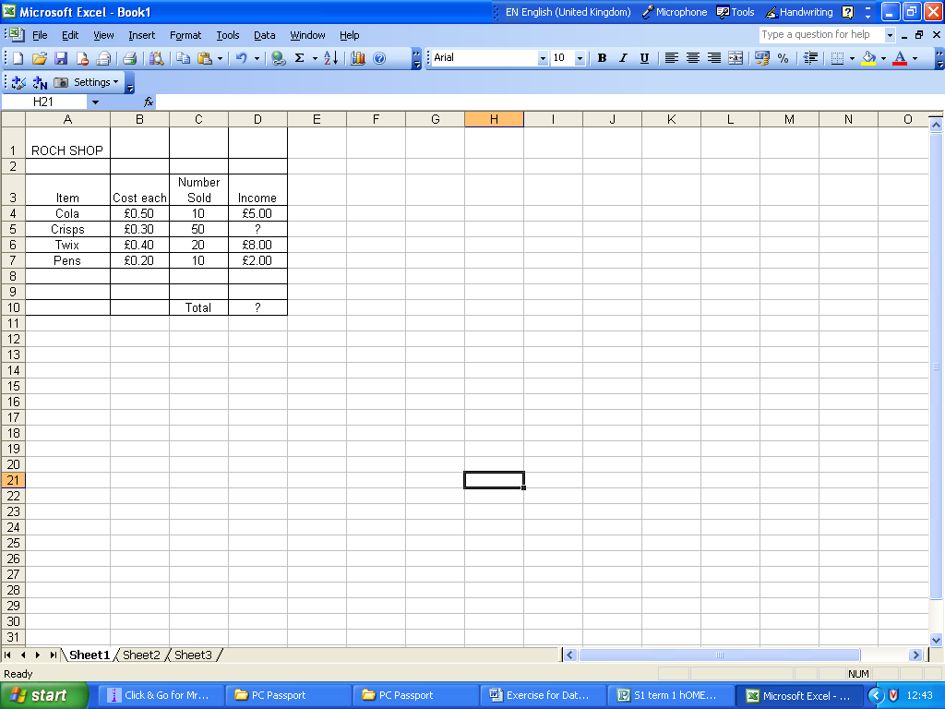

- What value is found in cell B5?
- What label is found in cell A3?
- What is the cost each of pens?
- How many Twix bars were sold?
- Name another cell that contains a value.
- Name another cell that contains a label.
- How has the value in cell D4 been calculated?
- What amount of money should appear in cell D5?
- What formula should go in cell D10?
- What will be the final total in cell D10?

2. What function do you use to work out the total from a list of numbers?

3. Write down the formula you would use to calculate the average income?

4. Describe how you could work out the highest income and the lowest income in your spreadsheet.

5. What could be done to the heading ‘Roch Shop’ to make it stand out?
Spreadsheets

1. Look at the spreadsheet below:

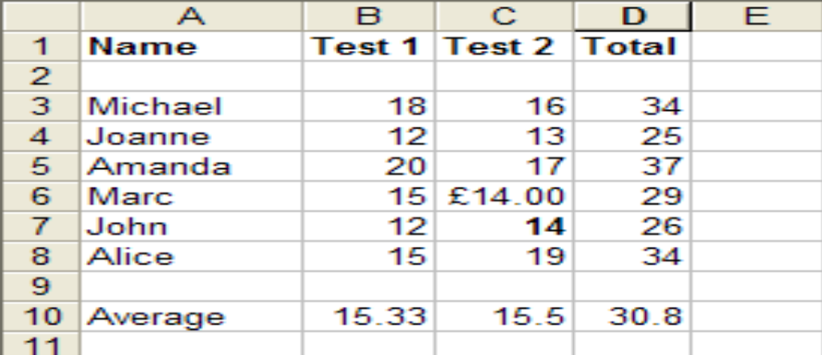

Write down a cell which contains:

  - Text
  - Value
  - Formula

- What formula would be used to work out the total of Michael’s two tests?

- What formula would be used calculate the average score from the total of the
tests?

- What has happened in cell C6?

- What other ways could the appearance of a cell be altered?

- Describe a better to way to display data so that easy comparison could be made
between all pupils test scores.
Presentation Software Questions

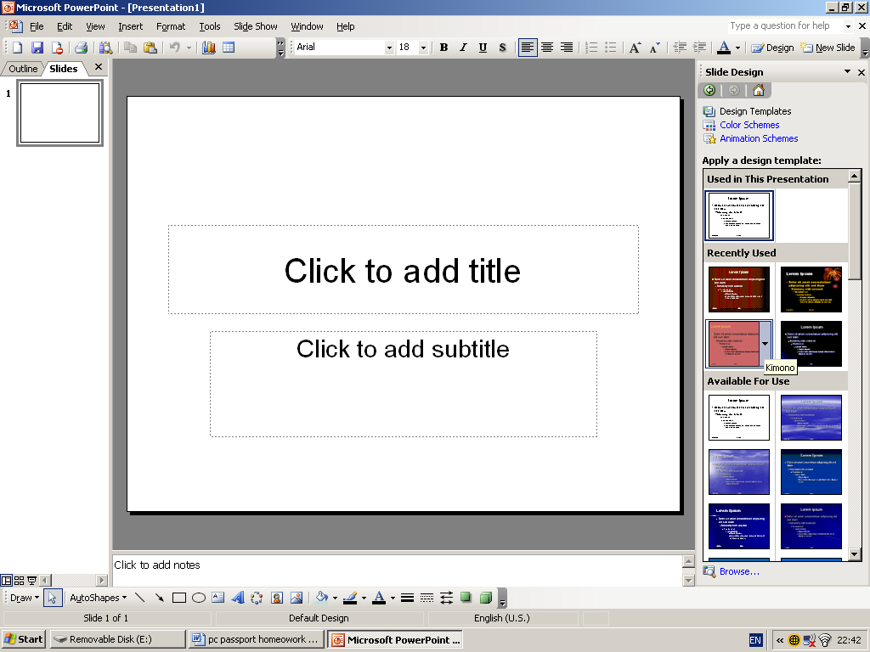
- What would you do if you found you needed to put extra slide into your PowerPoint presentation?

- List three types of data you could include in a PowerPoint Presentation.

- Using the following print options would give you what:
  - Print Current Slide
  - Handout Format

- List three ways you could make your slide show more attractive.

- Describe a method of showing a list of points.

- You are looking for information for your PowerPoint project – describe what type of website might be a reliable source.

- When would you use a slide sorter?

- Describe one consideration that should be taken into account when using a PowerPoint presentation to make a presentation to the rest of the class.

- Name three methods of slide transition.

Next Topic: Word Processing

- List three ways you could alter text.
- What is a spell check?
- Show the difference between landscape and portrait orientation (use a diagram).
- How could you alter to your document to give you more space round the edges of the paper?
- When would you use copy and paste?
- List three ways you could make a heading stand out?
- What is the purpose of find and replace?
- How could you go about only printing certain pages from your report?
- Describe the four methods of text alignment (draw a diagram if you need to).
- You find that you have made a mistake and which to go back to change what you just did. Describe a feature of word processing software that allows you to do this.
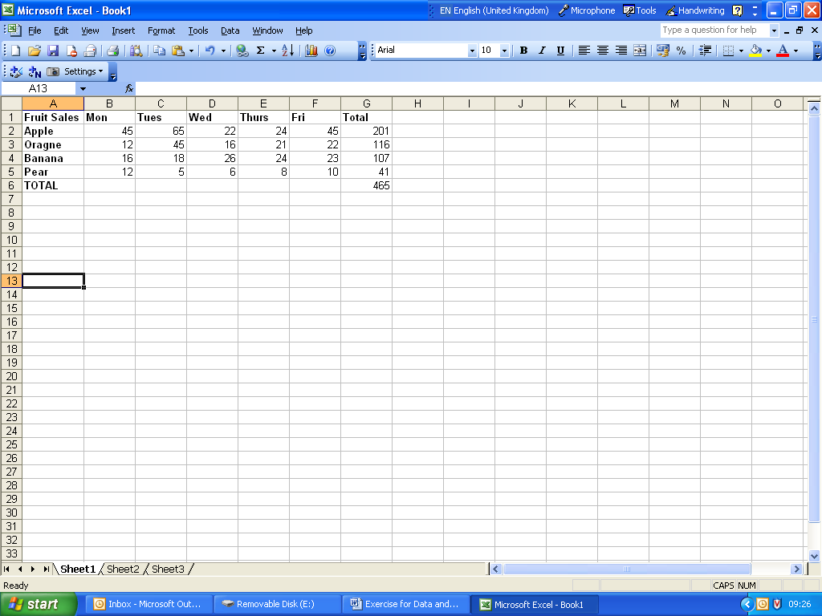

a. Name a cell which would contain:
  - Text
  - Value
  - Formula
b. State the formula used in G2.
c. The rest of the formulae in that column have not been keyed in. Which feature of a spreadsheet could have been used to achieve this?

d. The numbers in the above spreadsheet should have been displayed as money. How would you go about doing this?

e. Name three different types of chart.

E-Safety
Learning Objectives
The aims of this project are for you to learn/practise how to:
✓ Explain Cyber Bullying and the effects it can have on individuals.
✓ Protect yourself and your identity online.
✓ Find relevant information online and evaluate its usefulness.

Task 1: Answer the following questions as fully as you can. You can write out the questions and answers or type them and print them out.

1. What do you think ‘Cyber Bullying’ means?

2. Make a list of the different ways mean messages can be sent to another person.

3. What advice would you give to a friend who is bullied online or by text?

4. If you write mean things in a chat room, by email or in a text, it doesn’t hurt as much as saying it to someone’s face. What do you think about this statement?

Task 2: Design an ‘anti-Cyber Bullying’ logo. Draw by hand below or design using a computer and glue in to the space below.

Task 3: Complete the table below. You may decide to discuss each situation with a trusted adult first of all.
Situation | What would you do if this happened?
You click on a link and find a site with unsuitable content | Switch your monitor off. Tell your parents – they can block the site and check your computer for viruses which might have been downloaded.
A site asks you to register and give your personal details

You receive an email telling you that you have won £500 in a competition that you don’t remember entering
You find a site which has lots of free games to download

You get an email from a stranger which contains an attachment

You started to get rude or abusive texts or emails from a friend

You started to get rude or abusive texts or emails from a stranger

Describe two benefits and two dangers of using social networking sites such as Facebook.

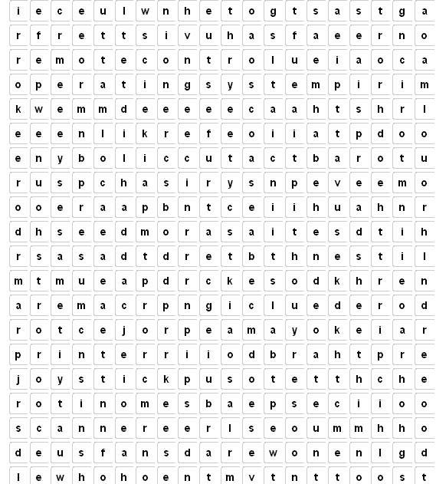
Keywords to find

Keyboard
Speaker
Mouse
USBstick
GraphicsCard
Printer
Monitor
Keypad
Touchpad
Trackerball
Remotecontrol
Joystick
Scanner
Camera
Webcam
Projector
Microphone
MICR
OCR
Spreadsheet
Operatingsystem
Processor
Presentation
Using the above words list all the input devices in this box:
Using the above words list all the output devices in this box:

Name the components.—you could do this whilst the video is playing/your teacher is doing the demonstration.


1
2
3
4
5
6
7
8
9
Label the computer components

1.

2.

3.

4.

5.

6.

7.

8.

9.

Right then you savvy techie you,

The picture below is the inside of a computer. Using your amazing powers of drag and drop, move the labels to the correct component.

(tip—the components are not always easy to see because they may be partially hidden or seen on a strange angle!)

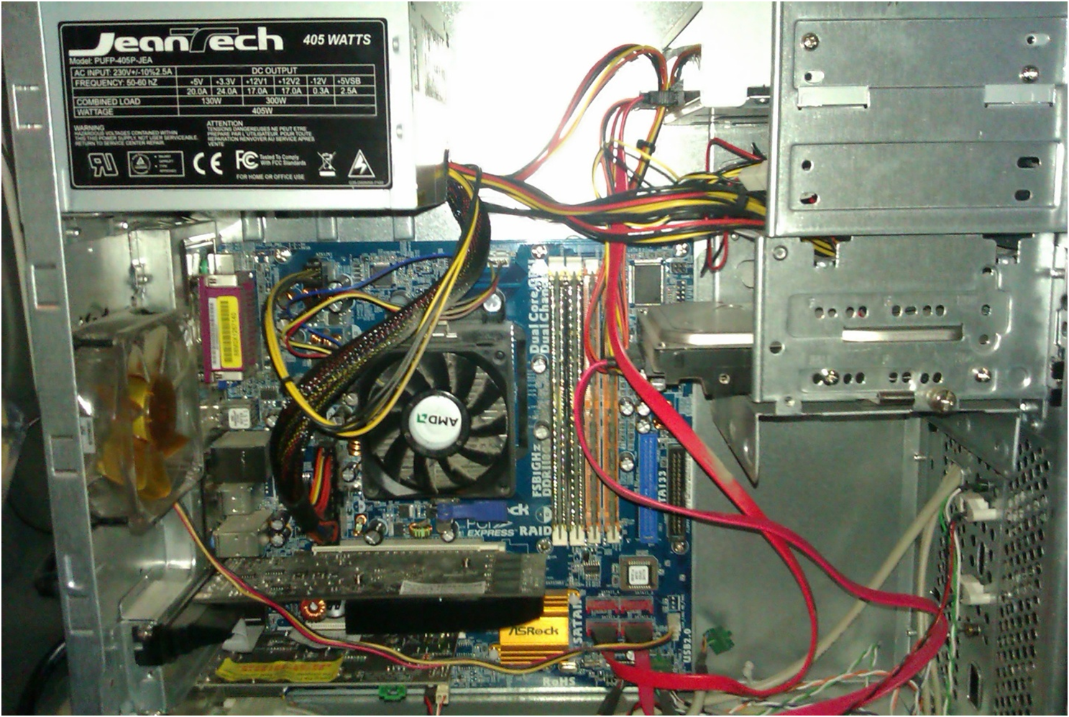

Power supply (PSU)
mother board
CPU
(central processing
unit)
RAM
Hard drive
optical drive
GPU
(video/graphics card)

How much do you know about computer hardware components now?
Let’s find out! Answer the questions below.

Question | Answer/s
Which component allows you to see images and video on your screen?

RAM (Random Access Memory) stores temporary data that is lost when the PC is turned off – can you give an example of what sort of job/s RAM does?

An optical drive is not necessary in a PC but you might want to include one……Why?

What hardware does all of the above either attach to or connect to?

What is the “brain” of the computer called?

Why is there a fan on the power supply? (PSU)

Can you name an input, process and output component?

Match the hardware with its correct definition. One has been done for you as an example

Graphic Card |  | It is the enclosure that contains the main components of a computer
Monitor |  | Random Access Memory
Hard Drive |  | It is an input device which features an arrangement of buttons. This hardware is used to type
System Case |  | Visual Display Unit
Keyboard |  | A board that allows other hardware to be connected on to it
Motherboard |  | Responsible for generating all the text and pictures that are displayed on a screen
RAM |  | A device used for storing large amounts of data

a) Explain what hardware is

___________________________________________________________________________

b) Explain what software is

__________________________________________________________________________________

What is the main function of an operating system? Circle the correct answer

- The operating system protects the computer from hackers
- The operating system allows the computer programs to function correctly by allowing them to communicate with other programs and the computer
- It allows end users to use Microsoft Word and Excel
- The operating systems lets you to watch videos

Give two examples of Operating Systems

What is the purpose of an Anti-Virus program?

___________________________________________________________________

Give two examples of Web Browsers

Circle the correct FOUR words that are Hardware

Internet Explorer Printer Cooling fan
Firewall Speakers Anti Virus
Power supply Photoshop Google Chrome
Microsoft Access Windows Media Player Mozilla Firefox

Give TWO advantages of using a PC when doing your school work

1.

2.

Which application would you use to create a letter document on the computer? Circle the correct answer
- MS Access
- MS Publisher
- MS Outlook
- MS Excel
- MS Word

Which application would you use to send an email from your computer? Circle the correct answer
- MS Access
- MS Publisher
- MS Outlook
- MS Excel
- MS Word [
List three Peripherals that you can attach to a PC
1.

2.

3.
Explain and give example of a portable computer
________________________________________________________________________________________________________________________________________________________________________________________________________________________________________________________________

Describe how data saved on a computer can be protected from potential threats.
______________________________________________________________________________________________________________________________________________________________________________________________________________________________________________________________________________________________________________________________________________________________________________________

Answer the following questions by referring to the computer specifications below
- Which PC comes with the best Operating system and Software?

- Which PC can store more data?

- Which PC would load faster when you start it?

- Which PC has the best biggest visual display unit?

The following are five different pieces of legislation relevant to computers.
a. The Data Protection Act 1998
b. The Freedom of Information Act 2000
c. The Computer Misuse Act 1990
d. The Copyright Designs and Patents Act 1988

Complete the following table to show which legislation applies to each statement.
You may use any statement more than once.

a, b, c, d
Fred has discovered Mia’s password and logs on to her computer to look at her homework
A company sells a list of the names and addresses of its customers to a mail-order frim without their knowledge
Igor has deliberately transmitted a virus to several computers
A company keeps records of personal details about its employees, but fails to keep these up-t-date.
Henry downloads a list of all the schools in a certain area, with the number of pupils in each school
Myra copies a music CD to give to a friend

CHALLENGE - Extended writing tasks

Extended writing - essay type question – use the links provided to help you with your research.

- What does the Data Protection Act say about information security? Use the link to help you write-up your response:
https://ico.org.uk/for-organisations/guide-to-data-protection/principle-7-security/

- Write a short essay explaining the types and dangers of malware on smartphones
http://www.bbc.co.uk/news/technology-36744925



- Produce a summary report discussing the features and functions of three leading Operating Systems in the mobile phone market.
Write a conclusion on which Operating System you think performs the best and why.
http://www.trustedreviews.com/opinions/which-mobile-operating-system-is-best


- Cloud based storage is becoming more and more popular. What are the risks and benefits of using cloud storage?
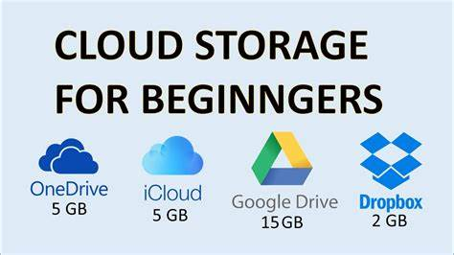
https://en.wikipedia.org/wiki/Cloud_storage


EXT TASKS:
Create posters using MS Publisher on following topics:
- Computer legislations – DPA/GDPR, Copyright design and patents act, Computer Misuse act and another act of your choice. – You need to make the poster informative and creative so that future 7 and students can use it to learn from it.
- Bitmap Vs Vector graphics – with examples
- Online safety tips for parents
- Green IT – How schools can adopt a greener way of using IT around the school.
- Social Network – FAKE NEWS – all about social network and how to be responsible
- Digital FOOTPRINT
- Computer storage devices
- Computer networks – LAN and WAN
- Choose any topic of your choice – related to IT and Computing

For all the posters above your target audiences are future year 7s and 8s – use appropriate images and suitable language as well as engaging and creative design skills to attract attention.

NOW COMPLETE AS MANY UNITS AS YOU CAN ON TEACHICT.COM

Choose KS3 courses and select your year once you have logged in.

Choose units in any order and complete the activities/worksheets set.

