

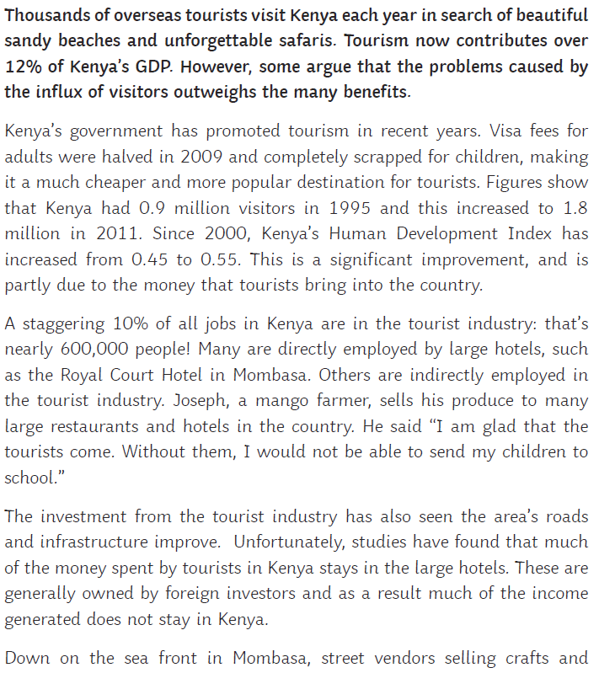

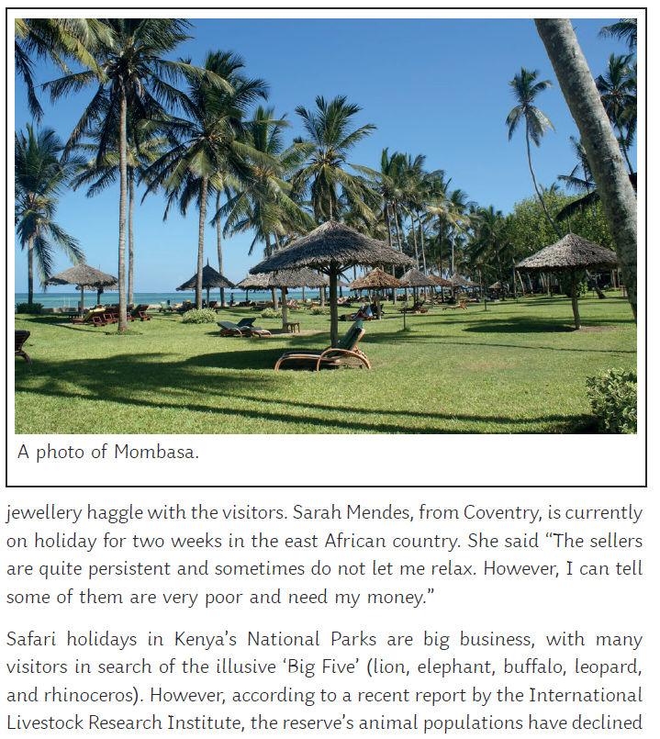

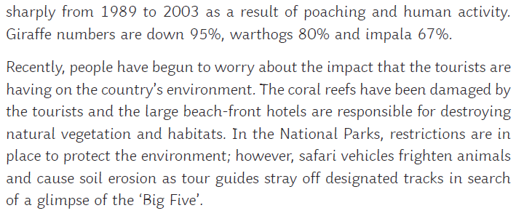

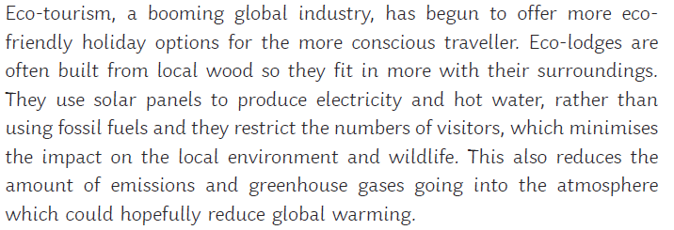

**Task:**

Use the information you have just read to complete this table, listing the benefits and problems of tourism in Kenya.

|  |  |
| --- | --- |
| **Benefits of tourism in Kenya** | **Problems of tourism in Kenya** |
|  |  |

