LANGDON PARK SCHOOL
KS3 HOME LEARNING BOOKLET
SCIENCE

Cells
Draw and label a plant and an animal cell.

What is the function of the following organelles?  Nucleus  Cell membrane  Cytoplasm | How many times bigger is an egg cell (0.2mm) than a sperm cell (0.05mm)?  What is the total magnification of a microscope with a x10 objective lens and a x4 eyepiece lens?
Why are root hair cells not green?

What is the role of roots in a plant?

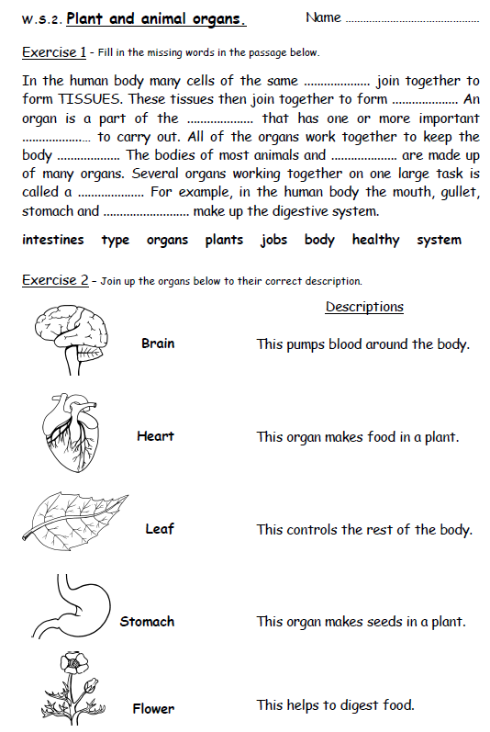

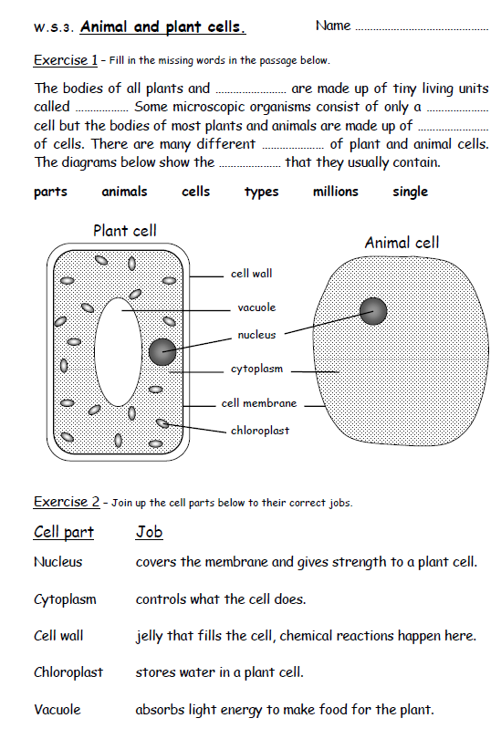

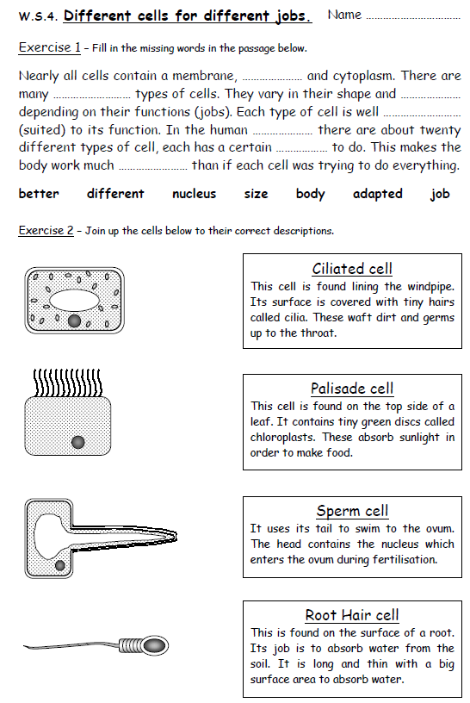

Particle Model
Draw and label particle diagrams for the three states of matter (solid, liquid and gas) and give the names for the changes of state e.g. solid liquid = melting.

At which two temperatures does water experience a change of state?  What state would water be at 15ºC?  What state would water be at -74ºC? | If you increase the pressure in a balloon what happens to the particles inside?  If you continued to add air what would happen and why?
What is diffusion? How does it help sharks track blood in water?
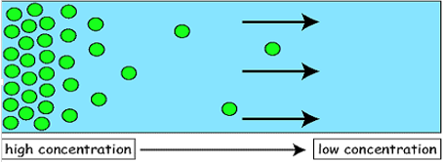

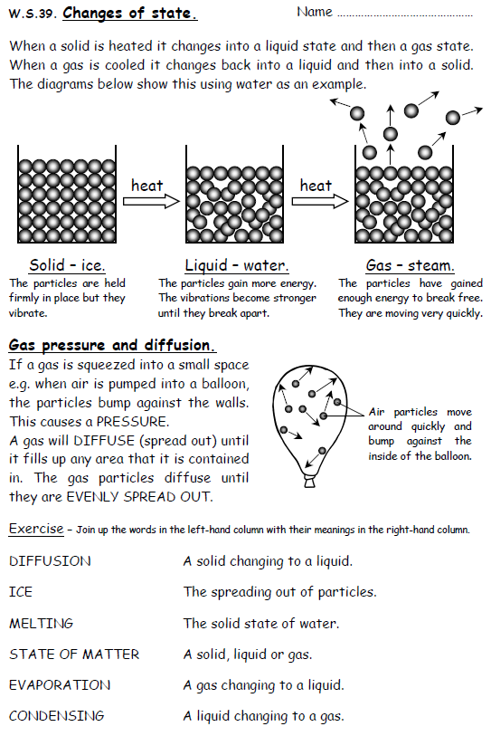

Separating Techniques
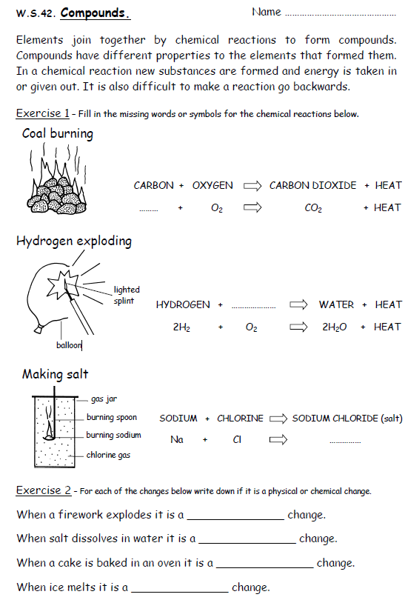
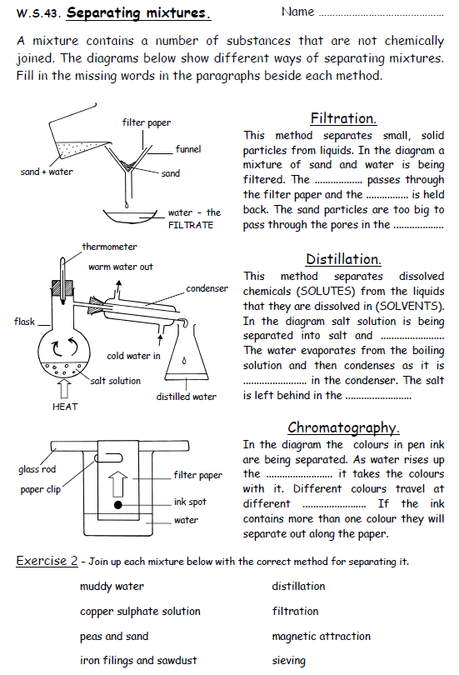

Speed
On the car below draw force arrows for the four forces it is experiencing and label them (the car is moving forward at a constant speed).

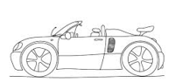

Jack and Jill go up a hill, the distance they travel is 75m and it takes them 2 minutes and 30 seconds, what was their average speed in m/s?  How far in metres would a car travel in 3 minutes going at 16 m/s? | What does the following graph show?  Explain the motion of the object.
Usain Bolt went from 0.0 to 11.0m/s in 3.4s. What was his acceleration?

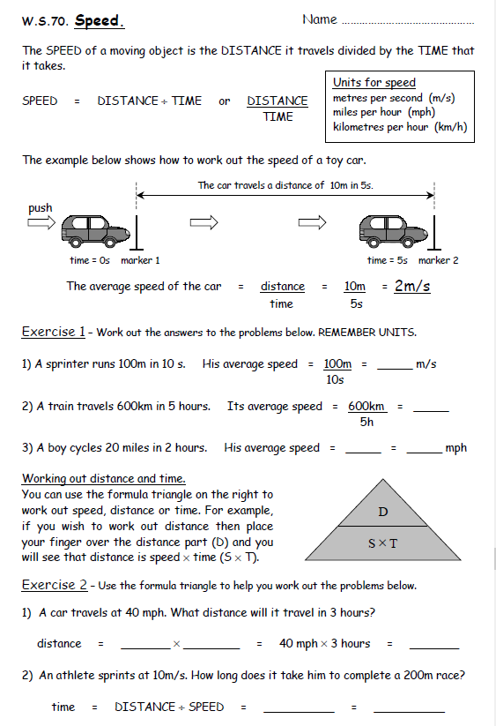
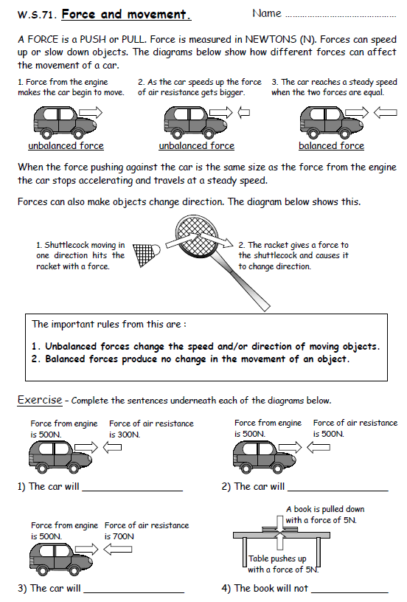

Gravity
What is the difference between mass and weight? Include units and factors that could affect the weight of an object in your explanation.

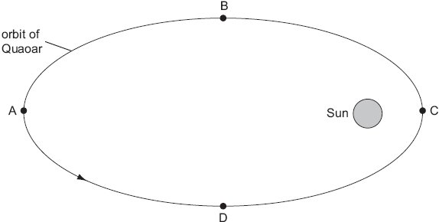  On the diagram above draw four force arrows to show the effect of the Sun’s gravity at the four points A, B, C and D.  Where is the effect of gravity the largest and why? | The gravity on Earth is 10N/kg.  Use the equation weight = mass x gravitational field strength to answer these questions.  What is the weight of a person who has a mass of 76kg?  What is the mass of a person who weighs 964N?  The gravity on the Moon is 1.6N/kg. How many times less is it than the Gravity on Earth?
Variation
What is a characteristic?

Explain the difference between inherited and environmental variation and give three examples of characteristics for each.

What adaptations do polar bears have? For each adaptation explain how it benefits the polar bear.  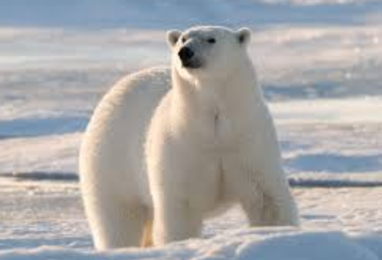 | What adaptations do camels have? For each adaptation explain how it benefits the camel.  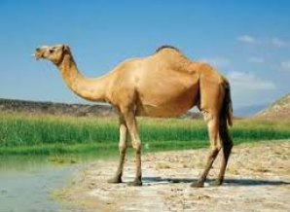
Write a paragraph explaining how natural selection leads to evolution.

Human Reproduction
Draw and label a diagram of a sperm cell. | Draw and label a diagram of an egg cell.
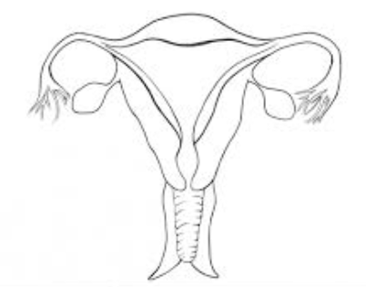  Label the female reproductive system. | Label the male reproductive system.  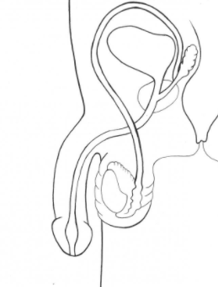
Describe the four stages of the menstrual cycle.

Acids and Alkalis
Colour in the pH scale below and add an example for each number.

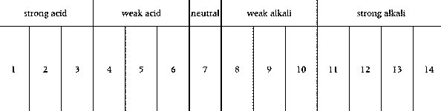
Fill in the table to show the colours that the litmus paper would go.  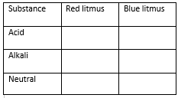 | Explain what happens during the process of neutralisation between acids and alkalis.
Name the following salts from neutralisation reactions:
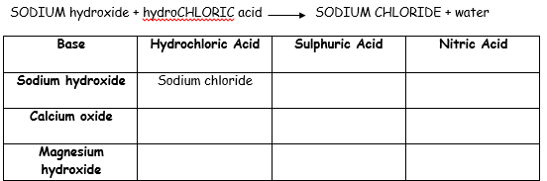
Metals and Non-Metals
Fill in the table below with properties of metals and non-metals and explain what each key word means, e.g. ductile – can be drawn into a wire.
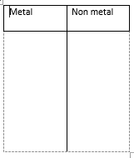
Keywords -
Complete the following word equations to show reactions between metals and acids.

Zinc + hydrochloric acid
Copper + nitric acid
+ sulphuric acid potassium sulphate
iron chloride + hydrogen

Explain what a displacement reaction is, using the example below to help in your explanation.

copper sulphate + magnesium magnesium sulphate + copper

Earth Structure
Label the rock cycle.
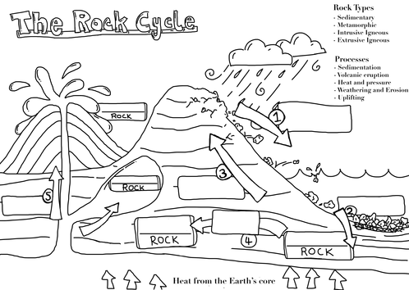
How are sedimentary rocks formed?  What conditions are needed to change a sedimentary rock into a metamorphic rock?  Why are fossils never found in igneous rocks? | The radius of the Earth is 6371km. The mantle is 2900km thick. What percentage of the Earth is this?  The diameter of the inner core is 1200km. How many times bigger is the Earth compared to this?
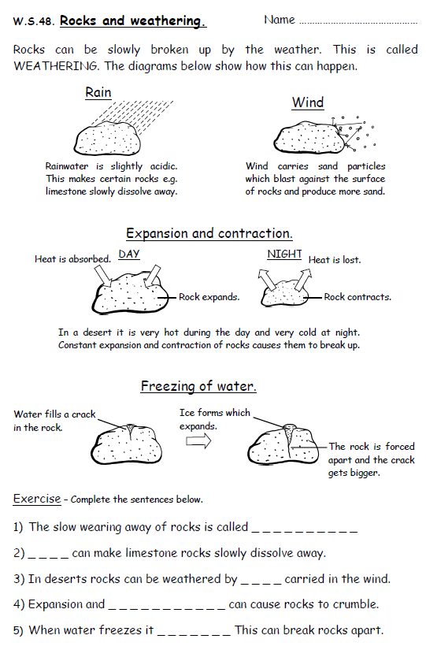
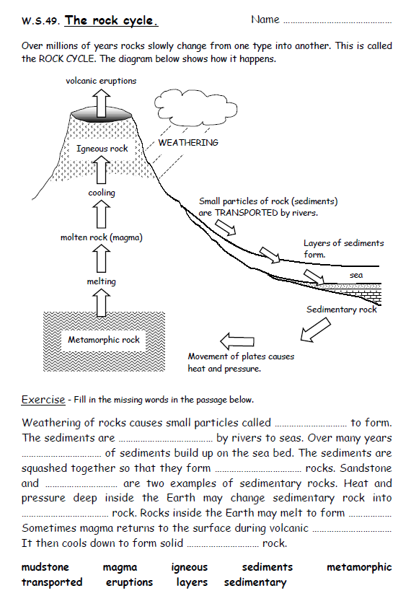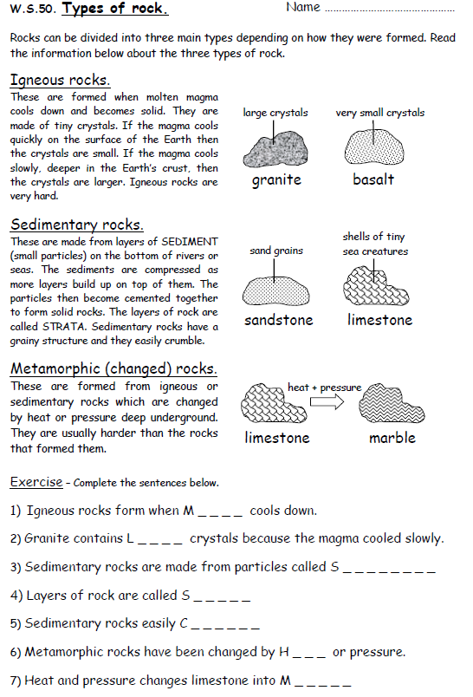
The Universe
Draw and label a diagram to explain why the Earth experiences seasons.

Define the following keywords:  Galaxy, planet, moon, Universe, Solar System. | Draw and label diagrams of a solar eclipse and a lunar eclipse and explain the difference between the two.
What are the main factors that limit us leaving Earth and living on another planet?

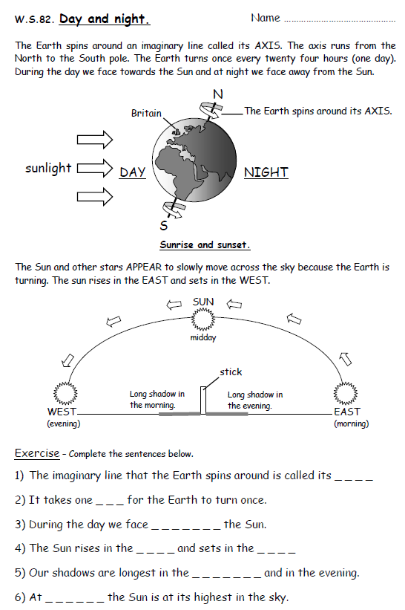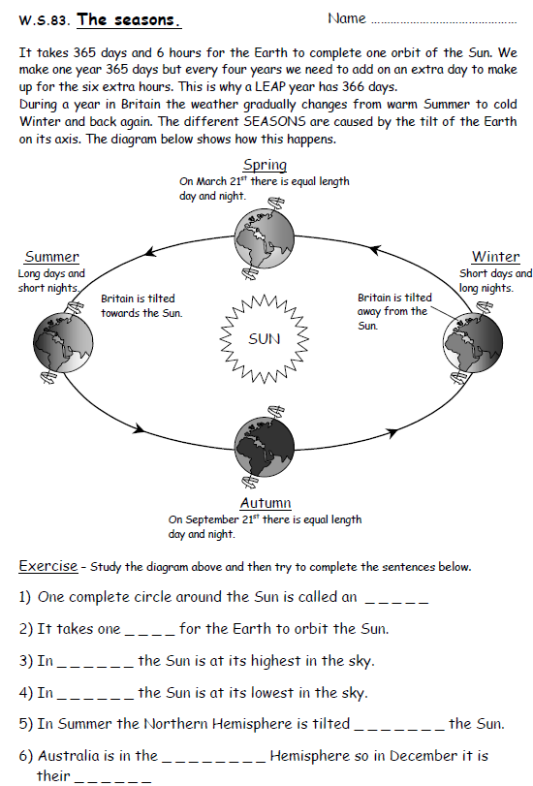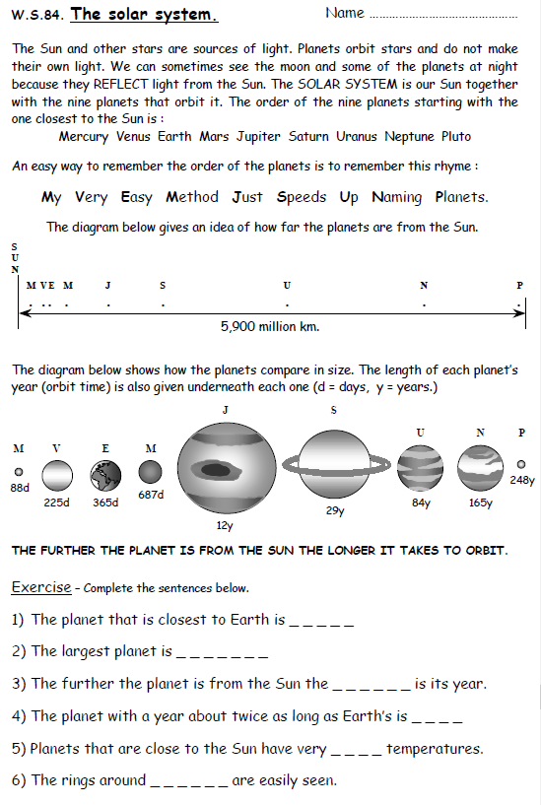
Contact Forces
Explain how weight and air resistance act on a falling seed
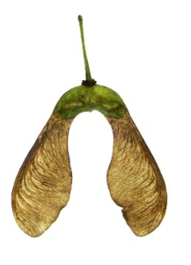

How can friction be reduced? | Calculate the moment of an object that is 3 metres from the pivot with a weight of 15 N  Calculate the distance a 10N weight needs to be from a pivot to counter 150 Nm
What happens to a spring when you double the force acting on it? Answer in terms of stretch of the spring

Pressure
If you pump up a bike tyre what happens to the pressure? Answer in terms of particles

Why are dams thicker at the bottom? | Calculate the stress of an athlete with a weight of 600N spread across 2 feet each area is 150cm ²
If you heat up a can then place it in cold water why does the can get crushed?

Ecosystems
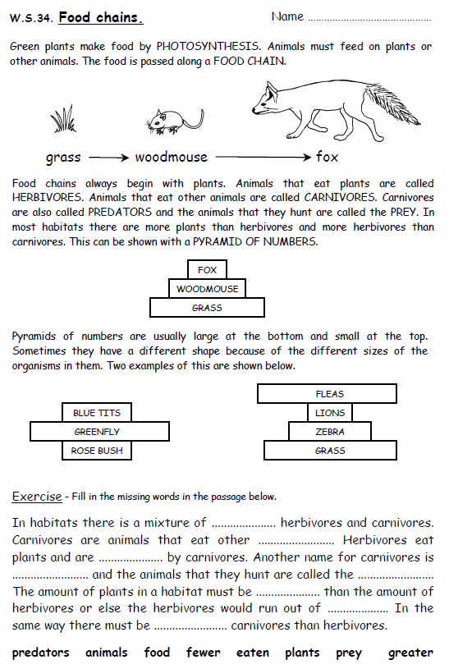
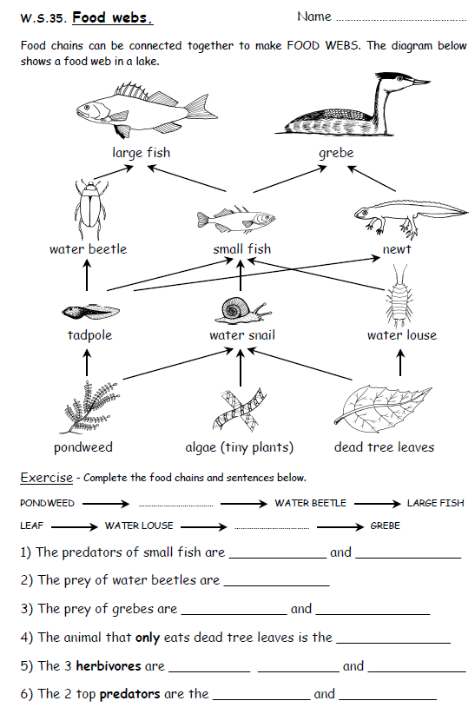
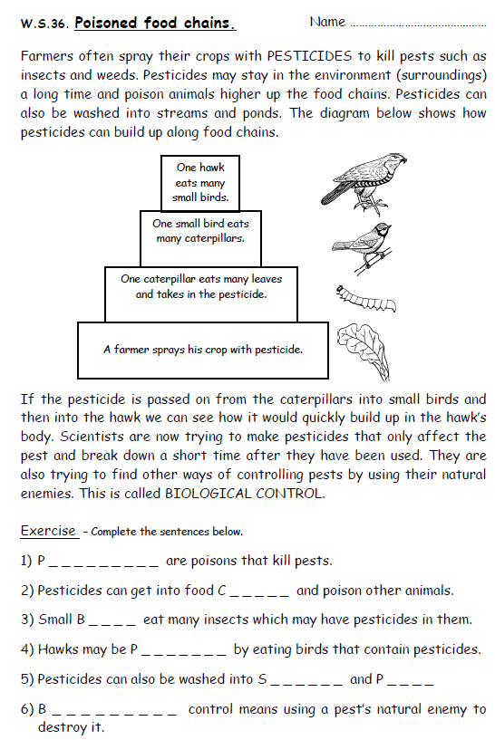

Energy
