GCSE YR10 FORCES PART 1
(Home Learning Questions and Answers Booklet)

Instructions:  - Watch all video clips on Educake homework titled: Forces In Action Part 1. Before attempting to answer GCSE practice questions on this booklet.  - You must attempt all practice questions in this booklet before looking at the answers.  - Watch video clips on forces, make notes and complete all set task on Educake and Easy-Education.  - Watch out for Forces Part 2 titled: Forces In Motion – I will be focusing on Newton’s Laws of Motion.  I.Ukiwah  Physics teacher/Head of Science  Email: ukiwahi@langdonpark.org | Name: ________________________  Class: ________________________  Date: ________________________

Time: | 75 minutes
Marks: | 70 marks

Q1.
Momentum is a vector quantity.
(a) How is a vector quantity different to a scalar quantity?
___________________________________________________________________
___________________________________________________________________
(1)
(b) Name another vector quantity.
___________________________________________________________________
(1)
(c) Give the definition of momentum.
___________________________________________________________________
___________________________________________________________________
(1)
(d) What is the unit of momentum?
___________________________________________________________________
(1)
(e) The image shows a golf club about to hit a stationary golf ball.
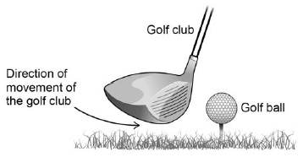
The golf club is in contact with the golf ball for 1.8 ms and exerts a force of 1500 N on the golf ball.
The mass of the golf ball is 0.045kg
Calculate the velocity of the golf ball as it leaves the golf club.
___________________________________________________________________
___________________________________________________________________
___________________________________________________________________
___________________________________________________________________
___________________________________________________________________
___________________________________________________________________
___________________________________________________________________
Velocity = ____________________ m/s
(4)
(f) When hitting the golf ball the golfer swings the golf club to keep it in contact with the golf ball for as long as possible.
The force acting on the golf ball is constant during this time.
Explain the effect that the time of contact between the golf club and the golf ball has on the distance the golf ball travels.
___________________________________________________________________
___________________________________________________________________
___________________________________________________________________
___________________________________________________________________
___________________________________________________________________
___________________________________________________________________
___________________________________________________________________
___________________________________________________________________
(4)
(Total 12 marks)
Q2.
Quantities in physics are either scalars or vectors.
(a) Use the correct answers from the box to complete the sentence.

acceleration | direction | distance | speed | time
Velocity is __________________________ in a given ________________ .
(2)
(b) Complete the table to show which quantities are scalars and which quantities are vectors.
Put one tick () in each row.
The first row has been completed for you.

Quantity | Scalar | Vector
Momentum
Acceleration
Distance
Force
Time
(3)
(c) The diagram shows two supermarket trolleys moving in the same direction.
Trolley A is full of shopping, has a total mass of 8 kg and is moving at a velocity of 2 m / s with a kinetic energy of 16 J.
Trolley B is empty, has a mass of 4 kg and is moving at a velocity of 0.5 m / s with a kinetic energy of 0.5 J.
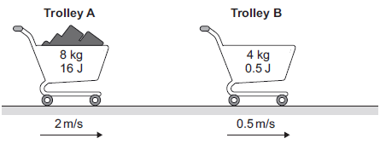
(i) Calculate the momentum of both trolley A and trolley B.
Give the unit.
______________________________________________________________
______________________________________________________________
Momentum of trolley A = _______________
Momentum of trolley B = _______________
Unit __________
(4)
(ii) The trolleys in the diagram collide and join together. They move off together.
Calculate the velocity with which they move off together.
______________________________________________________________
______________________________________________________________
______________________________________________________________
______________________________________________________________
Velocity = _______________ m / s
(3)
(iii) In a different situation, the trolleys in the digram move at the same speeds as before but now move towards each other.
Calculate the total momentum and the total kinetic energy of the two trolleys before they collide.
______________________________________________________________
______________________________________________________________
Total momentum = _________________
______________________________________________________________
______________________________________________________________
Total kinetic energy = _______________ J
(2)
(Total 14 marks)
Q3.
(a) Figure 1 shows an aircraft flying at a constant velocity and at a constant height above the ground.
Figure 1
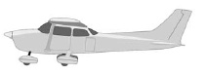
Complete the free body diagram in Figure 2 to show the other two forces acting on the aircraft.
Figure 2
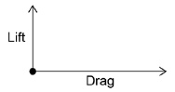
(2)
(b) A small aircraft accelerated down a runway at 4.0 m/s²
The aircraft started from rest and reached a speed of 34 m/s just before take-off.
Calculate the distance the aircraft travelled while accelerating.
Give your answer to 2 significant figures.
___________________________________________________________________
___________________________________________________________________
___________________________________________________________________
___________________________________________________________________
Distance = ____________________ m
(4)
(c) Figure 3 shows the small aircraft being used to tow a glider.
Figure 3
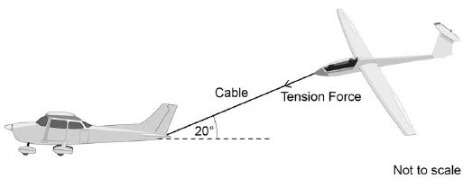
The tension force in the cable can be resolved into a horizontal component and a vertical component.
The tension in the cable is 2000 N
The cable makes an angle of 20° with the horizontal.
Draw a vector diagram to determine the magnitude of the two components of the tension force in the cable.
Magnitude of the horizontal component = ____________________ N
Magnitude of the vertical component = ____________________ N
(1)
(Total 10 marks)
Q4.
The graph shows how the distance travelled by a car changes with time during a short journey.
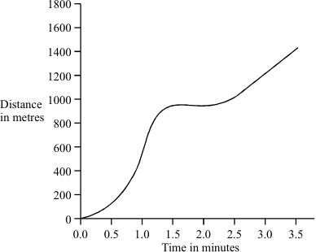
(i) Describe fully the motion of the car during the first two minutes of the journey.
___________________________________________________________________
___________________________________________________________________
___________________________________________________________________
___________________________________________________________________
___________________________________________________________________
(3)
(ii) During the last minute of the journey the velocity of the car changes although the speed remains constant. How is this possible?
___________________________________________________________________
___________________________________________________________________
(1)
(Total 4 marks)

Q5.
This question is about a car travelling through a town.
(a) The graph shows how far the car travelled and how long it took.
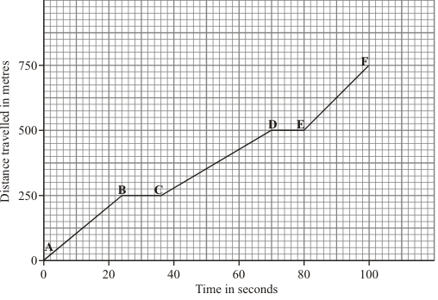
(i) Between which points was the car travelling fastest? Tick ( ) your answer.

Points | Tick ( )
A – B
B – C
C – D
D – E
E – F
(1)
(ii) Between which points was the car stationary?
______________________________________________________________
______________________________________________________________
(1)
(b) Complete the sentences by writing the correct words in the spaces.
When a car has to stop, the overall stopping distance is greater if:
• the car is poorly maintained;
• there are adverse weather conditions;
• the car is travelling ________________ ;
• the driver’s reactions are ________________ .
Also, the greater the speed of the car, then the greater the braking _____________
needed to stop in a certain time.
(3)
(Total 5 marks)
Q6.
A child goes out to visit a friend.
The graph shows the child’s journey.
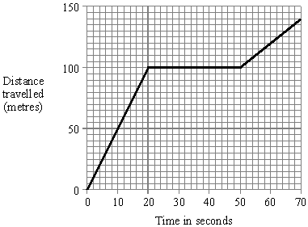
(a) Calculate the child’s average speed for the whole journey.
[Show your working and give the units in your answer.]
___________________________________________________________________
___________________________________________________________________
(3)
(b) How many times faster is the child travelling in the first part of the journey than in the final part of the journey?
[You should show how you obtained your answer.]
___________________________________________________________________
___________________________________________________________________
___________________________________________________________________
(2)
(Total 5 marks)
Q7.
A cyclist goes on a long ride. The graph shows how the distance travelled changes with time during the ride.
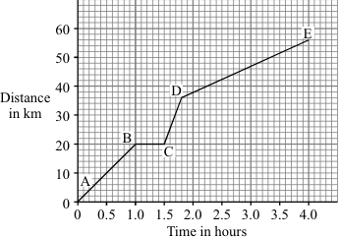
(i) Between which two points on the graph was the cyclist moving at the fastest speed?
___________________________________________________________________
(1)
(ii) State one way cyclists can reduce the air resistance acting on them.
___________________________________________________________________
___________________________________________________________________
(1)
(iii) How long did the cyclist stop and rest?
___________________________________________________________________
(1)
(iv) Write down the equation which links distance, speed and time.
___________________________________________________________________
(1)
(v) Calculate, in km/hr, the average speed of the cyclist while moving.
___________________________________________________________________
___________________________________________________________________
___________________________________________________________________
___________________________________________________________________
Average speed = _______________ km/hr
(3)
(Total 7 marks)
Q8.
The graph shows changes in the velocity of a racing car.
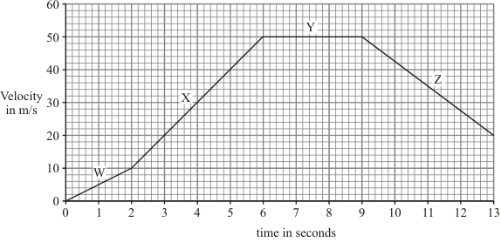
(a) Describe the motion of the racing car during:
(i) the period labelled W; ____________________________________________
______________________________________________________________
(1)
(ii) the period labelled Y. ____________________________________________
______________________________________________________________
(1)
(b) Calculate the acceleration of the racing car during the period labelled X.
Show clearly how you work out your answer and give the unit.
___________________________________________________________________
___________________________________________________________________
___________________________________________________________________
___________________________________________________________________
___________________________________________________________________
___________________________________________________________________
___________________________________________________________________
___________________________________________________________________
Acceleration = _______________________
(4)
(Total 6 marks)

Mark schemes
Q1.
(a) a vector has direction (a scalar does not)
1
(b) accept any vector quantities eg
• velocity
• force
• weight
• acceleration
• displacement
1
(c) mass × velocity
do not accept speed for velocity
do not accept symbols
1
(d) kilogram(s) metre per second
allow kg m/s
1
(e) 1.8 ms = 0.0018 s
an answer of 60 (m/s) scores 4 marks
1
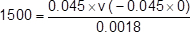
1
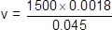
1
v = 60 (m/s)
an answer of 60 000 scores 3 marks
1
(g) longer the time of contact the greater the change of momentum
allow the converse
1
since the mass of the golf ball is constant
1
the velocity of the golf ball must increase
1
increasing the distance the golf ball travels
1
[12]
Q2.
(a) speed
must be in correct order
1
direction
1
(b)
Quantity | Scalar | Vector
Momentum
Acceleration
Distance
Force
Time
any three correct scores 2 marks
any two correct scores 1 mark
only one correct scores zero
3
(c) (i) 16 and 2
16 or 2 scores 2 marks
allow 1 mark for correct substitution, ie
8 × 2
or
4 × 0.5
3
kg m / s or N s
1
(ii) 1.5 (m / s)
or
their p_{A} + p_{B} = 12 × v correctly calculated
allow 2 marks for correct substitution, ie
18 = 12 × v
or
their p_{A} + p_{B} = 12 × v
18 or their p_{A} + p_{B} scores 1 mark if no other mark awarded
3
(iii) 14 (kg m / s)
or
their p_{A} - p_{B}
1
16.5 (J)
1
[14]
Q3.
(a) arrow vertically down – same size as lift – labelled weight
judge by eye
1
arrow to the left – same size as drag - labelled thrust
judge by eye
two correct arrows without labels gains 1 mark
1
(b) 34² – (0²) = 2 × 4.0 × s
1
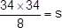
1
s = 144.5
1
s = 140 (2 sig figs)
an answer of 140 scores 4 marks
an answer of 144.5 scores 3 marks
1
(c) tension force drawn to a suitable scale and in correct direction
1
triangle completed showing correct components
1
scale used to determine both component forces
1
horizontal component = 1900 N
vertical component = 680 N
allow 1850 to 1925 inclusive
allow 660 to 700 inclusive
1
[10]
Q4.
(i) first statement must be accelerated
if it just accelerated then decelerates award 2 marks
1
final statement must be stationary
1
interim statement decelerates
1
(ii) direction is changing
1
[4]
Q5.
(a) (i) E-F (ticked)
1
(ii) B-C or D-E
accept both answers
1
(b) fast(er)
accept downhill
1
slow(er)
1
force
do not accept distance
1
[5]
Q6.
(a) evidence of
speed = 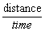 (travelled) or or
gains 1 mark
but or any correct calculation of gradient
(except when zero) gains 2 marks
or 2
gains 1 mark
units metres per second or m/s or ms⁻¹
(not mps)
for 1 mark
3
(b) evidence of calculating the two speeds
( and or 5 and 2) (evidence of this may be in (a))
or
noting distances travelled in same time (20 secs) i.e. 100m and 40m but 2.5
gains 2 marks
2
[5]
Q7.
(i) C and D or D and C
accept CD
accept DC
accept answers in terms of time
1
(ii) any one from:
streamline position streamline clothes
accept crouched position
accept tight clothes
accept design of cycle
accept cycle slower
1
(iii) 0.5 hours or 30 minutes or 1800 seconds
must have unit
1
(iv) speed = 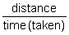

accept any correct rearrangement
accept s = d/t or v s/t
accept velocity for speed
accept 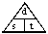
if subsequent use of 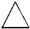 correct
1
(v) 16
allow for mark for each of time = 3.5 hours
distance = 56km
allow e.c.f. from part (a)(iii) if correctly used
an answer of 14 gains 2 marks
allow 1 mark for correct attempt to average the three sections
3
[7]
Q8.
(a) (i) acceleration / speeding up
do not accept acceleration increases
1
(ii) constant / steady velocity
accept constant / steady speed
1
(b) 10
3
m/s² or ms^{־2}
reject ms²
if answer not correct then allow 1 mark for
acceleration = 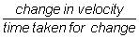

and allow 1 mark for 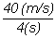
1
[6]

