Casey et al.’s (2011) study
Background to the study:
The Stanford marshmallow experiment was a series of studies on delayed gratification in the late 1960s and early 1970s led by psychologist Walter Mischel, then a professor at Stanford University. In these studies, a child was offered a choice between one small reward provided immediately or two small rewards (i.e., a larger later reward) if they waited for a short period, approximately 15 minutes, during which the tester left the room and then returned.

In follow-up studies, the researchers found that children who were able to wait longer for the preferred rewards tended to have better life outcomes, as measured by SAT scores, educational attainment, body mass index (BMI), and other life measures.

Casey’s study is a follow- up study to the Marshmallow test. The aim of which was to build on previous research and assess whether the cookie task performed in childhood could predict the capacity to self-control in adulthood.

Casey recognised that when we age, adults are more tempted by social relationships and acceptance rather than sweets. Casey wanted to use the tempting qualities of facial expressions in an impulse control task in order to examine brain activity (using fMRI) when people delay, or give in to temptation.

There were a number of different factors in Casey et al.’s (2011) study. The study was conducted over a number of years with the same participants. The participants naturally fell into either high-delaying or low-delaying groups after the original marshmallow test. This could not have been manipulated by the experimenter, meaning there could not be random allocation to groups and as there were two pre-existing groups. The study also used a correlation to consider the relationship of brain areas and behaviours during delay of gratification.
- IV: Whether participant was a ‘high delayer’ or ‘low delayer’ (based on the original marshmallow test and self-reports on control in their 20s and 30s)

- DV: Performance on the impulse control tasks (in terms of reaction time and accuracy) reaction times on this test and the fMRI activity readings.

Participants
- Initial stages:
562 4 year olds did the delay of gratification task (Marshmallow test) in the 60s and 70s
155 of them completed self-control scales in their 20s (1993) and 135 of them in their 30s (2003)

- In their 40s (2011):
Participants classified as either ‘low delayers’ or ‘high delayers’ based on their results on the delay of gratification tests and the self-control scales.
In Experiment 1, there were 59 participants (32 high delayers and 27 low delayers).
In Experiment 2, 26 of the 59 took part (15 high delayers and 11 low delayers.

Casey et al.’s procedure

Experiment 1
Tested whether participants who were less able to delay gratification as children and young adults (low delayers) would show less impulse control in suppression of a response to “hot” relative to “cool” cues.

59 participants completed two versions of the go/no go task.
Cool version consisted of male and female stimuli which were presented, one sex as a ‘go’ (press the button) target and one as a ‘no go’ (do not press the button) target.

Each face appeared for 500ms, followed by a 1s interval
160 trials in total (120 go and 40 no-go)

‘Hot’ version was identical to ‘cool’ version, except that fearful and happy expressions served as stimuli.

Tasks presented on programmed laptops sent to participants’ homes

Experiment 2
MRI was used to examine brain function. It was anticipated that low delayers would show diminished activity in the right pre-frontal cortex and amplified activity in the ventral striatum compared to high delayers.

Of the 59 who participated in experiment 1:
27 (13 males and 14 females) part took in experiment 2 which used an fMRI machine (15 high-delayers and 11 low-delayers). One man was excluded from the sample for abnormally low performance.

Participants completed a ‘hot’ version of the go/no go task
Each face stimulus was presented for 500ms, followed by a jittered inter-trial interval ranging from 2 to 14.5s

A total of 48s trials were presented and response and reaction time was recorded.

Casey et al.’s results

Experiment 1
- Reaction times (outside of scanner)
- There were no effects of delay group on reaction time measures to correct “go” trials

- Accuracy (outside of scanner)
- Participants performed with high level of accuracy for correctly responding to “go” trials 99% on both cool and hot tasks
- Low delayers had more difficulty in delaying their response (“no-go trial”) to the emotional “hot cues”. They had more difficulty supressing their responses to happy faces.

Experiment 2
- Reaction times (inside the scanner)
- No significant difference in correct “go” trials

- Accuracy (inside the scanner)
- Participants performed with high level of accuracy for correctly responding to “go” trials 99% on both cool and hot tasks
- Low delayers committing more false alarms than high delayers in the “hot” version of “no-go” trials

- Imaging results
- Right inferior gyrus was involved in accurately withholding response
- Low delayers had diminished activity in the right inferior gyrus for “no go” trials.
- Ventral striatum showed significant difference in recruitment between low and high delayers (exaggerated in low delayers on no-go trials)

- What is delayed gratification?

- What is the function of the inferior frontal gyrus?

- What is the function of the ventral striatum?

- What is the function of the pre-frontal cortex?

- What is a go/no go task? How does it measure delay of gratification?

- Describe the background to the study

- Identify the aim of the Experiment

- Why did Casey et al. use facial expressions in an impulse control task, rather than sweets?

- What research method is being used? Justify your answer.

- What experimental design is being used? Justify your answer.

- Is it a quasi-experiment? Justify your answer.

- Identify the IV and DV

- Describe the participants

- What was the difference between the ‘hot’ and ‘cool’ versions of the tasks in experiment 1?

- Why was it anticipated that low delayers would show diminished activity in the right pre-frontal cortex and amplified activity in the ventral striatum compared to high delayers?

1. Background – Brain areas – Complete the table
The Ventral Striatum The Inferior Frontal Gyrus
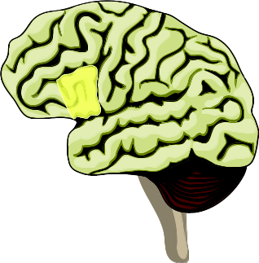
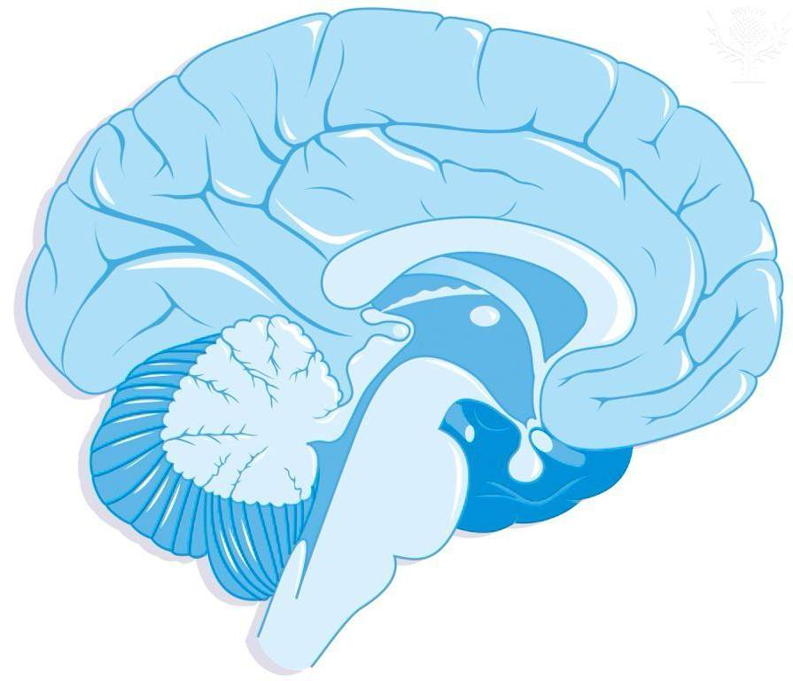

Ventral Striatum

Note: (side view, eyes would be on the right in this image) Note: (side view, eyes would be on the left in this image)

The Ventral Striatum | Brain Area | The Inferior Frontal Gyrus
 | What function has the area been associated with? (include “desires”, “emotions”, “cognitive control” into appropriate areas).
 | Which behaviours could be associated with this area of the brain if it was ‘over-active’ in an individual.
 | What would this area ‘demand’ when faced with the option of one cookie now or ten cookies later if you don’t touch the cookie.
 | What would this area ‘demand’ when faced with someone smiling warmly at you but you were told try not to smile back.

- Identify 2 findings from the study (4 marks)

- Identify 2 conclusions from the study (4 marks)

- Identify two strengths and two weaknesses of this study (8 marks)

- What are the main assumptions of the biological approach?

- Identify the 3 main biological explanations
-
-
-

- How would we study biology?
-
-
-

- Identify the strengths of this approach to psychology

- Identify the weaknesses of this approach to psychology

- Identify 1 similarities and 1 difference between the biological area and each of the other areas and perspectives we have studied.

- Social area

- Cognitive area

- Developmental area

- Individual differences area

- Behaviourist perspective

- Psychodynamic perspective

