Year 7 – Art and Design | Landscapes
Enquiry Question: How are the formal elements used in Art?
Unit title: Landscapes
Why now? Students will explore the formal elements in art, such as tone, texture, line, shape, pattern, form and space. They will do this by investigating various art styles throughout history and mainly focusing on one of the most influential living British artists, David Hockney. His art practice has taken on many forms over the years and his latest landscape work is made using digital technology.

ipad drawings
Knowledge  Students will know about… | Application/Skills  Students will be able to… | Vocabulary  (Tier 2 and 3) | Home Learning | Assessment | Extra Resources  Extended Reading | Cultural Capital
What the Formal elements  are and how to use them in different ways.  A variety of ways to compose a landscape.  British artist David Hockney’s and his extensive art career.  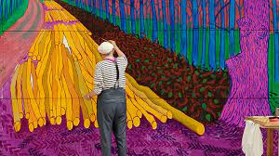  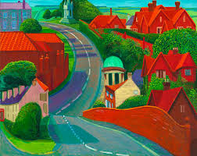 | Produce drawings from memory  Produce observational drawings and have a clear understanding of how to use tone.  Paint a colour wheel with an understanding of primary, secondary and tertiary colours.  Create a range of mark making techniques with tertiary colours using paint, pen and pencil.  Create a landscape using various techniques; frottage, painting and collage.  Produce a landscape using the rules of perspective/ one point perspective  Analyse other artists using a range of art vocabulary. | Mark making  Symbolism  Observation  Perspective  Interpretation  Foreground  Middle ground  Background  Frottage  Vanishing point  Horizon line  Mixed media  Formal elements  Tone, Texture, Line, Shape, Pattern, Form and  Space.  Numeracy  Proportion  Scale | - Landscape research  - Artist research/ factsheet | Class discussions about the topic.  Group critiques to assess each other’s work.  Peer assessment.  Written analysis of relevant artists.  Assessment of their final piece in reference to the success criteria. | How to draw a hand  https://www.youtube.com/watch?v=SN_XYBfawiU  How to paint a colour wheel  https://www.youtube.com/watch?v=_BHHf1-dmco  David Hockney website  https://www.hockney.com/home  Royal Academy of Arts  David Hockney: The Arrival of Spring, Normandy on until September 26 2021020  https://www.royalacademy.org.uk/exhibition/david-hockney | Take a visit to the following galleries:  National Gallery  Royal Academy of Arts  Tate Modern  Tate Britain  You will find lots of artists that you recognise.

