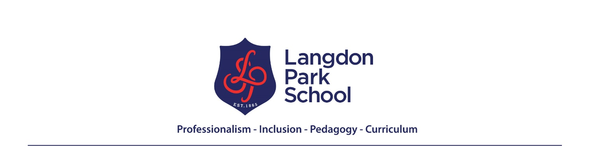

In Languages, we promote a love of languages, tolerance of different cultures and modern global citizens.
Year 11 FRENCH Learning Journey
Autumn
Term 1 – Au collège – at school  Pourquoi est-ce que l’éducation est importante? Why is Education important? | Term 2 – Travail et ambitions – work and ambitions  Qu’est-ce que c’est pour toi être professionnel au travail ? What does it mean to be professional at work?
- School subjects and Timetable.  - Opinions about subjects and facilities.  - Differences between French and English schools.  - Rules and regulations.  - Healthy and unhealthy habits.  - School clubs and activities.  - Past habits at school.  - Past academic successes | - Future projects, hopes and wishes.  - Pros and cons of different careers.  - Types of jobs and workplaces  - Personal skills  - Future career plans  - Pocket money and house chores  - Past work experience
Spring
Term 3 - An eye on the world – Un œil sur le monde  Si vous étiez président de la France que feriez-vous pour améliorer l’environnement? If you were the French president what would you do to improve the environment? | Term 4 – Révisions - Revisions  How can I achieve a grade 9 in the Higher Exam?  How can I achieve a grade 5 in the Foundation exam?
- Global issues.  - Weather forecast.  - Natural disasters.  - Ways to protect the environment.  - My plans to help the environment.  - French charities.  - Social issues and volunteer work.  - Helping others in the future. | - Revision of Family and Relationships.  - Technology and social media.  - Free time activities and entertainment.  - My region, city and area.  - Holidays.  - Food and healthy living.  - School.  - Jobs.  - Global issues.
Summer
GCSE EXAM | GCSE EXAM
- Using Grade 9 and Grade 5 language strategies in Speaking and Writing  - Using a variety of tenses in Speaking and Writing | - Speaking  - Reading  - Listening  - Writing

