
UNIT OVERVIEW: Ça c’est moi ! – This is me !
ENQUIRY: Pourquoi on ne parle pas la même langue? Why don't we all speak the same language?

YEAR 7 TERM I & 2

Unit intention: To learn or revise basic vocabulary in French to be able to communicate information about yourself and understand some basic grammatical concepts such as gender of nouns, articles and key verbs.
Success criteria |  |  | 
- I can greet people and introduce myself using French phonics.
- I can use the French alphabet to spell names.
- I can say where I live
- I can count to 31.
- I can say how old I am using the correct verb.
- I can name days of the week and months to write the date.
- I can say when my birthday is
- I can describe what is / isn’t in my schoolbag using singular and plural forms and the correct gender of nouns.
Unit summative and formative assessment details:
Retrieval activities every lesson to review key vocabulary.
Speaking practice in lessons.
Term 1: Reading and Listening assessments + vocabulary test.
Term 2: Extended Writing and Translation assessment.
Home Learning (What and how often):
Vocabulary knowledge organiser, independent research about culture, grammar and vocabulary exercises.
Topic Sequence  - Greeting and introducing yourself.  - Alphabet and spelling names.  - Say where I live.  - Numbers up to 31.  - Telling your age.  - Days of the week, months, seasons and dates.  - Birthday.  - School equipment.   |   Independent learning   Facts about France  https://www.kids-world-travel-guide.com/france-facts.html   Understanding basic French  https://www.bbc.co.uk/bitesize/subjects/zgdqxnb  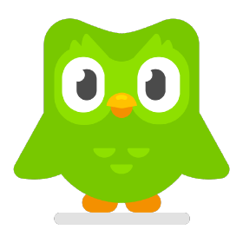   App to learn French – Duolingo  https://www.duolingo.com   Place to visit - Dockland Museum https://www.museumoflondon.org.uk/museum-london-docklands

Success criteria Have you met them? Show your evidence in the boxes below.
1.

2.

3.

4.
5.
6.
7.
8.
How will you improve your work?

End of Unit EVALUATION

