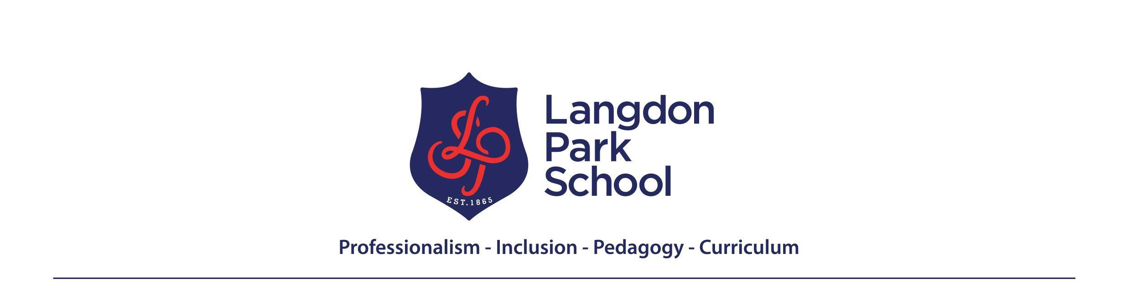

In the mathematics faculty we aim to inspire the mathematician in every student, developing fluency and confidence in using mathematics to reason and solve problems. We also aim to develop an appreciation of the beauty and humanity of mathematics and of its historical development and wider social relevance. We seek to do this without placing limits on the attainment of any student and while developing universal human values including anti-racism and challenging sexism, homophobia and other forms of discrimination.
Year 10 Learning Journey
Autumn
Term1 – Introduction to proof, asking “How do we know in maths?” Circles Why did the ancient Greeks believe the circle was the perfect shape? | Term 2 – Interpreting and Reasoning with Data – Should you always believe a graph or a chart?
PROOF  - Proof with logic  - Number and proof  - Expressions and proof  - Equations and proof  - Geometry and proof  CIRCLES  - Parts of a circle  - Drawing circles accurately  - All about PI  - Finding the circumference- and finding radius or diameter given circumference | - Finding the area- and finding radius or diameter given area  - Working with compound shapes involving circles and parts of circles  - Problems involving circles  INTERPRETING AND REASONING WITH DATA  - Drawing conclusions from graphs and charts  - Understanding problems and limitations of different graphs and charts  - Critiquing and comparing graphs and charts  - Getting the big picture- correlation, causation and trends  - Data in context- exploring (in)equalities and climate crisis
Spring
Term 3 Graphs and Functions Can a function model a pandemic? | Term 4 - Pythagoras - How can you tell if there’s a right angle just by measuring lengths?
GRAPHS AND FUNCTIONS  - Cartesian coordinates  - All about functions  - All about graphs  - Equation of a straight line graph  - Non linear functions and graphs  FROM 2D TO 3D  - Recap properties of 2D shapes  - Area and perimeter of 2D shapes | - Properties of 3D shapes – including nets, edges, faces and vertices  - Surface area of 3D  - Volume of 3D shapes  - Problems with 3D shapes in context  RATIO AND PROPORTION WITH ALGEBRA  - Representing ratio with algebra and graphically  - Direct proportion  - Inverse proportion  Proportion in context- from science to art
Summer
Term 5 – Constructions and geometry How are Islamic tiling patterns made? | Term 6 – Introduction to Probability What’s the probability of winning the lottery? Trigonometry How can you measure the height of a mountain?
CONSTUCTION AND GEOMETRY  - Circles, triangles, and congruence  - Rhombi and Kites  - Perpendicular bisectors  - Angle bisectors  - More constructions  - Loci  PROBABILITY  1. Calculating simple probabilities | 2. Combining probabilities  3. Tree diagrams  4. Conditional probability  TRIGONOMETRY  1. Labelling triangles  2. The basic ratios  3. Finding missing sides  4. Finding missing angles  5. Trigonometry in context
Recommended reading/videos:  - Perfect Number Proof – Numberphile  - https://www.samiramian.uk/ for Islamic tiling patterns that use compass and straight edge | Places to visit:  London Central Mosque for examples of constructions in action

