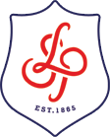
Year 7
Table Tennis - Scheme of Work

Aim: Pupils will focus on replicating and developing techniques as well as implementing and refining strategic play to outwit opponents. Pupils will be able to demonstrate the essential elements of attack and defence. In net games, it is the player aim to get the ball to land in the target area so that the opponent cannot return it. Pupil should be able to accurately score and officiate table tennis games.

Motor Competence  Use table tennis skills to develop observation skills on peer performances, skills and techniques as well as observing the use of tactics. Ask questions about the effectiveness of these tactics. Physical warm ups aid as a useful fitness tool in developing a pupils physical capacity. Understanding the law of physics and how topspin and slice will effective the ball flight and after effect. | Rules, Strategies & Tactics  Pupils should be able to recognise the importance of responding to changing situations within the game in attack and defence. Pupils will be faced with strategic and tactical decisions based on the movement of the ball around the table using a variety of spin & skill execution. Opportunities to score/coach pupils or small groups will develop communication and decision making skills. | Healthy Participation  Suggest any table tennis clubs within the school timetable and promote community links. Highlight table tennis fitness needs and the necessary components of fitness needed. i.e. coordination, speed, balance and agility. To understand why regular exercise has a positive effect on their health, fitness and social wellbeing.

Cross-Curricular Links  Literacy (key words), Maths (scoring), Citizenship (sportsmanship), Science (bodily functions and healthy lifestyle consequences) | Recommended Reading  Spin – Tom Lodziak

Year 7
Table Tennis Scheme of Work
Please note that half terms range from 5-8 weeks - activities change each half term and therefore teachers must deliver number of lessons relevant to half term length. Please deliver the assessment lesson in the final lesson of term.

Lesson | Core Skill | Lesson intention | Teaching Points | Suggested Drills | Questions to be asked
1 | Backhand Push | To know the teaching points of the backhand push and to demonstrate this is practice and competitive situations | - Body is square to the table and knees are bent – Ready position  - Bat facing slightly towards the sky  - Keep wrist still  - Extend the arm at the elbow | 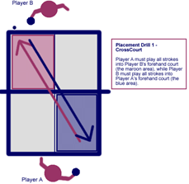 | Retrieval:  Students are using their knowledge of the skill to assess the effectiveness of a peer performance. They should be encouraged to use WWW. EBI  Application of knowledge to peer assess.
2 | Serving  (rules) | To know the teaching points of the serving and to demonstrate this is practice and competitive situations | Stand behind white line along hand/bat  - Open palm with ball displayed to opponent  - Toss ball up  - Eyes on the ball  5- Extend arm contacting the ball bouncing it on your side of the table then your opponent’s side. | 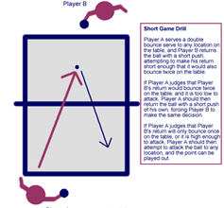 | Retrieval:  Students are using their knowledge of the skill to assess the effectiveness of a peer performance. They should be encouraged to use WWW. EBI  Application of knowledge to peer assess
3 | Forehand Push | To know the teaching points of the forehand push and to demonstrate this is practice and competitive situations | - Have your body in the ready position  - Bat facing slightly towards the sky  - Keep wrist still  4- Extend the arm at the elbow | - Target Game – Students have to perform isolated shots towards 3/5 targets (pieces of paper) if successful at hitting them they collect a point.  - Continuous Rally – Students will perform a continuous rally with their partner and count how many shots they can do consecutively. | Retrieval:  Students are using their knowledge of the skill to assess the effectiveness of a peer performance. They should be encouraged to use WWW. EBI  Application of knowledge to peer assess
4 | Forehand Drive | To know the teaching points of the forehand drive and to demonstrate this is practice and competitive situations | - Body shape is side on  - Bat starts next to the body at hip height  - Keep a flat bat (facing down)  4- Push bat away from the body | 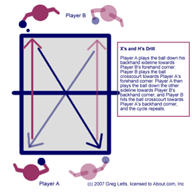 | Retrieval:  Students are using their knowledge of the skill to assess the effectiveness of a peer performance. They should be encouraged to use WWW. EBI  Application of knowledge to peer assess
5 | Backhand Drive | To know the teaching points of the backhand drive and to demonstrate this is practice and competitive situations | - Stand square to the table  - Start with the bat at your stomach  - Bat facing down  - Brush the ball with your bat  - Extend arm at elbow | https://www.youtube.com/watch?v=EnrbMBqabGE | Retrieval:  Students are using their knowledge of the skill to assess the effectiveness of a peer performance. They should be encouraged to use WWW. EBI  Application of knowledge to peer assess
6 | Smash Shot | To know the teaching points of the smash shot and to demonstrate this is practice and competitive situations | - Side on body position  - Bat facing down  - Bat up and to the side of your body  - Strike down on the table tennis ball | - Throw and Smash: Students will work in pairs. One will throw the ball up for their partner to smash across the net.  Progressions:  - Add a target to keep score  - Add an opponent to return the shot | Retrieval:  Students are using their knowledge of the skill to assess the effectiveness of a peer performance. They should be encouraged to use WWW. EBI  Application of knowledge to peer assess
7 | Lob Shot | To know the teaching points of the lob shot and to demonstrate this is practice and competitive situations | - Stand away from the table  - Bat open faced  - Bat starts by the side of your body  - Open bat face  - Looped shot over to opponents’ side of the table. | - Double Table Drill: Students will join two table together length ways. They will play a match or rally over using the two ends of the extended table. | Retrieval:  Students are using their knowledge of the skill to assess the effectiveness of a peer performance. They should be encouraged to use WWW. EBI  Application of knowledge to peer assess
8 | Core Task | Assessment | Core Task | Students to be assessed against Assessment Matrix for final grade.

