UNIT OVERVIEW: GCE Magnetic Fields and Electromagnetic Induction
ENQUIRY: How does a generator work?

Unit intention: Understand concepts of Magnetic Fields and Electromagnetic Induction
Success criteria: Describe magnetic fields; charges moving in magnetic fields; cyclotrons and mass spectrometers; Electromagnetic Induction; State Faraday’s law and Lenz’s law; ac generators and transformers |  |  | X
- To describe magnetic fields and the electric motor
- Explain how charges move in a magnetic field
- Describe velocity selectors, the use of cyclotrons and mass spectrometers
- Required practical 10: Determine the magnetic flux density for ceramic magnets
- An introduction to Electromagnetic Induction
- Describe Faradays’ law and Lenz’s law
- Explain how ac generators work
- Practical: Investigate alternating current using an oscilloscope and frequency generator
- Recall how a transformer works and methods to increase its efficiency
- Required Practical 11: Investigate emf versus angle in a coil
Unit summative and formative assessment details:
Minitests
Assessment on Seneca
Tailored Exampro Questions
Exam paper questions
Home Learning (What and how often):
http://www.schoolphysics.co.uk
https://phet.colorado.edu/en/simulations/category/physics
CGP Revision Guide
AQA Physics Textbook
Watch GCE Physics videos on Youtube and make notes before lesson – Flip learning task.
Complete worksheets on Magnetic Fields and Electromagnetic Induction
Topic Sequence  - Magnetic Fields  - Charges in a magnetic field  - Velocity selectors  - Required practical 10: Magnetic Field Density  - Electromagnetic Induction  - Faraday’s law and Lenz’s law  - AC Generator  - Practical: Investigating ac  - Transformers  - Required practical 11: Investigate flux linkage | Recommended reading:  Magnetic Fields: Uncover The Mysteries Of Magnetism  by Son Umphenour  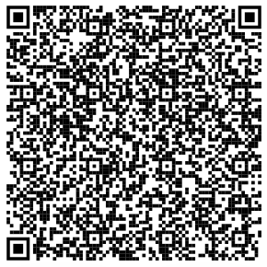

PRE-ASSESSMENT EVALUATION
Success criteria – Have you met them? Show your evidence in preparation for your assessment.
1.

2.

3.

4.

5.

6.

How will you improve your work?

