UNIT OVERVIEW: GCE Circular Motion
ENQUIRY: How does the ‘wall of death’ work?

Unit intention: Understand about the nature of Circular Motion
Success criteria: use of angular velocity, centripetal acceleration and force. Identify forces in circular motion |  |  | X
- What is Circular Motion. An introduction.
- What is Centripetal Force. The nature of the force in different situations.
- Examples of Circular Motion and Force diagram.

Unit summative and formative assessment details:

Minitests
Assessment on Seneca
Tailored Exampro Questions
Exam paper questions
Home Learning (What and how often):
http://www.schoolphysics.co.uk
https://phet.colorado.edu/en/simulations/category/physics
CGP Revision Guide
AQA Physics Textbook
Watch GCE Physics videos on Youtube and make notes before lesson – Flip learning task.
Complete worksheets on Circular Motion
Topic Sequence  - Circular Motion  - Centripetal Force  - Examples of Circular Motion | Recommended reading:  Circular Motion Solved Problems: 50+ solved problems. By Dhanuka Dulaniana  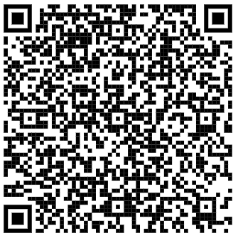

Success criteria – Have you met them? Show your evidence in preparation for your assessment.
1.

2.

3.

4.

5.

6.

How will you improve your work?

PRE-ASSESSMENT EVALUATION

