Drama

Home Learning Book

Component 1B: Understanding Drama: Blood Brothers

AQA GCSE Drama

Name: ______________________________________________

Target: _____________________________________________
Tutor: _________________________________________________
Teacher: Miss Robinson

Why is regular home learning important?
- It can improve a student’s thinking and memory skills. This is vital for the new content heavy GCSEs.

- It helps students to develop positive study skills and habits that will serve them well throughout life.

- Home learning encourages students to use time wisely and efficiently.

- It teaches students to work independently.

- Home learning teaches students to take responsibility for their own work.

- It allows students to review and practice what has been covered in class and consolidate their knowledge and skills.

- Equally important, it helps students to get ready for the next day’s class.

- It helps students learn to use resources, such as libraries, reference materials, and computer Web sites to find information.

- It encourages students to explore subjects more fully than classroom time permits.

- It allows students to extend their learning by applying skills to new situations.

- Home learning helps parents learn more about what their children learning in school.

- It allows parents to communicate with teachers about learning in order to support their children efficiently.

TASK | PAGE/S | DATE
Week 1 - C1B: Blood Brothers plot, Willy Russell in context and Liverpool at the time | 4
Week 2 - C1B: Themes, issues and character overviews | 5
Week 3 - C1B: Set design | 6
Week 4 - C1B: Costume, hair and make-up design | 7-9
Week 5 - C1B: Interpretation of a character | 10
Week 6 - C1B: Character revision sheet | 11
Week 7 - C1B: Space, interactions and proxemics | 12, 19-24
Week 8 - C1B: Lighting, music and sound design | 13-18
Week 9 - C1B: Practise questions for set play | 25

Provide research that explores the plot of Blood Brothers, information about Willy Russell, the context of Liverpool at the time and how this might be portrayed in production.

Plot

Willy Russell

Context: social, historical and cultural

How the above

might be portrayed in production

Create a mind-map that explores character over views, the themes and issues in Blood Brothers. Link the themes to specific characters, scenes and quotes.

Create a set design for Blood Brothers, this could be visually demonstrated on the page or a model design using a shoebox. Think about the performance space, key themes, demands of the text and the context. Justify your choices.

Create three costume, hair and make-up designs for characters from Blood Brothers. Two must be for the same character but illustrate the passing of time, perhaps between Act 1 and Act 2.

Create a character study for 5 characters from Blood Brothers using the prompts below.

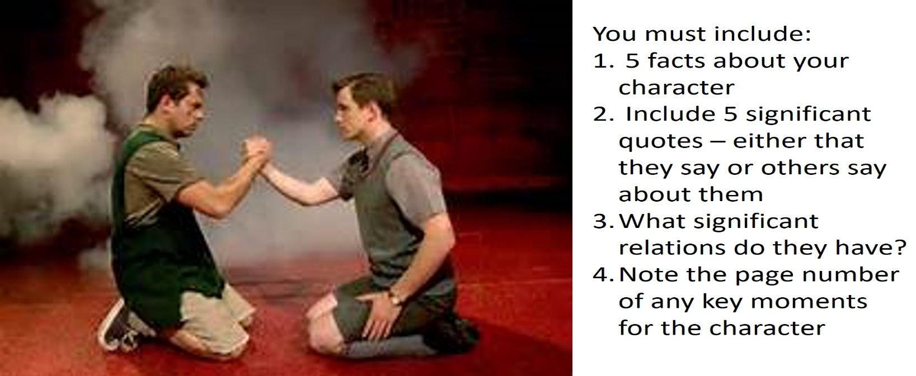
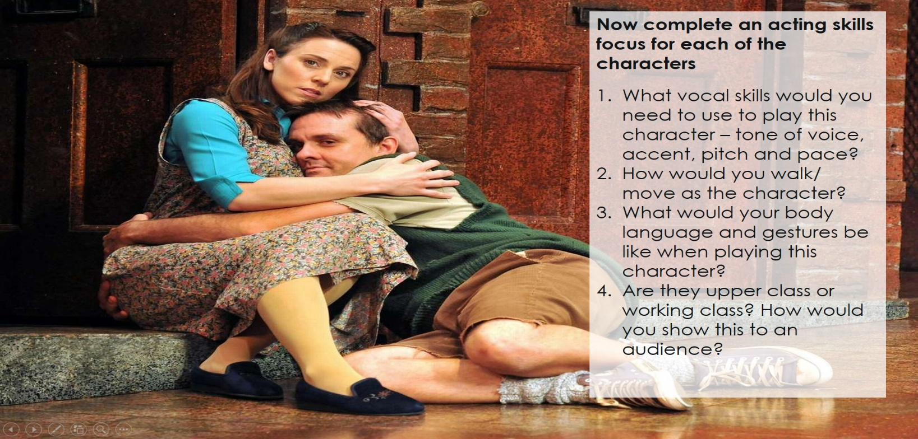
Complete the sheet below to reflect on the character of Mrs Lyons. Then create another character revision sheet for a character of your choice using the prompts below.

Create 5 story boards for specific moments in Blood Brothers where space, interactions and proxemics are key to adding meaning. This can be done artistically or a functional birds-eye view. Justify your choices.

Scene: ______________________________p___

Justifications: ____________________________

________________________________________

________________________________________

________________________________________
Scene: ______________________________p___

Justifications: ____________________________

________________________________________

________________________________________

________________________________________
Scene: ______________________________p___

Justifications: ____________________________

________________________________________

________________________________________

________________________________________
Scene: ______________________________p___

Justifications: ____________________________

________________________________________

________________________________________

________________________________________
Scene: ______________________________p___

Justifications: ____________________________

________________________________________

________________________________________

________________________________________
Complete the sheets below to explore the entire production of 3 key scenes of your choice.

Plan your essay question by filling in the sheets below.
You are performing the role of Eddie. Describe how you would use your acting skills to interpret Eddie’s character in this extract and explain why your ideas are appropriate both for this extract and the play as a whole. (20 marks) 25 mins

What we need to do | Do it…
- Statement about the character overall.

- Link to the context of the play and how the character fits in with this.

- Introduce the extract, explaining where about in the play it is and what the character is like at this point.

- Identify one of your aims for the character. 1

- Explain how you would communicate your aim to the audience, focussing on a specific moment in the scene.

- Use a quote.

- Use a range of appropriate theatrical terminology.

- Link your point to the play as a whole. You could mention how you would play the character at this point in the play compared to how you have played them up until this scene/ after this scene.

- Identify your next aim. 2

- Explain how you would communicate your aim to the audience, focussing on a specific moment in the scene.

- Use a quote.

- Link your point to the play as a whole. You could mention how you would play the character at this point in the play compared to how you have played them up until this scene/ after this scene.

- You could give a detailed example of what you would do at another point in the play and link back to the extract. 3

- You can either explore another moment from the extract, or from the play as a whole. 4

Cover 4 moments from the play (these can include moments from this extract and relevant moments from the play as a whole).

What I need to do…. | Do it…..
- Explain where the extract takes place e.g. on the street, in a large house etc. Link location to context (Liverpool/time period).

- Explain the impact that the location would have on the scene. E.g. do the actors have lots of room or minimal room? Is this a new place or somewhere they are familiar with?

- Link back to the question.

- Explain what the characters’ relationship has been like up until this point. It may be the first time the characters have met, or we may have seen them together several times before.

What is their relationship like in this extract?

- Identify your aims.
- Pick a quote and give a detailed direction either for the other actor or explaining what you would do to create the effect that the question asks for (comedy).

- Use theatrical terminology
Eye contact, levels, tone of voice,
physical contact etc.

- If in the previous example, you explained what the other actor would do, In this example you need to explain what you would do.

- Use a quote.

- Explain what will be communicated to the audience, this should link to the language from the question e.g. if the question asks about how you would create comedy, you should explain how comedy is created for the audience.
- Pick a quote and give a direction either for the other actor or explaining what you would do.

- Use theatrical terminology
Eye contact, levels, tone of voice, physical contact etc.

- If in the previous example, you explained what the other actor would do, In this example you need to explain what you would do.

- Use a quote.

- Explain what will be communicated to the audience, this should link to the language from the question e.g. if the question asks about how you would create comedy, you should explain how comedy is created for the audience.

Checklist
I have:
- Included at least 4 quotes
- Referred to at least 2 different moments in the scene
- Considered the impact on the audience
- Given examples of how stage space is used (as this is what the question asks)
- Given examples of how the two characters would interact.
- Used the language from the question
- Shown my understanding of the relationship between the two characters

Complete the practise questions for Blood Brothers. Answer the first three questions and then choose between question 4 or 5.

