LPS DRAMA
Component 1: Section A
Retrieval Booklet

- Theatre Roles/Responsibilities
- Stage Configurations dis/advantages
- Stage Positions

Name:__________________________________________

Task 1: Stage Positions
Label the stage positons in their correct boxes.

Centre stage Stage Left Stage Right Upstage Centre
Downstage Centre Upstage Right Upstage Left Downstage Right
Downstage Left
/9
Area for improvement:
Task 2: Placement Task
1. Place an A Upstage centre
2. Place a B Downstage Right
3. Pace a C Upstage Left
4. Place a D Downstage Centre /4
Area for improvement:
Task 3: Identify the Misconceptions

Circle the incorrect stage positons and write the correct positions underneath.

Downstage Left | Downstage Centre | Upstage Left
Stage Right | Centre Stage | Stage Left
Upstage Right | Upstage Centre | Downstage Right

/5
Area for improvement:

Task 4: Draw the following pathways on the stage using a dotted line.

1. Downstage centre - upstage centre - upstage left
2. Upstage right – centre stage – downstage right
3. Upstage centre – downstage left – downstage right
4. Downstage left – upstage right – upstage left – downstage right /4
Area for improvement:

Task 5: Stage positions
Place an X centre stage Place an X stage right Place an X upstage left

Place an X downstage left Place an X upstage right Place an X downstage centre

Draw an arrowed line to show the following movements of an actor walking across the stage

Centre stage to downstage centre Stage left to downstage right Downstage left to upstage right

Upstage centre to downstage left Upstage right to downstage left Stage left to stage right

Write the stage directions of the following arrows from…………….to……………….to…………….

/15
Area for improvement:
Task 6: Identify the stage positions
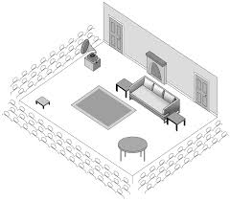
1: The Rug
a) Downstage centre
b) Centre stage
c) Upstage centre

2: Circular table
a) Downstage right
b) Downstage left
c) Upstage left

3: Small Stall
a) Downstage left
b) Downstage right
c) Upstage right

4: Sofa
a) Centre stage
b) Upstage left
c) Upstage right

5: Gramophone
a) Centre stage
b) Upstage left
c) Upstage right

6: Fireplace
a) Downstage centre
b) Centre stage
c) Upstage centre
/6

Area for improvement:
Task 7: Identify the stage positons of the numbered items
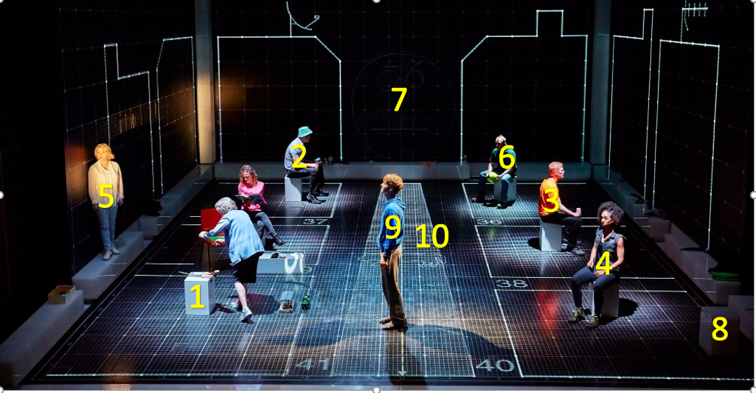

1.
2.
3.
4.
5.
6.
7.
8.
9.
10.

/10
Area for improvement:
Task 8: Stage Configurations
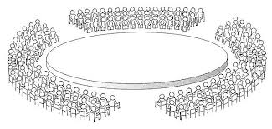
1. The name for this stage type is
a) Theatre in the round
b) Thrust staging
c) Promenade

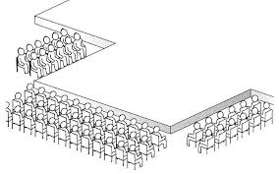

2. The name for this stage type is
a) Theatre in the round
b) Thrust staging
c) Promenade
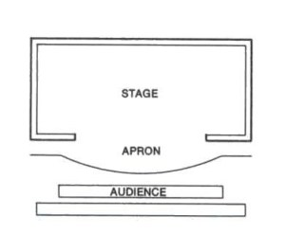

3. The name for this stage type is
a) Theatre in the round
b) Thrust staging
c) Promenade

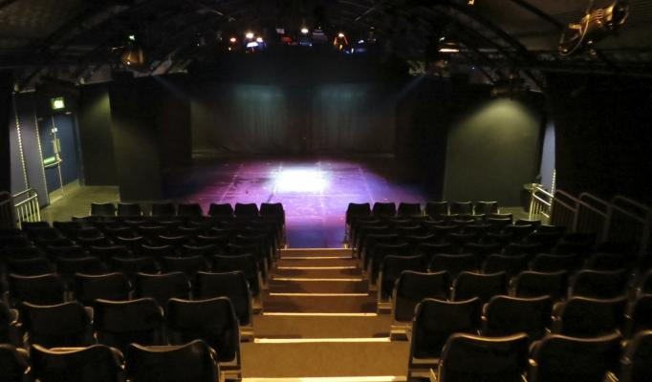
4. The name for this stage type is
a) Theatre in the round
b) End on
c) Promenade

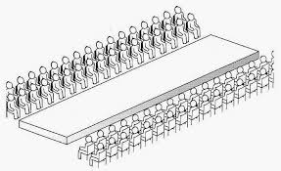

5. The name for this stage type is
a) Traverse
b) End on
c) Promenade

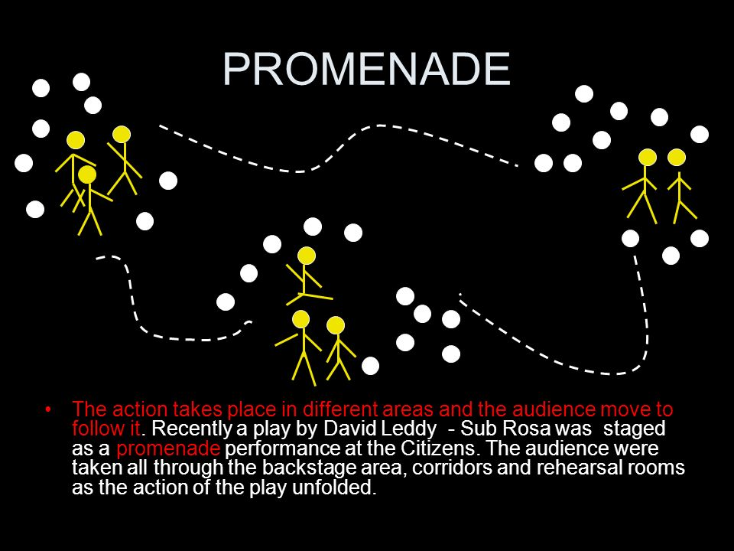
5. The name for this stage type is
a) Traverse
b) End on
c) Promenade

/5
Area for improvement:

Task 9: Characteristics of Stage Configurations

1. The audience sit on three sides of the stage creating closeness to actors and intimacy.
a) Thrust
b) In the round
c) Traverse

2. The audience sit facing the stage all from the same direction being able to see all action at all times.
a) Thrust
b) End on
c) Traverse

3. The frame shapes the action and creates a 4th wall between the actors and audience.
a) Proscenium Arch
b) In the round
c) Traverse

4. Actors have to enter and exit through the audience.
a) Thrust
b) In the round
c) Traverse

5. The best stage for large ensemble productions.
a) Thrust
b) In the round
c) Proscenium arch /5
Area for improvement:
Task 10: Characteristics of Stage Configurations

1. The most interactive and intimate stage providing each audience member with a different experience?
a) Thrust
b) In the round
c) Promenade

2. The audience sit facing each other on two sides and get to see each other’s reactions.
a) Thrust
b) In the round
c) Traverse

3. The audience may become tired/miss part of the action from moving around.
a) Thrust
b) Promenade
c) Traverse

4. Theatres or large spaces and be completely transformed into the word of the play.
a) Thrust
b) Promenade
c) Traverse

5. You may have an actor’s back to you for some periods of time
a) In the Round
b) Promenade
c) Traverse

6. No backdrop and minimal set/props can be used due to obstructing sight lines.
a) Thrust
b) Promenade
c) End on

7. Lacks intimacy as some audience members will be sat high up and far back.
a) Thrust
b) Proscenium Arch
c) In the Round

8. The acting space is long and central with the audience seated either side facing each other.
a) Thrust
b) Promenade
c) Traverse

9. There is large wing space for the actors and to store scenery.
a) Proscenium Arch
b) Promenade
c) Traverse /9
Area for improvement:
Task 11: Characteristics of Stage Configurations

1. There is no audience on one side of the stage so backdrops and large scenery can be used.
a) Thrust
b) In the Round
c) Traverse

2. The acting area is long and thin which could cause challenges for blocking.
a) End on
b) Promenade
c) Traverse

3. Lacks the frame, wing space that proscenium arch theatres have.
a) End on
b) Promenade
c) Traverse

4. The audience all have a similar view of the performance.
a) End on
b) Promenade
c) In the Round

5. Can be created outside of theatres in site specific locations.
a) End on
b) Promenade
c) In the Round

6. Which one of these stages does the audience not feel close to the action?
a) In the Round
b) Promenade
c) Proscenium Arch

7. What is the stage type that is most common for large theatres and opera houses is?
a) Traverse
b) Promenade
c) Proscenium Arch

8. The area in front of a proscenium arch stage is called…
a) Apron
b) Wings
c) Backstage

9. There are large health and safety concerns with this form of staging
a) In the Round
b) Promenade
c) Thrust /9
Area for improvement:

Task 12: Stage configurations Advantages

Circle the advantage for the stage type

1. In the round
a) Large backdrops and scenery can be used
b) An intimate 360 view of the actors
c) Large casts can be used

2. Traverse
a) Intimate performance space
b) Large scenery can be used
c) The audience can move around

3. Promenade
a) Large spaces can be transformed into the world of the play
b) All audience have the same view
c) No backs will be to the audience

4. Thrust
a) No backs to the audience
b) Intimate performance space for the audience
c) 360 view of the action

5. End on
a) All the audience are close to the action
b) Actors enter and exit through the audience
c) All the audience have the same front on view

6. Proscenium Arch
a) Intimate performance space for an audience
b) Large scale scenery and set can be used along with large casts
c) 360 view of the action

/6

Area for improvement:
Task 13: Disadvantages of Stage Configurations

Circle the disadvantage of the stage type

1. In The Round
a) Stage furniture has to be chosen carefully to not block sightlines
b) The audience may get tired
c) Health and safety is a considerable challenge

2. Proscenium Arch
a) There is no fourth wall
b) Some audience member may feel too distant from the action and interaction is difficult.
c) Big set designs cannot be used due to obstructing sightlines.

3. Thrust
a) Set cannot be used
b) Sightlines for those on the extreme sides by be limited or obstructed
c) Audience interaction is difficult

4. Traverse
a) The acting area is long and thin which makes blocking difficult
b) Lacks intimacy for an audience
c) Audience feel distant from the stage

5. End on
a) Large Sets cannot be used
b) Doesn’t have the frame of a proscenium arch which can enhance performances.
c) Only suitable for small casts

6. Promenade
a) Lacks intimacy with audience
b) only suitable for small casts
c) Actors and crew need to be highly skilled at moving the audience around and controlling their focus

/6

Area for improvement:
Task 14: Match the description to the correct stage configuration
A: Large spaces like warehouses or site-specific locations are used for this staging. The audience walk about or are led room to room as the play unfolds. Health and safety can be an obstacle for this type of staging but the audience get an individualised and intimate experience due to being in the action.
B: The most traditional of theatre spaces that can host large-scale productions. Full set design, orchestra, large casts can be hosted. A larch arch frames the stage with large curtains hung called front of house tabs. All the audience have the same view of the production but those seating up high or far back may have a poor view.
C: This stage has audience sat all around it giving audiences a 360 view of the actors and view of other audience member’s reactions. Small props and set items can be used but nothing that will obstruct the audiences view can feature on stage. Actors enter through the audience.
D: Audience sit on three sides of this stage creating an intimate performance space as the audience are close to the actors. Actors have to be aware where their backs are at all times to avoid having their back to one section of the audience for too long.
E: Usually a large studio space with all the audience sat facing the action in tired seating. Large backdrops, sets and cast can be used.
F: This stage has audiences sat on two sides with a large thin acting area in the middle. The audience have each other in their view as well as a 180 degree of the action. Minimal set can be used to avoid blocking sightlines. There are two entrances and exits.

1:

2:

3:

4:

5:

/6

6:
Area for improvement:

Task 15: Theatre Roles and Responsibilities

Match the description to the role.

1. Person who writes the play
2. Responsible for running the backstage area, crew, rehearsal schedules and calling prompts.
3. Performs a character in the production
4. In charge of the lighting design, colours, placements, special effects, cues.
5. Supports the designers by running the technical elements during the shows like operating lighting or sound.
6. In charge of the theatre building, front of house, box office team.
7. Designs what the actors wear to represent their character in the performance
8. Learns a role and is on standby to replace the actor at short notice.
9. Designs large or hand held puppets to feature in the production.
10. Is in charge of the vision, concept, and direction of the production.
11: Creates/designs/sources all the music/sound effects needed for the performance

A: Director G: Actor
B: Stage Manger H: Understudy
C: Lighting Designer I: Theatre Manager
D: Sound Designer J: Technician
E: Costume Designer K: Puppet Designer
F: Playwright

/11
Area for improvement:
Task 16: Circle the correct Role for the Responsibility
1. Who is in charge of the rehearsal schedule?
- Director
- Theatre Manager
- Stage Manager
2. Who is in charge of setting up equipment such as microphones?
- Sound designer
- Technician
- Director
3. Who is the person responsible for and manages front-of-house?
- Stage manager
- Theatre manager
- Director
4. Who is responsible for learning a part in case they need to take over a role for someone?
a) Director
b) Playwright
c) Understudy

5. Who is responsible for designing the set of a play and providing sketches.
a) Director
b) Set Designer
c) Theatre Manager

6. Who is responsible for running the back stage area, supervising crew, keeping lists of props and rehearsal schedule.
a) Director
b) Playwright
c) Stage Manger

7. Who auditions and casts the actors for a performance
a) Director
b) Playwright
c) Theatre Manager

8. Who is responsible for operating technical equipment such as lighting and sound boards during a performance.
a) Technician
b) Stage Manger
c) Theatre Manager

9. Who writes the play being performed?
a) Director
b) Playwright
c) Actor
/9
Area for improvement:
Task 17: Match the Job description to the role
1. I am responsible for the set dressing, providing sketches of the stage design. I over see the creation of the set once I have designed it.
a) Director
b) Actor
c) Set Designer
2. I run the backstage area supervising the crew. I organise rehearsal schedules, keep lists of props. I create a prompt book to call the cues during the show.
a) Theatre Manager
b) Technician
c) Stage Manager

3. I design the sound required for the performance which includes music, sound effects and sound plots.
a) Sound Designer
b) Technician
c) Stage Manger

4. I design what actors will wear in stage. I made sure costumes are appropriate for the style and period of the production and make sure they fit the actors properly. I sometimes make custom items from scratch and provide sketches to the director.
a) Technician
b) Costume designer
c) Set Designer

5. I learn a part so I am able to take over a role for someone if needed when there is planned or unexpected absence.
a) Understudy
b) Actor
c) Director

6. I design the lighting states for the production including any effects. I have to understand the lighting capabilities of the theatre to create my lighting plot.
a) Technician
b) Lighting Designer
c) Stage Manager

7. I perform in the production creating a character on stage in front of an audience
a) Actor
b) Understudy
c) Director

8. I write the script of the play including the dialogue, stage directions and setting.
a) Playwright
b) Director
c) Actor
/8
Area for improvement:
Task 18: Match the Job description to the role
1. I design and build puppets for productions. I also have to consider how they will be operated.
a) Puppet Designer
b) Set Designer
c) Technician

2. I operate technical equipment like lighting or sound boards during performances.
a) Stage Manager
b) Theatre Manager
c) Technician

3. I oversee all creative aspects of a production and build a concept for the show. I largely work with actors to help them assume their roles and give them notes on how to deliver the text. I liase with all designers to make sure their designs fit my concept.
a) Director
b) Theatre Manager
c) Set Designer

4. I organise costume fittings and alterations for the actors nearer the show.
a) Director
b) Stage Manager
c) Costume Designer

5. I learn the lines of my role, attend all rehearsals for direction and blocking.
a) Director
b) Actor
c) Technician

6. I rehearse the performers
a) Director
b) Understudy
c) Stage Manager

7. I make sure the set is built and can be operated properly
a) Set Designer
b) Stage Manager
c) Theatre Manager

8. I create cue sheets for the lighting design
a) Set Designer
b) Director
c) Lighting Designer

9. I am responsible for health and safety in the theatre
a) Theatre Manager
b) Stage Manager
c) Set Designer /9
Area for improvement:
Task 19: Match the Job description to the role

1. I cast the actors
a) Director
b) Stage Manager
c) Theatre Manager

2. I read, study, research the script and build a concept for the production that I then outline for the production team.
a) Director
b) Stage Manager
c) Actor

3. I complete set changes in the production
a) Technician
b) Theatre Manager
c) Sound Designer

4. I ensure the smooth running of the show by calling cues for actors and technicians.
a) Director
b) Understudy
c) Stage Manager

5. I can step in the play a role with little notice.
a) Actor
b) Understudy
c) Director

6. I oversee the box office and front of house staff
a) Theatre Manager
b) Stage Manger
c) Director

7. I deal with any audience issues
a) Stage Manager
b) Theatre Manager
c) Actor

8. I operate the sound during productions
a) Technician
b) Sound Designer
c) Set Designer /8

Area for improvement:

Task 20: Stage Positions
Label the stage positons in their correct boxes.

Centre stage Stage Left Stage Right Upstage Centre
Downstage Centre Upstage Right Upstage Left Downstage Right
Downstage Left
/9
Area for improvement:
Task 21: Characteristics of Stage Configurations

1. The audience sit on three sides of the stage creating closeness to actors and intimacy.
a) Thrust
b) In the round
c) Traverse

2. The audience sit facing the stage all from the same direction being able to see all action at all times.
a) Thrust
b) End on
c) Traverse

3. The frame shapes the action and creates a 4th wall between the actors and audience.
a) Proscenium Arch
b) In the round
c) Traverse

4. Actors have to enter and exit through the audience.
a) Thrust
b) In the round
c) Traverse /4
Area for improvement:
Task 22: Stage Configurations
1. The name for this stage type is
a) Theatre in the round
b) Thrust staging
c) Promenade

2. The name for this stage type is
a) Theatre in the round
b) Thrust staging
c) Promenade

3. The name for this stage type is
a) Theatre in the round
b) Thrust staging
c) Promenade

4. The name for this stage type is
a) Theatre in the round
b) End on
c) Promenade

5. The name for this stage type is
a) Traverse
b) End on
c) Promenade

5. The name for this stage type is
a) Traverse
b) End on
c) Promenade

/5
Area for improvement:

Task 23: Placement Task
1. Place an A Upstage centre
2. Place a B Downstage Right
3. Pace a C Upstage Left
4. Place a D Downstage Centre /4
Area for improvement:

Task 24: Match the Job description to the role
1. I design and build puppets for productions. I also have to consider how they will be operated.
a) Puppet Designer
b) Set Designer
c) Technician

2. I operate technical equipment like lighting or sound boards during performances.
a) Stage Manager
b) Theatre Manager
c) Technician

3. I oversee all creative aspects of a production and build a concept for the show. I largely work with actors to help them assume their roles and give them notes on how to deliver the text. I liase with all designers to make sure their designs fit my concept.
a) Director
b) Theatre Manager
c) Set Designer

4. I organise costume fittings and alterations for the actors nearer the show.
a) Director
b) Stage Manager
c) Costume Designer

5. I can step in the play a role with little notice.
a) Actor
b) Understudy
c) Director

6. I oversee the box office and front of house staff
a) Theatre Manager
b) Stage Manger
c) Director

7. I deal with any audience issues
a) Stage Manager
b) Theatre Manager
c) Actor

8. I operate the sound during productions
a) Technician
b) Sound Designer
c) Set Designer /8
Area for improvement:

Task 25: Characteristics of Stage Configurations

1. There is no audience on one side of the stage so backdrops and large scenery can be used.
a) Thrust
b) In the Round
c) Traverse

2. The acting area is long and thin which could cause challenges for blocking.
a) End on
b) Promenade
c) Traverse

3. Lacks the frame, wing space that proscenium arch theatres have.
a) End on
b) Promenade
c) Traverse

4. Actors have to enter and exit through the audience.
a) Thrust
b) In the round
c) Traverse

5. The best stage for large ensemble productions.
a) Thrust
b) In the round
c) Proscenium arch

6. No backdrop and minimal set/props can be used due to obstructing sight lines.
a) Thrust
b) Promenade
c) End on

7. Lacks intimacy as some audience members will be sat high up and far back.
a) Thrust
b) Proscenium Arch
c) In the Round

8. The acting space is long and central with the audience seated either side facing each other.
a) Thrust
b) Promenade
c) Traverse

9. There is large wing space for the actors and to store scenery.
a) Proscenium Arch
b) Promenade
c) Traverse

/9
Area for improvement:
Task 26: Identify the stage positions
1: The Rug
a) Downstage centre
b) Centre stage
c) Upstage centre

2: Circular table
a) Downstage right
b) Downstage left
c) Upstage left

3: Small Stall
a) Downstage left
b) Downstage right
c) Upstage right

4: Sofa
a) Centre stage
b) Upstage left
c) Upstage right

5: Gramophone
a) Centre stage
b) Upstage left
c) Upstage right

6: Fireplace
a) Downstage centre
b) Centre stage
c) Upstage centre
/6

Area for improvement:

Task 27: Match the Job description to the role

1. I cast the actors
a) Director
b) Stage Manager
c) Theatre Manager

2. I read, study, research the script and build a concept for the production that I then outline for the production team.
a) Director
b) Stage Manager
c) Actor

3. I complete set changes in the production
a) Technician
b) Theatre Manager
c) Sound Designer

4. I ensure the smooth running of the show by calling cues for actors and technicians.
a) Director
b) Understudy
c) Stage Manager

5. I can step in the play a role with little notice.
a) Actor
b) Understudy
c) Director

6. I oversee the box office and front of house staff
a) Theatre Manager
b) Stage Manger
c) Director

7. I deal with any audience issues
a) Stage Manager
b) Theatre Manager
c) Actor

8. I operate the sound during productions
a) Technician
b) Sound Designer
c) Set Designer /8

Area for improvement:
Task 28: Match the Job tile to the responsibilities

Director Actor Stage Manager Technician Set Designer

/5
Area for improvement:
Task 29: Stage positions
Place an X centre stage Place an X stage right Place an X upstage left
Place an X Downstage centre Place an X Downstage stage right
Area for improvement:

Task 30: Match the Job tile to the responsibilities

Understudy Puppet Designer Costume Designer Theatre Manager Sound Designer

Task 31: Circle the incorrect stage positons and write the correct positions underneath.

Downstage Right | Downstage Centre | Downstage Left
Stage Right | Centre Stage | Stage Left
Upstage Right | Upstage Centre | Upstage Left

/6
Area for improvement:

Task 32: Circle the incorrect stage positons and write the correct positions underneath.

Upstage Left | Upstage Centre | Upstage Right
Stage Left | Centre Stage | Stage Right
Downstage Left | Downstage Centre | Downstage Right
/5
Area for improvement:

Task 33: Circle the incorrect stage positons and write the correct positions underneath.

Downstage Left | Upstage Centre | Downstage Right
Stage Right | Centre Stage | Stage Left
Upstage Left | Downstage Centre | Upstage Right
/4
Area for improvement:
Task 34: Circle the incorrect stage positons and write the correct positions underneath.

Upstage Right | Downstage Centre | Upstage Left
Stage Left | Centre Stage | Stage Right
Downstage Right | Upstage Centre | Downstage Left

/4
Area for improvement:
Task 35: Match the Job description to the role
1. I am responsible for the set dressing, providing sketches of the stage design. I over see the creation of the set once I have designed it.
a) Director
b) Actor
c) Set Designer
2. I run the backstage area supervising the crew. I organise rehearsal schedules, keep lists of props. I create a prompt book to call the cues during the show.
a) Theatre Manager
b) Technician
c) Stage Manager

3. I design the sound required for the performance which includes music, sound effects and sound plots.
a) Sound Designer
b) Technician
c) Stage Manger

4. I design what actors will wear in stage. I made sure costumes are appropriate for the style and period of the production and make sure they fit the actors properly. I sometimes make custom items from scratch and provide sketches to the director.
a) Technician
b) Costume designer
c) Set Designer

5. I learn a part so I am able to take over a role for someone if needed when there is planned or unexpected absence.
a) Understudy
b) Actor
c) Director

6. I design the lighting states for the production including any effects. I have to understand the lighting capabilities of the theatre to create my lighting plot.
a) Technician
b) Lighting Designer
c) Stage Manager

7. I perform in the production creating a character on stage in front of an audience
a) Actor
b) Understudy
c) Director

8. I write the script of the play including the dialogue, stage directions and setting.
a) Playwright
b) Director
c) Actor
Area for improvement:
Task 35: Placement Task
1. Place an A Upstage centre
2. Place a B Downstage Left
3. Pace a C Upstage Right
4. Place a D Downstage Centre /4
Area for improvement:
Task 36: Placement Task
1. Place an A Centre Stage
2. Place a B Stage Left
3. Pace a C Stage Right
4. Place a D Downstage Right /4
Area for improvement:

