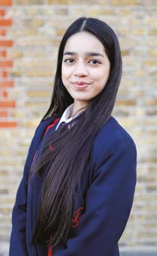
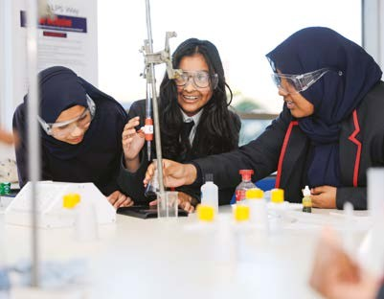



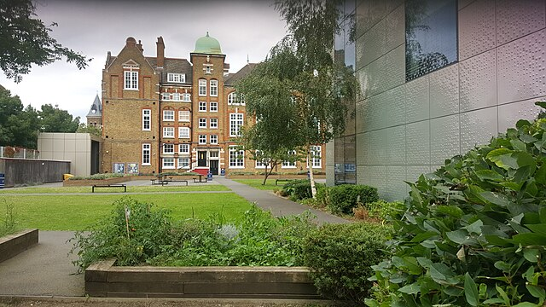



K S 4 P R O G R E S S I O N B O O K L E T

The LPS KS4 Progression Booklet has been designed to equip all Year 9 students with the resources required to excel in their end of Key Stage 3 exams. Students should use the exam revision material, revision timetable and feedback from their classroom teachers to revise. Revision should occur daily at home or in school in the homework club.

Our end of Key Stage 3 exams have been designed to acknowledge our students’ progress and identify the gaps needed to be addressed for them to be successful in Key Stage 4.
This is part of our commitment in providing an ambitious, challenging and demanding curriculum where students are equipped to be global citizens.

Our curriculum is underpinned by our 4Bes: our curriculum is designed to enable our students to be professional; be inclusive; be a learner and be knowledgeable. These values have been carefully chosen to equip our students with the social, academic and cognitive skills required to improve their life chances.

By developing these attributes in our students, they will achieve the best
qualifications, purpose, self-confidence, self-belief and a readiness to play a
positive role within their local and the global community.
contents

year 9 revision timetable
english
geography
history
maths
MFL
performing arts
science

year 9 revision timetable

Year 9 Revision Timetable: 2024-25

Revision:
The word revised comes from the Latin word revisere, which means “look at again, or visit again.” To be professional, knowledgeable and an effective learner, you will need to be consistent in visiting your previous learning so it is embedded in your long-term memory. This is the secret to success.

Timetable:

Times  (adjustable start times) | Monday | Tuesday | Wednesday | Thursday | Friday | Saturday/Sunday
16:00 - !6:45 | English (45 mins) | Maths (30 mins) | Science (45 mins) | History (45 mins) | Geography (45 mins) | MFL Performing Arts (60 mins)
17:00- 17:30 | Independent reading (30mins) | Independent reading (30mins) | Independent reading (30mins) | Independent reading (30mins) | Independent reading (30mins) | Independent reading (30mins x2)

Resources:
Exam papers can be found in your KS4 Progression Booklet. You will find additional material in: your exercise book; Google Classroom; Educake and My Maths etc.

Revision Strategies:

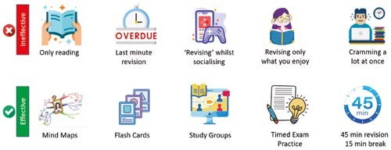

Y9 End of Year Exam (unseen poetry and Gothic writing)

Section A unseen identity poetry
This part of the exam will ask you to complete an essay question based on the theme of identity (the same theme as the poems we studied in class). You will be expected to write no more than two sides of A4 showcasing your understanding of the writer’s message, methods and the writer’s intentions or motive.

Example Question
How does the poet explore ideas about identity in the poem ‘Warning’’?
‘Warning’ by Jenny Joseph
When I am an old woman I shall wear purple
With a red hat which doesn’t go, and doesn’t suit me.
And I shall spend my pension on brandy and summer gloves
And satin sandals, and say we’ve no money for butter.
I shall sit down on the pavement when I’m tired
And gobble up samples in shops and press alarm bells
And run my stick along the public railings
And make up for the sobriety of my youth.
I shall go out in my slippers in the rain
And pick flowers in other people’s gardens
And learn to spit.

You can wear terrible shirts and grow more fat
And eat three pounds of sausages at a go
Or only bread and pickle for a week
And hoard pens and pencils and beermats and things in boxes.

But now we must have clothes that keep us dry
And pay our rent and not swear in the street
And set a good example for the children.
We must have friends to dinner and read the papers.

But maybe I ought to practise a little now?
So people who know me are not too shocked and surprised
When suddenly I am old, and start to wear purple.

Skills Checklist (this is what you need to include in a great piece of analytical writing)

- An understanding of the writer’s message - what is Joseph suggesting about her identity? (the big idea)
- An understanding of the methods used in the poem - these could be related to form, structure, sound, imagery etc.
- Quotations from the poem
- An understanding of the methods used in the poem and the EFFECTS. This could be related to:
- – the form of the poem
- - the shape of the poem
- - imagery/ language used in the poem (metaphors, personification, similes)
- - pattern (repetition)
- - sound
- A clear and coherent essay
- Your own opinion

How can you prepare?
- Poetry revision https://www.bbc.co.uk/bitesize/topics/zmbj382
- Poetry revision https://www.bbc.co.uk/bitesize/topics/ztbsp39
Revision Task: Write an analytical essay in response to How does the poet explore ideas about identity in the poem ‘Warning’’?

Include:
• The poet’s feelings
• The writer’s methods
• The writer’s use of specific words.
• Evidence from the poem

Success criteria:
• A clear argument in response to the question
• Evidence that proves your argument
• Clear explanation of your evidence
•Identify the writer’s methods and explain their effects
•Multiple layers of analysis (could your evidence/ method suggest something else)
• Link to the poet’s intention or motive

Sentence starters (if required):
Joseph presents identity …………
At first glance Joseph presents identity........however at a deeper level………
This is illustrated when ‘......’
This use of (METHOD IF RELEVANT) suggests....
The use of the WORD is particularly effective because....
Alternatively, this may also ...............
Joseph is (criticizing, celebrating, ridiculing, etc)
Overall, this suggests......

Revision Task: Make revision notes including any poetic terms you have used and ambitious vocabulary learnt this year.

Section B Gothic creative writing.
This part of the exam will ask you to complete a piece of creative writing based on an image (see image below as an example). You will be expected to write no more than two sides of A4 showcasing your use of sophisticated vocabulary, sentence structures, descriptive features and organisation.

Example Question
Use the image on the next page as inspiration for a gothic story.

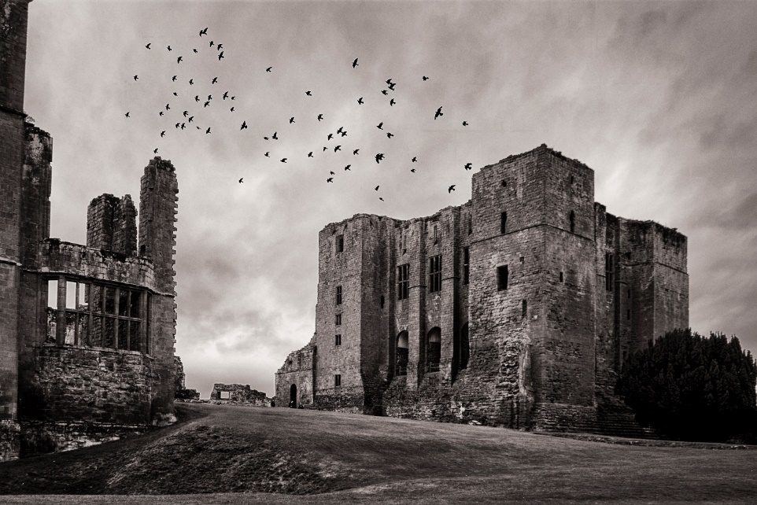

Skills Checklist (this is what you need to include in a great piece of creative writing)
- Writing should be clear and coherent
- Use formal English
- Use sophisticated vocabulary (but this should fit the mood of your piece)
- Use figurative language to create mood(metaphor, simile, personification, pathetic fallacy)
- Use structural features (opening, foreshadowing, motif, ending, flashback)
- Use elements from the Gothic genre (setting, character archetype, supernatural)
- Use a range of sentence types
- Ensure you use accurate punctuation and grammar and clear paragraphs.
How can you prepare?
- The best way to revise for creative writing is by reading! Read for 20 minutes a night and highlight or write down any interesting/ effective sentences you notice in your book. You can then use these in your own creative writing.
- Revise using online revision. These videos have top tips for creative writing: https://www.youtube.com/watch?v=B5vEfuLS2Qc [First, Second or Third Person narrative]
https://www.youtube.com/watch?v=xjKruwAfZWk [Writing for suspense]
https://www.youtube.com/watch?v=RSoRzTtwgP4&list=RDLVRSoRzTtwgP4&start_radio=1&rv=RSoRzTtwgP4&t=2 [Writing Descriptively]
- You can also use websites to help improve your writing
https://www.bbc.co.uk/bitesize/guides/zx499j6/revision/1 [Descriptive Writing Revision]
https://studyrocket.co.uk/revision/gcse-english-language-aqa/paper-1-writing/descriptive-writing [This site uses the Descriptive Writing Question of the GCSE paper to help students improve their written answers]
- Look at model answers and replicate the style. Look at the model paragraphs below which establish setting and character (see if you can notice the use of sentence structures, methods and sophisticated vocabulary).
Revision Task: Read the model paragraphs and annotate how they are successful.

Revision Task: Rewrite one of the paragraphs – text hug and create a Gothic mood or atmosphere.

Model Paragraph 1 (setting)
Moulding brickwork encases its hideous heart. Moss-covered and rotten from the aftermath of the seasons’ rain and sun: the roof revealed a solitary chimney which, for the first time in almost three hundred years, emitted soft swirls of smoke high into night sky. The forest, a sinister home to a thousand nightmares, had parted allowing the Manor to nestle within the seclusion of the trees. In the distance, haunting howls of beasts unknown created a cacophony of horror. Under the moonlight Wakely Manor had stood patiently waiting for this very night
Model paragraph 2 (character)
Horace had a face like an antique map. An illustration of lines and furrows entrenching his old features – each reflecting a memory, a journey, or a rash and violent decision. Knotted veins strangle the hands that worked busily in the autumn sun. Withered scars illuminated in the soft amber light. Specks of polishing oil dotted his greying flannel shirt and soft, thumb shaped smudges of gun powder decorated his faded jeans. He longed to escape into the crimson tide of October foliage, bask in the quiet stillness of it all but he was uneasy.
As the sun began to set an uncomfortable glare of the florescent porch-light looked down upon him, superior, like an old enemy taunting him, exposing his sins. He sighed, continuing to clean his hunting rifle, coughing abruptly – attempting to eject the memory from his brain, eject it from his conscience. He could still smell her; a mix of almonds and floral shampoo. He hated that shampoo. And the way she never threw away her empty shampoo bottles. The hollow bottles a symbol and a stark reminder of the emptiness of their lives: a couple no longer able to pretend. His polishing cloth, stained red, moved to the angled, oak-panelled stock and he recalled the shape of his wife’s head, the angles of it, like a shiny hard corn kernel or a riverbed fossil. Eyes travelling from the smooth barrel of the rifle fixated on the white unweathered skin where his wedding band used to be. Fighting a rush of memories that flooded his body, he closed his eyes and surrendered to the memory of that day

Geography Y9 Exam Overview
Part A - Africa and the Middle East (20 marks)
Part B - Globalisation (10 marks)
Part C - Weather and Climate Change (20 marks)
Time - 1 hour

Topic Checklist
Revision topic | Revision complete
What instruments can be used to measure weather
Air masses (maritime, continental, polar and tropical)
Beast from the East and drought case studies
How climate has changed throughout time
What is the evidence for climate change? (Tree rings, ice cores, paintings)
Mitigation and adaptation strategies
Technology that has caused globalisation
TNC case study - McDonald’s
Advantages and disadvantages of commodity chains
Biomes in Africa
Formation of Atlas Mountains and Great Rift Valley
Urbanisation case study - Lagos, Nigeria
Biomes in the Middle East
Rain shadow effect
Desert cities case studies - Dubai and Riyadh

Content Revision

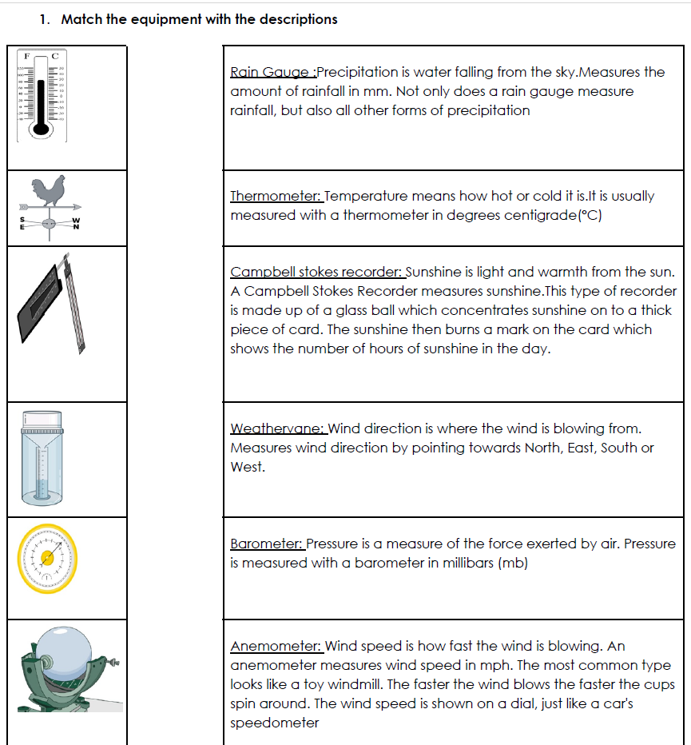
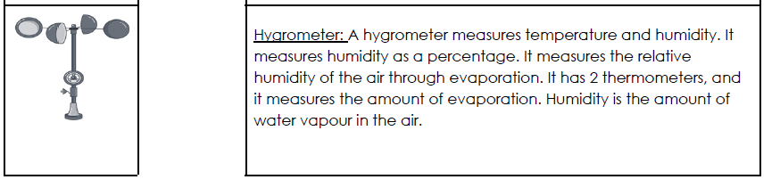

Case study: why is Bangladesh at risk of climate change?

Impacts of the 2022 floods:

Rural families are spending 158 billion taka (almost $2 billion) in total every year to repair damage caused by flooding. | 7.2 million people were affected by the 2022 floods across 9 districts of Bangladesh. | 106,000 fresh water points were contaminated leaving thousands of families without clean drinking water. | The Bangladesh national government spends around $1 billion per year on repairing damage caused by flooding.
Hundreds of thousands of hectares of agricultural land was submerged and damaged. | Extensive damage to infrastructure such as roads and bridges occurred in Sylhet. | Power was cut off in the districts of Sylhet and Sunamganj. | At least 141 people lost their lives in the floods in northeastern Bangladesh.
640 schools were closed in Sylhet. | $12.5 million of crops were damaged. | Flooding erodes soil and it can become infertile, leading to reduced biodiversity. | Flooding can cause anxiety and trauma for affected people.

Solutions for the impacts of climate change in Bangladesh

1. Renewable energy sources in Bangladesh

By 2041, Bangladesh aims to source 40% of its national energy from renewable sources. 10 wind energy power plants are under construction along Bangladesh’s south coast.

2. Global agreements (COP) on reducing fossil fuel consumption

Every year leaders from most countries meet to discuss climate change at the Conference of Parties. For many years attending countries have been agreeing to reducing their carbon emissions in order to mitigate climate change, however there are no consequences if they do not meet their targets.

3. Global agreements (COP) for funding adaptation to climate change

Many developing countries emit much less greenhouse gases than developed countries, but are experiencing negative impacts of climate change. For example, Bangladesh only contributes 0.4% of global greenhouse gas emissions. At COP 27 in Sharm el-Sheikh, a loss and damage fund was introduced, which developed countries pay money into, to help developing countries pay for adaptation technology. Despite the establishment of a fund, the United Nations Environment Program notes ”no decisions have been made on who should pay into the fund, where this money will come from and which countries will benefit”.

4. “Floating gardens”

To prevent the damage of crops from floodwater and prevent the loss of income from farmers, rural farmers have created an ingenious technique called floating gardens. By creating a floating raft of the plant Water Hyacinth and planting crops in it, crops can be grown without the risk of being destroyed by rising water levels.

5. Bangladesh Red Crescent Society (NGO)

Bangladesh Red Crescent Society disaster response team carefully monitor flooding in Bangladesh and issue help where needed. During the 2022 floods, this NGO worked in north eastern Bangladesh to distribute dry and cooked food, clean drinking water, set up a water purification plant and provided medical assistance through setting up 4 medical camps.

6. Bangladesh Delta Plan 2100

The government of Bangladesh has issued a national plan to reduce the impacts of flooding. This involves building higher flood barriers around rivers and coastal areas. This has been critiqued because these flood barriers have failed before, and water levels continue to rise. Furthermore, people have a false sense of security that it is now safe to build near the coast and near rivers, however if the flood barriers fail then more people are at risk.

Comparing the Tropical Rainforest and Desert climates

Tropical Rainforest climate graph Desert climate graph

Lagos case study
The larger the population a city has, the bigger the workforce. TNCs want to open businesses where there is a large workforce. | 700,000 new homes must be built in Lagos every year in order to keep up with the growing demand for houses. | Nigeria aims to improve rural transport links by 20% and improve rural access to electricity by 40% by 2025, to slow down the rate of urbanisation. | If Lagos was its own country, it would be the 4th biggest economy in Africa.
Manufacturing currently makes up 12% of Nigeria’s GDP, and has grown from 8% in 2017. This provides many jobs to people living in cities. | 3.7% of Nigeria’s forests are lost every year to make space for growing urban areas. | The rising cost of land and building materials means that many homes in Lagos are unaffordable. | Nigeria is a member of the recently established African Continental Free Trade Agreement (AfCFTA) which will mean an increase of trade between other member countries.
Air pollution in Lagos is 10 times the maximum level considered safe by the World Health Organisation. | When people move to the city and cannot find housing, they end up building their own homes in informal settlements. | Informal settlements often lack connection to electricity, water and proper sewers because people have built the houses themselves. | Rising car ownership due to rising salaries in Lagos has resulted in frequent traffic jams. This causes stress for people and wastes productive time.

Biomes in the Middle East

Rain shadow

Practice exam questions

Y9 Revision booklet
Space for notes on final page of pack
Topic 1- Problems & Changes in 1920s Germany
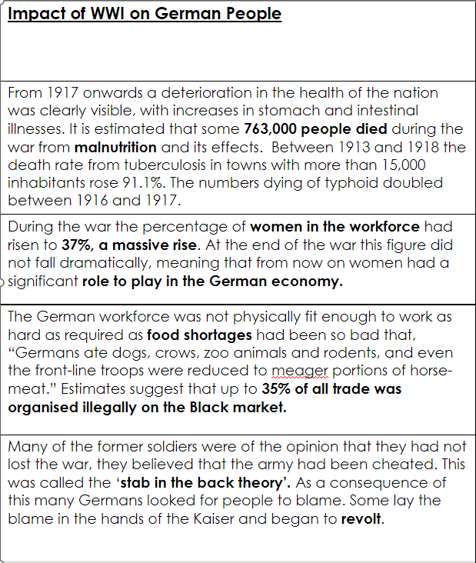

How much impact did the First World War and the Treaty of Versailles have on the German people?
____________________________________________________________________________________________________________________________________________________________________________________________

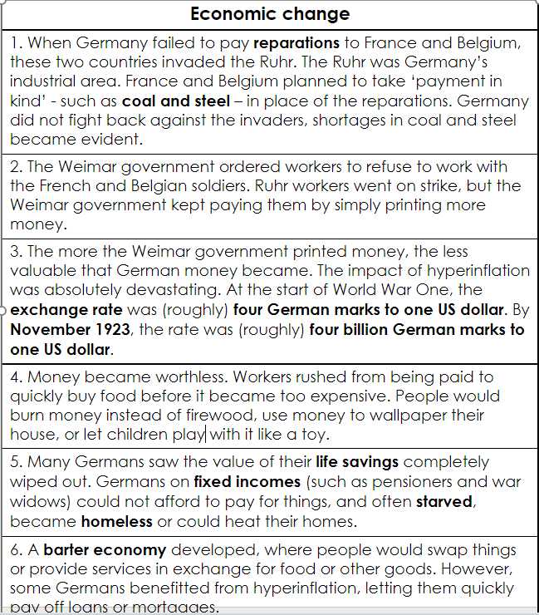
What were the main economic difficulties faced by German people in the 1920s? What impact did this have?

Women | LOGBTQ | Berlin
The classic image of German women in the 1920s is that of the so-called ‘New Woman’, like the ‘Flapper’ in 1920s USA.  The flappers were known for liberation, and were known to drink strong alcohol, smoke cigarettes and attend dancing clubs. However, this was mostly younger women in cities. Most women had a more traditional role. | Berlin became a place where people became more tolerant and accepting of people’s sexual orientation.​​  Cabarets became known as places where transvestites and openly gay men and women could visit, despite homosexuality being illegal at the time. Consequently, Berlin became more tolerant of people’s sexual preference; it was the LGBTQ+ capital of Europe in the 1920s. | The Greater Berlin Act of 1920 made Berlin the third largest city in the world and established it as the centre of German cultural and intellectual life. Many of Germany’s most prominent artists, writers, academics, and performers were based in the city

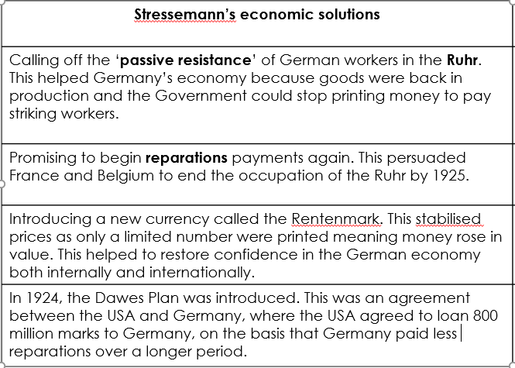

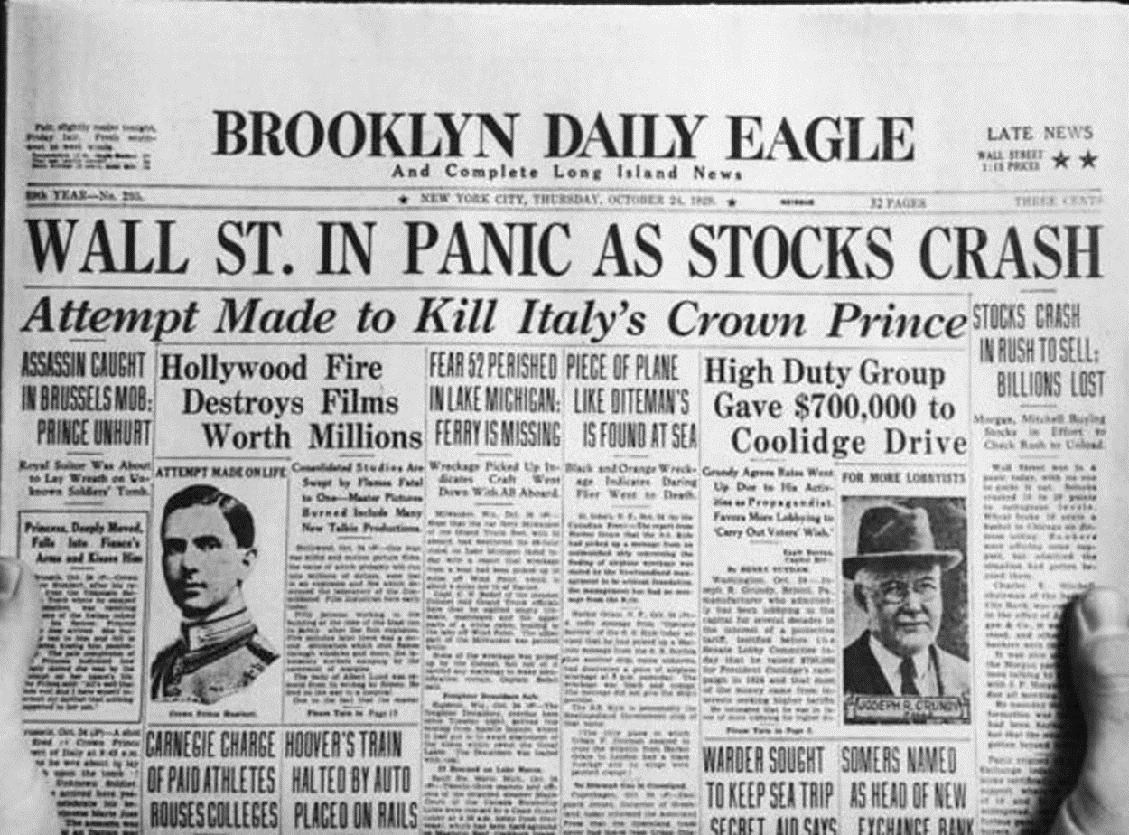

Impact of Wall Street Crash

What was the main impact of the Wall Street Crash on Germany?

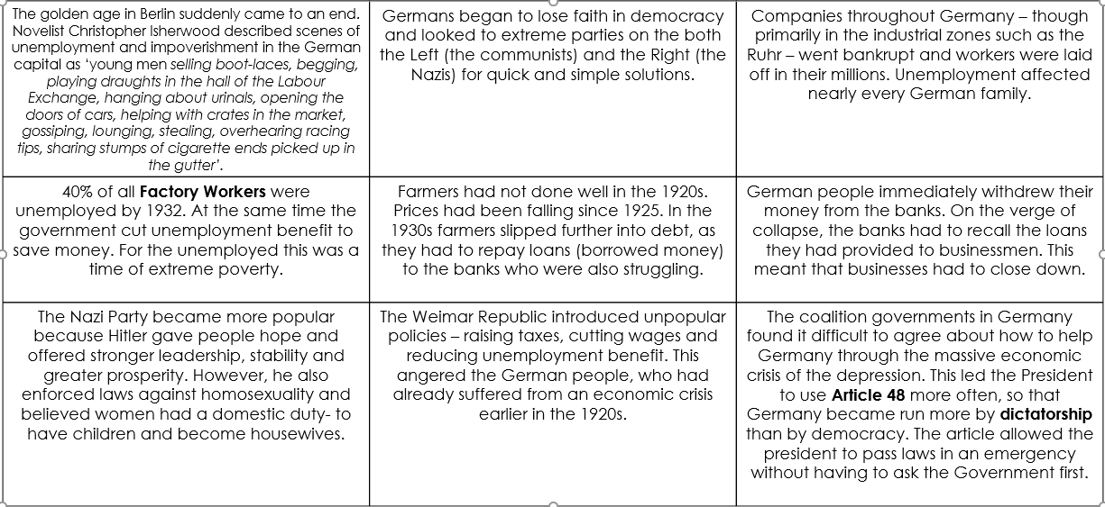
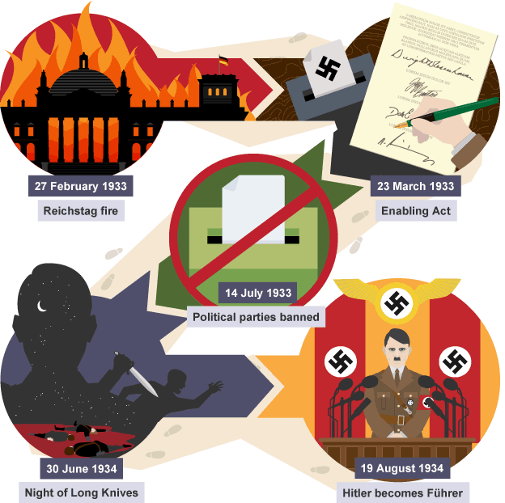

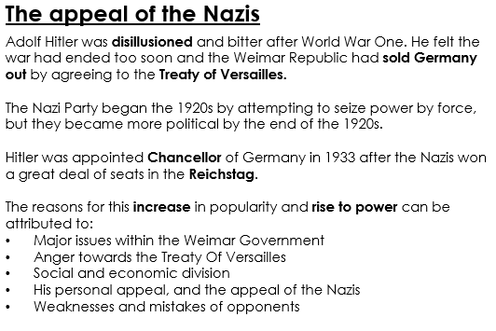

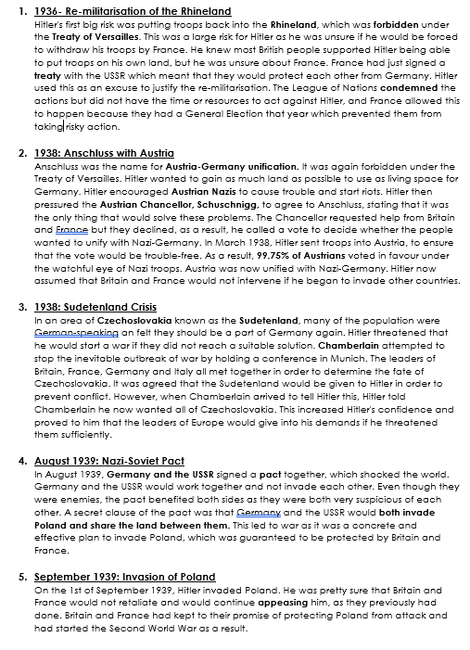

Topic 3- The ‘mother country’ and its colonies
The Empire at war-
- Britain colonised 25% of the globe
- These colonies viewed Britain as their 'mother country'
- Britain called upon its colonies for support during the Second World War.
- Some faced major challenges whilst fighting for Britain, others wanted independence at the end of the war.
 | When Britain called on the Caribbean for support in World War Two, more than 10,000 men and women crossed the Atlantic in response. In Lancashire factories, airfields in Kent and forests in the Scottish Highlands, West Indians provided fundamental support to the war effort. However, few made it to the front line due to their skin colour. The Royal Navy had a colour bar, and only the RAF accepted black crew members. In Britain, many also experienced everyday racism.  For many there was a sense of patriotic duty despite bitterness of colonial rule. The colonial governments, schools, the churches, and most of the media fostered love for the ‘Mother Country’. Placards were posted everywhere: ‘Do you want to help the war cause? England needs you!’  Due to the lack of pilots, the RAF began to accept black colonials as aircrew. Some 300 or so West Indians served as aircrew, and some 90 men received decorations.  On their arrival, some discovered that they had to build their own barracks - and they all discovered that they were to be paid less than they had been promised. The period of their service was reduced, and some were repatriated (flown back to the Caribbean) before their contracts had expired.
 | Many countries saw Britain as the ‘Mother country’. This included India, who volunteered 2.5 million men to the British war effort. The most soldiers from the colonies.​  Indians fought throughout the world, including in the European theatre against Germany, in North Africa against Germany and Italy, in the South Asian region defending India against the Japanese and fighting the Japanese in Burma.  Following the announcement of the Atlantic Charter in 1941, Indians pushed to help Britain win the war so they would be granted independence. This happened in 1947 with the help of Ghandi and the ‘Quit India’ campaign.
 | Australia’s relationship with the ‘mother country’ is slightly different. They were declared an independent country before the war, in 1901 but were still loyal to their ‘mother country’, having contributed 50,000 troops during WW1.  They would prove to be vital for helping allied forces in the War in the Pacific Theatre, they were also involved in campaigns against Germany and Italy in Europe, the Mediterranean and North Africa.  100,000 US troops were sent to Australia, due to its location in the Pacific to fight against Japan. They were vital in helping British-US relationships during WW2.
 | Nigeria, with its huge reserves of men, food, and raw materials, was critical to the ‘Mother Country’.  Nigerians were deployed as soldiers and workers, on a large scale, to theatres of war in Europe and the Middle East. 45,000 soldiers participated. Nigeria was also crucial for the export of Kernels, Rubber, Palm Oil and Cocoa.

What was the relationship like between Britain and its mother countries during the Second World War? Consider the contribution of the colonies, and the challenges faced by some.
____________________________________________________________________________________________________________________________________________________________________________________________________________________________________________________________________________________________________________________________________________________________________________________________________________________________________________________________________________________________________________________________________________________________________________________________________________________________________________________________________________________________________________________________

NOTES

maths

maths

maths - Langdon Park Maths - Key Stage 3

Unit 1 | Indices and standard form
Intention | To develop proficiency in indices, calculations, and estimations, enabling effective problem-solving and understanding of standard form in mathematical contexts.
Key words | index, indices, base, powers, exponent, exponential, raising, root
Study | https://sites.google.com/langdonpark.org/maths/study/key-stage-3

Success criteria | R | A | G
I can apply laws of indices to multiplication and division problems
I can raise algebraic expressions to powers and simplify the result
I can simplify terms with negative indices
I can simplify terms with negative fractional indices
I can convert large and small ordinary numbers to standard form
I can convert standard form numbers to large and small ordinary numbers
I can identify non-standard form numbers and convert it to standard form

Unit sequence | Top career
- Indices  - Calculations and estimates  - More indices  - Standard form | Microbiologist  Studies microorganisms, including bacteria and viruses to understand behaviour, interactions, and impact on health, agriculture, and the environment.  Salary  £55,000 - £80,000+ per year

Useful links | YouTube channels
https://www.sparxmaths.uk/  https://sites.google.com/langdonpark.org/maths  https://www.1stclassmaths.com/edexcelrevision  https://www.mathsgenie.co.uk/  https://corbettmaths.com/  https://mmerevise.co.uk/gcse-maths-revision/  https://www.thenational.academy/pupils/years/  https://www.maths4everyone.com/ | @ExamSolutions_Maths  @1stClassMaths  @mathsgenie7808  @corbettmaths  @mathsmadeeasy123  @TheGCSEMathsTutor  @Cognitoedu  @DrFrostMaths

Be Inclusive
Kizzmekia Corbett (born 1986) is a prominent Black microbiologist and viral immunologist known for her pivotal role during in immunisation during the pandemic. Her achievements have inspired many in the fields of science and medicine.

Unit 2 | Expressions and formulae
Intention | To develop proficiency in manipulating and solving equations, enabling effective use of index laws and expansion of double brackets in mathematical contexts.
Key words | term, expression, equation, identity, brackets, root, index, exponent
Study | https://sites.google.com/langdonpark.org/maths/study/key-stage-3

Success criteria | R | A | G
I can solve multiple step equations with variables on both sides
I can solve multiple step equations fraction a fraction and bracket
I can substitute values into algebraic expressions and simplify
I can write and apply formulae in different contexts
I can rearrange formulae with a fraction to make a variable the subject
I can apply index laws to simplify expressions with brackets
I can expand double brackets to create equivalent expressions

Unit sequence | Top career
- Solving equations  - Substituting into expressions  - Writing and using formulae  - Using and rearranging formulae  - Index laws and brackets  - Expanding double brackets | Civil engineer  Designs and manages construction projects, calculating areas, volumes, and surface areas for structures.  Salary  £60,000 - £90,000+ per year

Useful links | YouTube channels
https://www.sparxmaths.uk/  https://sites.google.com/langdonpark.org/maths  https://www.1stclassmaths.com/edexcelrevision  https://www.mathsgenie.co.uk/  https://corbettmaths.com/  https://mmerevise.co.uk/gcse-maths-revision/  https://www.thenational.academy/pupils/years/  https://www.maths4everyone.com/ | @ExamSolutions_Maths  @1stClassMaths  @mathsgenie7808  @corbettmaths  @mathsmadeeasy123  @TheGCSEMathsTutor  @Cognitoedu  @DrFrostMaths

Be Inclusive
Srinivasa Ramanujan (1887–1920) was a self-taught Indian mathematician celebrated for his groundbreaking contributions to number theory and infinite series. His work profoundly influenced mathematics, with this extraordinary journey depicted in the film The Man Who Knew Infinity (2015).

Unit 3 | Dealing with data
Intention | To develop skills in planning and conducting surveys, collecting and calculating data, and effectively displaying and analysing results compare findings in meaningful ways.
Key words | survey, primary, secondary, qualitative, quantitative, leaf diagrams, misleading
Study | https://sites.google.com/langdonpark.org/maths/study/key-stage-3

Success criteria | R | A | G
I can identify primary, secondary, qualitative and quantitative data
I can plan and design surveys to collect data in various real-life context
I can calculate mean, median, and mode from a data set and in grouped tables
I can evaluate best graphs and charts to use to represent data
I can draw and present data clearly to various audiences
I can analyse data to draw meaningful conclusions in different visual representations
I can compare data sets to identify trends and differences

Unit sequence | Top career
- Planning a survey  - Collecting data  - Calculating averages  - Displaying and analysing data  - Presenting and comparing data | Information Designer  Transforms complex data into visually engaging graphics, including charts and infographics, to enhance understanding and communication.  Salary  £55,000 - £85,000+ per year

Useful links | YouTube channels
https://www.sparxmaths.uk/  https://sites.google.com/langdonpark.org/maths  https://www.1stclassmaths.com/edexcelrevision  https://www.mathsgenie.co.uk/  https://corbettmaths.com/  https://mmerevise.co.uk/gcse-maths-revision/  https://www.thenational.academy/pupils/years/  https://www.maths4everyone.com/ | @ExamSolutions_Maths  @1stClassMaths  @mathsgenie7808  @corbettmaths  @mathsmadeeasy123  @TheGCSEMathsTutor  @Cognitoedu  @DrFrostMaths

Be Inclusive
Florence Nightingale (1820–1910) was a pioneering nurse and statistician who used innovative data visualisation, like the polar area diagram, to highlight health issues and improve sanitation in healthcare during the Crimean War.

Unit 4 | Multiplicative reasoning
Intention | To develop multiplicative reasoning across transformations, percentages, direct and inverse proportions.
Key words | terms, expressions, equations, formulae, factorise, expand, rearrange, balancing
Study | https://sites.google.com/langdonpark.org/maths/study/key-stage-3

Success criteria | R | A | G
I can perform enlargements using positive scale factors
I can perform enlargements using negative and fractional scale factors
I can describe the effects of negative and fractional scale factors on shapes
I can calculate percentage changes, including increases and decreases
I can solve problems involving compound measures and convert between units
I can identify and calculate direct proportionality in real-life contexts
I can identify and calculate inverse proportionality problems in real-life contexts

Unit sequence | Top career
- Enlargement (transformations)  - Negative and fractional scale factors  - Percentage change  - Compound measures  - Direct and inverse proportion | Accountant  Uses percentages for tax calculations, financial reporting, and budgeting to ensure accurate financial statements and compliance.  Salary  £60,000 - £200,000+ per year

Useful links | YouTube channels
https://www.sparxmaths.uk/  https://sites.google.com/langdonpark.org/maths  https://www.1stclassmaths.com/edexcelrevision  https://www.mathsgenie.co.uk/  https://corbettmaths.com/  https://mmerevise.co.uk/gcse-maths-revision/  https://www.thenational.academy/pupils/years/  https://www.maths4everyone.com/ | @ExamSolutions_Maths  @1stClassMaths  @mathsgenie7808  @corbettmaths  @mathsmadeeasy123  @TheGCSEMathsTutor  @Cognitoedu  @DrFrostMaths

Be Inclusive
Gita Gopinath (born 1971) is an influential Indian American economist who serves as the Chief Economist of the International Monetary Fund (IMF). Known for her work on international finance and macroeconomics, particularly in areas related to exchange rates and global trade.

Unit 5 | Constructions
Intention | To develop skills in constructions, using compasses and protractors to accurately draw triangles and lines, enabling effective application of scale diagrams.
Key words | constructions, bisector, perpendicular, scalene, isosceles, scale
Study | https://sites.google.com/langdonpark.org/maths/study/key-stage-3

Success criteria | R | A | G
I can read and interpret scales accurately for various measurements
I can perform basic constructions using a compass and straightedge confidently
I can construct different types of triangles based on given measurements and angles
I can apply the properties of triangles to verify my constructions
I can create accurate scale diagrams to represent real-world objects or scenarios
I can use scales to calculate dimensions and distances in scale drawings
I can check my constructions for accuracy and make necessary adjustments

Unit sequence | Top career
- Using scales  - Basic constructions  - Constructing triangles  - Using accurate scale diagrams | Cartographer  Uses compasses for navigation and orientation, along with protractors to measure angles and create accurate maps.  Salary  £30,000 - £40,000+ per year

Useful links | YouTube channels
https://www.sparxmaths.uk/  https://sites.google.com/langdonpark.org/maths  https://www.1stclassmaths.com/edexcelrevision  https://www.mathsgenie.co.uk/  https://corbettmaths.com/  https://mmerevise.co.uk/gcse-maths-revision/  https://www.thenational.academy/pupils/years/  https://www.maths4everyone.com/ | @ExamSolutions_Maths  @1stClassMaths  @mathsgenie7808  @corbettmaths  @mathsmadeeasy123  @TheGCSEMathsTutor  @Cognitoedu  @DrFrostMaths

Be Inclusive
Muhammad Al-Idrisi (1100-1165) was a prominent Arab geographer, cartographer, and traveller, best known for creating the Tabula Rogeriana, a highly detailed world map commissioned by King Roger II of Sicily. This map, completed in 1154, was one of the most accurate and comprehensive representations of the world at that time, depicting Europe, Africa, and Asia.

Unit 6 | Sequences, inequalities, equations and proportions
Intention | To develop skills in identifying the nth term of arithmetic sequences, non-linear sequences, solving inequalities and equations, and proportions in different contexts.
Key words | significant figures, estimation, place value, ratios, proportions, direct
Study | https://sites.google.com/langdonpark.org/maths/study/key-stage-3

Success criteria | R | A | G
I can identify and derive the nth term of arithmetic sequences
I can recognise and analyse non-linear sequences to determine patterns
I can solve linear inequalities and represent them on number lines
I can apply understanding of inequalities to solve real-life problems
I can solve multi-step linear equations with fractions using the balancing method
I can use proportions to compare quantities and solve real-life contexts
I can apply sequences, inequalities, and proportions to real-life contexts

Unit sequence | Top career
- nth term of arithmetic sequences  - Non-linear sequences  - Inequalities  - Solving equations  - Proportion | Machine Learning Engineer  Develop algorithms that enable computers to learn from data patterns, improving performance over time in many computer-related fields.  Salary  £100,000 - £200,000+ per year

Useful links | YouTube channels
https://www.sparxmaths.uk/  https://sites.google.com/langdonpark.org/maths  https://www.1stclassmaths.com/edexcelrevision  https://www.mathsgenie.co.uk/  https://corbettmaths.com/  https://mmerevise.co.uk/gcse-maths-revision/  https://www.thenational.academy/pupils/years/  https://www.maths4everyone.com/ | @ExamSolutions_Maths  @1stClassMaths  @mathsgenie7808  @corbettmaths  @mathsmadeeasy123  @TheGCSEMathsTutor  @Cognitoedu  @DrFrostMaths

Be Inclusive
Andrew Chi-Chih Yao (born 1946) is a Chinese American computer scientist renowned for his work in computational complexity theory. He received the Turing Award in 2000 and currently serves as the Dean of the Institute for Interdisciplinary Information Sciences at Tsinghua University.

Unit 7 | Circles, Pythagoras and prisms
Intention | To understand and apply formulae for circle properties, Pythagoras’ theorem, prism and cylinder volumes, and manage calculations with errors and bounds.
Key words | chord, sector, segment, arc, circumference, hypotenuse, lower and upper bound
Study | https://sites.google.com/langdonpark.org/maths/study/key-stage-3

Success criteria | R | A | G
I can calculate the circumference and area of a circle
I can use Pythagoras’ theorem to find missing side lengths in right-angled triangles
I can calculate the volume of prisms and cylinders
I can use correct formulae for various 2D and 3D shapes
I can identify lower and upper bounds of measurements
I can determine error margins and intervals in measurements
I can evaluate the impact of errors and bounds on real-world problems

Unit sequence | Top career
- Circumference of a circle  - Area of a circle  - Pythagoras’ theorem  - Prisms and cylinders  - Errors and bounds | Electrical engineer  Design, develop, and test electrical systems and equipment, working on projects ranging from small-scale electronics to large power systems.  Salary  £60,000 - £90,000+ per year

Useful links | YouTube channels
https://www.sparxmaths.uk/  https://sites.google.com/langdonpark.org/maths  https://www.1stclassmaths.com/edexcelrevision  https://www.mathsgenie.co.uk/  https://corbettmaths.com/  https://mmerevise.co.uk/gcse-maths-revision/  https://www.thenational.academy/pupils/years/  https://www.maths4everyone.com/ | @ExamSolutions_Maths  @1stClassMaths  @mathsgenie7808  @corbettmaths  @mathsmadeeasy123  @TheGCSEMathsTutor  @Cognitoedu  @DrFrostMaths

Be Inclusive
Hedy Lamarr (1914-2000), originally a Hollywood star, was also a self-taught inventor who co-developed frequency-hopping technology during WWII, later foundational for secure Wi-Fi, GPS, and Bluetooth systems.

maths

maths

maths

maths

maths

maths
T

maths

maths

maths

maths

maths

maths

maths

maths

Year 9 French & Spanish Exam Preparation. Topic List.
Food
- Food and drinks.

- Mealtimes.
- Menus and ordering food.
- Healthy vs unhealthy diet.
- Future eating habits.
- Parts of the body and illness.
- Resolutions for healthier lifestyle.
- Advice to be healthier.

Careers

- Importance of foreign languages.
- Jobs and opinions.
- Typical day at work.
- House chores and pocket money.
- Future school plans.
- Ideal job in the conditional.
- A workday in the past.


Revising little and often is best with languages. Set aside 10-15 minutes each day at the same time to do your Spanish practice! Setting an alarm on your phone may help too.


HOW TO REVISE.

- GOOGLE CLASSROOM has up-to-date lessons where students can find all vocabulary learnt in class, reading texts and model answers for writing tasks.

- KNOWLEDGE ORGANISERS teachers give out Knowledge organisers for each topic as a printed sheet which can be used at home to revise.

- LOOK/COVER/CHECK – look at the Knowledge organisers, cover the Spanish vocabulary, look at each English word and write and say it in Spanish. Finally check your answers. Re-write the wrong ones three times and repeat the process until all answers are correct.

- DUOLINGO- is a free app which can be used to memorise words. Look for the topics of Food and Work/Jobs/Careers and complete the activities online.

- BBC BITESIZE – has a Spanish beginner sections with lots of engaging exercises to practice all skills.

Year 9 Drama Exam Revision Tips.

Course Structure Key Assessments:
Year 9 Drama Exam 1= Performing an extract from a script ‘The Container’
Year 9 Drama Exam 2 = Devising a performance based on ‘The Hate You Give’

Key Dates:
End of Drama carousel (different for each class)

Revision Topics

Unit/Topic Areas For Revision Resources

- Working with script. Elements of performance
Characterisation
Body language and facial expression Movement
Tone of voice Pace
Pauses

- Devising your own original drama. Performance techniques
Thoughts aloud Monologues Slow motion
Choral speaking and moment Narration
Flashbacks
Your drama Google Classroom contains the lesson PowerPoints and other resources.

Watch ‘The Container’
in your Google Classroom.

Use google to research your theme, story and characters.

Research Stanislavski’s method acting techniques.

Research Brechtian conventions for devising.

Useful revision techniques and how to help your child improve their grades. Drama Revision Tips:
- Learn your lines.
- Rehearse rehearse rehearse - no piece of drama is ever completely finished it can always be improved!
- Add your own ideas to make it your own interpretation.
- Know the assessment criteria and what you need to do to achieve your end of Yr9 target!
- Be confident - remember self-belief and confidence will help you to be successful in life.
- Draw on everything you have learnt over the last 3 years in Drama.
- Watch the professional actors in The Container and The Hate You Give and get ideas.
- Use BBC Bitesize ‘Drama’ – take the quizzes and watch the videos to improve your knowledge.

Year 9 Music Exam Revision Tips.

Course Structure

Key Assessments:
_{Year 9 Music}
Assessment 1 = Perform part of a Rock Anthem, or a Ballad
Assessment 2 = Compose a soundtrack to a given film scene (with a specific genre)
Assessment 3 = Compose and/or perform a section of a song

Key Dates:
End of Music carousel (different for each class)

Revision Topics

Unit/Topic Areas For Revision Resources

- Performance. Elements of performance
Tempo Dynamics Timbre
Rhythm

- Composing a soundtrack Compositions
Analyse a film or game trailer/clip. What can you hear? - How is it used? How does it impact the game/film clip?
Your Music Google Classroom contains the lesson PowerPoints and other resources.
Use lpsmusic.co.uk to access additional resources
Using the Music room at break and lunch to practice individual parts, or a group rehearsal
Links found on Unit and Curriculum Overviews.

Useful revision techniques and how to help your child improve their grades. Music Revision Tips:
- Good rehearsal technique in lessons.
- Use enrichment time to benefit you.
- Have a growth mindset, nothing is impossible.
- Be creative.
- Know the assessment criteria and what you need to do to achieve your end of Yr9 target!
- Be confident - remember self-belief and confidence will help you to be successful in life.
- Draw on everything you have learnt over the last 3 years in Music.
- Watch performances of professional musicians.
- Use BBC Bitesize ‘Music’ – take the quizzes and watch the videos to improve your knowledge.

Various helpful links:

Biology.
Checklist: https://docs.google.com/document/d/1U6jqSSoicyYAP0Z23MmWw5JNPtcPq1QL/edit?usp=share_ link&ouid=103028310767051131692&rtpof=true&sd=true
Practice Paper: https://docs.google.com/document/d/1i33VEHB1UJdzEsrBXhX2O9Nuz3a2uyRR/edit?usp=share_ link&ouid=103028310767051131692&rtpof=true&sd=true

Chemistry.
Checklist: https://docs.google.com/document/d/1qqvebOmqCFThEUfCcBV5RcoW9Mlc7gF-/edit?usp=share_ link&ouid=103028310767051131692&rtpof=true&sd=true
Practice Paper: https://docs.google.com/document/d/1RNXPfqKQEj8xZcNaROBNczHcrszItZyw/edit?usp=share_ link&ouid=103028310767051131692&rtpof=true&sd=true

Physics.
Checklist: https://docs.google.com/document/d/1thJHcqT7ZDF8YmjlhJ9cyRxPhKBK1iJ3/edit?usp=share_ link&ouid=103028310767051131692&rtpof=true&sd=true
Practice Paper: https://docs.google.com/document/d/1rvxjYVV-oJqfpyvv_KGCXkCJdXU1wPwx/edit?usp=share_ link&ouid=103028310767051131692&rtpof=true&sd=true

Review B1 Cell Biology.
B1.1 Cell Structure. Can you...?
Name the main organelles of plant and animal cells (eukaryotic cells).
Recall the relative size of bacterial cells (prokaryotic cells).
Describe the difference in how the genetic material is found within eukaryotic and prokaryotic cells.
Explain how the main sub-cellular structures, including the nucleus, cell membranes, mitochondria, cell wall and chloroplasts in plant cells and plasmids in bacterial cells are related to their functions.
Explain how the structure of different types of cell relate to their function in a tissue, an organ or organ system, or the whole organism. Including sperm cells, nerve cells and muscle cells in animals and root hair cells, xylem and phloem cells in plants.
Describe cell differentiation.
Describe the differences in magnification and resolution between electron and light microscopes.
Define binary fission (biology only).
Explain how to prepare an uncontaminated culture (biology only).

Review B1 Cell Biology.
B1.2 Cell Division. Can you...?
Recall that the nucleus of a cell contains chromosomes made of DNA molecules.
Each chromosome carries a large number of genes. In body cells the chromosomes are normally found in pairs.
Give an overview of mitosis.
Understand that Cell division by mitosis is important in the growth and development of multicellular organisms.
Recognise and describe situations where mitosis is occurring.
Define a stem cell.
Recall that stem cells from human embryos and adult bone marrow can be cloned and made to differentiate into many different types of human cells.
Name some conditions which may be helped by treatment with stem cells.
Discuss the ethical or religious objections and potential risk of stem cell use.
Recall that stem cells from meristems in plants can be used to produce clones of plants quickly and economically and describe possible uses.

Review B1 Cell Biology.
B1.3 Transport in Cells. Can you...?
Explain how substances may move into and out of cells across the cell membranes via diffusion.
Describe diffusion.
Recall that some of the substances transported in and out of cells by diffusion are oxygen and carbon dioxide in gas exchange, and of the waste product urea from cells into the blood plasma for excretion in the kidney.
Describe factors the affect the rate of diffusion.
Recall that a single-celled organism has a relatively large surface area to volume ratio to allow sufficient transport of molecules into and out of the cell.
Explain how the small intestine and lungs in mammals, gills in fish, and the roots and leaves in plants, are adapted for exchanging materials.
List factors that increase the effectiveness of an exchange surface.
Describe osmosis.
Recall that active transport moves substances from a more dilute solution to a more concentrated solution (against a concentration gradient). This requires energy from respiration.
Link the structure of a root hair cell to its function.
Describe a use for active transport in both plants and animals.
Explain the difference between diffusion, osmosis and active transport.

C1 Atomic Structure & The Periodic Table.
1.1.1 Atoms, elements and compounds. Can you...?
Define the word ‘element’ in terms of atoms.
Recall that there are about 100 different elements which are shown in the periodic table.
Describe what a compound is and how they are represented.
Describe how compounds are formed and separated, and what this involves.
Use the names and symbols of the first 20 elements in the periodic table, the elements in Groups 1 and 7, and other elements in the Chemistry course.
Name compounds of these elements from formulae or symbol equations.
Write word equations for all the chemical reactions in the Chemistry course.
Write formulae and balanced chemical equations for all the chemical reactions in the Chemistry course.

C1 Atomic Structure & The Periodic Table.
1.1.2 Mixtures. Can you...?
Describe what a mixture is and whether the properties of each substance in the mixture are changed or unchanged.
State the 5 processes which can be used to separate mixtures, and remember that they do not involve chemical reactions.
For each process, state the mixture(s) it can be used to separate.
Describe, explain and give examples of the each of these processes.
Suggest suitable separation and purification techniques for mixtures when given information.

C1 Atomic Structure & The Periodic Table.
1.1.3 The development of the model of the atom. Can you...?
Explain what may lead to a scientific model being changed or replaced.
Describe how the model of the atom changed as new evidence was discovered.
Describe the roles of Niels Bohr and James Chadwick in the development of the model of the atom.
Explain why the new evidence from the scattering experiment led to a change in the atomic model.
Describe the difference between the plum pudding model of the atom and the nuclear model of the atom.

C1 Atomic Structure & The Periodic Table.
1.1.4 Relative electrical charges of subatomic particles. Can you...?
State the relative charges of protons, neutrons and electrons.
Explain why atoms have no overall electrical charge.
State what atomic number represents.
State how atoms of different elements differ from each other.
Use the nuclear model to describe the structure of atoms.

C1 Atomic Structure & The Periodic Table.
1.1.5 Sizer and mass of atoms. Can you...?
State the radius of an atom.
State the radius of a nucleus.
State where most of the mass of an atom is.
State the relative masses of protons, neutrons and electrons.
State what mass number represents.
Describe what an isotope is, how they differ from one another and how they are the same.
Use the mass number and atomic number to calculate the number of protons, neutrons and electrons in an atom or ion.
Relate the size of atoms to objects that can be seen.

C1 Atomic Structure & The Periodic Table.
1.1.6 Relative atomic mass. Can you...?
State what relative atomic mass is and how it is calculated.
Calculate relative atomic mass from data given.

C1 Atomic Structure & The Periodic Table.
1.1.7 Electronic Structure. Can you...?
Describe how electrons fill up the energy levels (or ‘shells’) around the nucleus, starting from the lowest energy level (or innermost available shell).
Represent the electronic structure of the first 20 elements of the periodic table in the following forms.

C1 Atomic Structure & The Periodic Table.
1.2.1 Periodic table. Can you...?
Describe how elements in the periodic table are arranged and why it is called the periodic table.
State the name of the columns in the periodic table and why elements are placed in the same column.
Explain how the position of an element in the periodic table is related to the arrangement of electrons in its atoms and its atomic number.
Predict possible reactions and reactivity of elements from their positions in the periodic table.

C1 Atomic Structure & The Periodic Table.
1.2.2 Development of the periodic table. Can you...?
State how scientists initially classified elements.
Describe problems with the early periodic table.
Explain how Mendeleev overcame these problems.
Explain how Mendeleev was proved right, and why the initial order based on atomic weights was not always correct.
Describe the steps in the development of the periodic table.

C1 Atomic Structure & The Periodic Table.
1.2.3 Metals and non-metals. Can you...?
Identify where metals and non-metals appear in the periodic table.
State the type of ion metals form.
State the type of ion non-metals form.
Describe the physical and chemical properties of metals.
Describe the physical and chemical properties of non-metals
Explain how the atomic structure of metals and non-metals relates to their position in the periodic table.
Explain how the reactions of elements are related to the arrangement of electrons in their atoms and therefore their atomic number.

C1 Atomic Structure & The Periodic Table.
1.2.4 Group 0 (Noble Gases). Can you...?
Explain why the noble gases (group 0) are unreactive, in terms of their outer electrons.
Describe the trend in boiling point going down group 0.
Predict properties from trends down the group.

C1 Atomic Structure & The Periodic Table.
1.2.5 Group 1 (Alkali Metals). Can you...?
Describe the electronic structure of the alkali metals (group 1) and explain how their properties depend on this.
Describe the reactions (observations and products) of the first 3 alkali metals with oxygen.
Describe the reactions (observations and products) of the first 3 alkali metals with chlorine.
Describe the reactions (observations and products) of the first 3 alkali metals with water.
Explain the trend in reactivity going down the group.
Predict properties from trends down the group.

C1 Atomic Structure & The Periodic Table.
1.2.6 Group 7 (Halogens). Can you...?
Describe the electronic structure of the halogens (group 7) and explain how their properties depend on this.
State the type of element the halogens are and describe what their molecules consist of.
Describe the type of compounds formed when they react with metals.
Describe the type of compounds formed when they react with non-metals.
Explain the trend in reactivity going down the group.
Explain displacement reactions involving halogens and solutions of their salts.
Predict properties from trends down the group.

C1 Atomic Structure & The Periodic Table.
1.3.1 Comparison of transition metals with group 1 elements (Chemistry only). Can you...?
State what the transition elements are.
Describe the difference compared with group 1 in melting points, strength, hardness and reactivity with oxygen, water and halogens.
Give examples of general properties with reference to Cr, Mn, Fe, Co, Ni, Cu.

C1 Atomic Structure & The Periodic Table.
1.3.2 Typical properties of transition metals
(Chemistry only). Can you...?
Describe the typical properties of transition elements.
Give examples of general properties with reference to compounds of Cr, Mn, Fe, Co, Ni, Cu.

Review P1 Energy.  4.1.1 Energy changes in a system, and the ways energy is stored before and after such changes. | Taught | Practised | Mastered
Presenting and writing descriptions and explanations:
Ask students to explore questions such as:
- Why do the wheels of a bike get very hot when braking hard?
- Which type of car is more efficient – petrol or electric?
- How is the gravitational potential energy store of an object increased?
- Why does a flow of electrons along a wire allow bulbs to light and motors to spin?

Describe the changes involved in the way energy is stored in simple systems. Examples could include:
- vehicle braking systems (such as bike brakes)
- a ball being thrown upwards
Presenting and writing descriptions and explanations:
Describe and explain what is happening in terms of changes in energy stores when a motor is used to raise a load.
Ask students to explore questions such as:
When an object falls is the decrease in the gravitational potential energy store equal to the increase in the kinetic energy store?
Calculate:
Calculate the kinetic energy of a moving body.
Calculate the amount of energy stored by various objects including stretched springs and objects raised above the ground.
Calculation of an object’s speed given the kinetic energy of the object.
Calculate the speed of an object, just before impact, when dropped from a given height by equating the increase in the kinetic energy store to the decrease in the gravitational potential energy store.
Presenting and writing descriptions and explanations:
Explain the effect on the kinetic energy of an object when the speed and mass increases. In particular what will happen to the kinetic energy when
the speed doubles and when the mass doubles?
Application and implication:
Explain the effect of increasing the spring constant of a spring on the ease that it stretches and on the amount of energy stored in the spring.

Review P1 Energy  4.1.1 Energy changes in a system, and the ways energy is stored before and after such changes. | Taught | Practised | Mastered
Ask students to explore questions such as:
- What determines how fast the temperature of a substance increases? Presenting and writing descriptions and explanations:
Describe how the energy stored in a system changes when it is heated.
Calculate:
Calculate the increase in stored energy when a substance is heated. Presenting and writing descriptions and explanations:
Describe what is happening at an atomic level when a substance is heated. Developing explanations using ideas and models:
Give students an opportunity to create their own models to explain what is happening when a solid is heated. This can be in the form of a diagram,
a 2D or 3D model as they see fit.
Calculate:
Carry out calculations involving specific heat capacity. Students should also be able to rearrange the equation to find any unknown in the equation.
Presenting and writing arguments:
Evaluate the use of concrete in storage heaters:
- Why is concrete used?
- What are the problems associated with the use of concrete?
- Why aren’t other materials with a higher or lower specific heat capacity used?
Applications, implications and cultural understanding. Developing argument:
Evaluate the benefits and drawbacks of using lower power devices such as compact fluorescent lamps (CFLs).
Calculations:
Carry out calculations to determine power, using energy transferred divided by time and work done divided by time.

Review P1 Energy  4.1.2 Conservation and dissipation of energy. | Taught | Practised | Mastered
Ask students to explore questions such as:
- Can energy be created or destroyed?
- What is meant when people say ‘energy is lost’?
- How can we reduce the amount of energy being wasted by a machine?
- What is the best way to reduce heat loss in the home? Presenting and writing descriptions and explanations: Presenting and writing arguments:
Describe, in terms of energy stores/work done, what happens when an appliance (such as a radio) is working.
Evaluate the use of various types of insulation in the home. Look in particular at the effectiveness of loft insulation and cavity wall insulation.
Communication for audience and purpose:
Design a poster to illustrate the reasons why insulating the home is beneficial for both the homeowner and the environment. Select specific examples and suggest what could happen if insulation was not used in the home.
Ask students to explore questions such as:
- Which type of power station is the most efficient?
- Which type of light bulb would cost the least amount of money to use?
Research different types of power station to find out if combustion based power stations are less efficient that either nuclear or wind. Investigate ways of increasing the efficiency of a coal fired power station.
Prepare a presentation on different types of light bulb. Find out the cost of buying and running the light bulbs in a home for one year. Determine whether energy saving light bulbs will save money over incandescent light bulbs.
State the equations used to find efficiency.
Calculate the efficiency of a machine as either a decimal or a percentage.
Rearrange the equation to determine the total power input the machine or the useful power output.
Students may have to analyse data to determine the useful energy output if they are told the energy input and the amount of wasted energy.
Interpret data on efficiencies of different machines.

Review P1 Energy  4.1.3 National and global energy resources. | Taught | Practised | Mastered
Define renewable energy resource and give examples of them. Define non-renewable energy resource and give examples of them.
Describe the way in which different energy resources are used and identify patterns and trends in the use of energy resources.
Research the different types of energy resources that are available to generate electricity.
For each type of energy resource find the environmental impacts.
Explain why each type of energy resource is used to generate electricity even though it does have these environmental impacts.
For a given location determine the best way of generating electricity.
Role-play a meeting between a group of local councillors/MPs, local environmental groups and electricity companies trying to get a new power station built. Which type of power station would each group want?
How persuasive are each group in getting their choice?
Evaluate the use of different energy resources for a given situation,
e.g. generating electricity in remote locations. The evaluation should include ethical and environmental issues.
Compare the use of different fuels for heating homes and transport. Determine the most suitable fuel for a particular use depending on the characteristics of the fuel.
Identify the political, social, ethical and economic considerations that may arise from the use of different energy resources.

The Student Development Curriculum 2024 - 25.
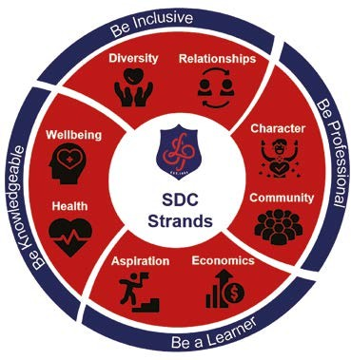
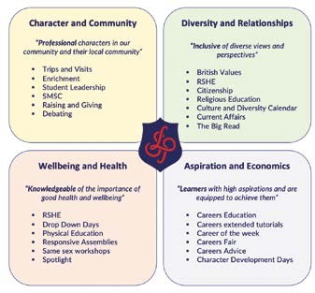

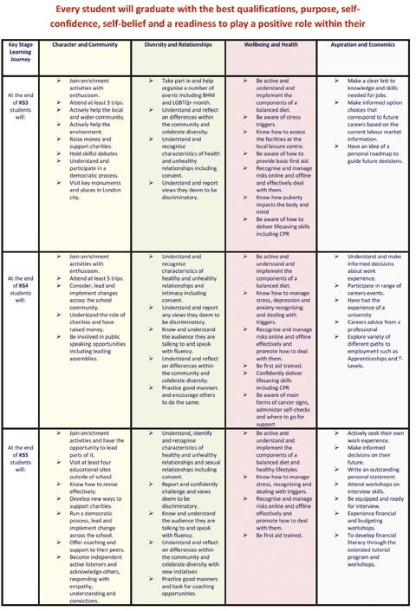

Every student will graduate with the best qualifications, purpose, self confidence,
self-belief and a readiness to play a positive role within their local and the global community.

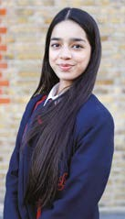


Recommended Reading:

Pre 20th Century Classics
- Daniel Defoe, Robinson Crusoe
- Frances Hodges Burnett, The Secret Garden
- Jonathan Swift, Gulliver’s Travels
- Emily Bronte, Wuthering Heights
- George Orwell, Animal Farm

20th Century Classic Fiction
- Alice Walker, The Color Purple
- Joseph Conrad, Heart of Darkness

Modern and Contemporary
- Iain Banks, The Crow Road
- Ian McEwan, Atonement
- Toni Morrison, Beloved

Fantasy and science fiction
- Douglas Adams, The Hitchhikers Guide to the Galaxy
- George Orwell, 1984
- Jack Finney, Invasion of the Body Snatchers
- Kazuo Ishiguro, Never let me go
- Lewis Carol, Alice in wonderland
- Philip K. D, The Man in the High Castle
- Arthur Miller, The Crucible
- Starg Larsson, The Girl With the Dragon Tattoo

Horror
- Bram Stoker, Dracula
- Mary Shelley, Frankenstein

War
- Joseph Heller, Catch 22
- Leo Tolstoy, War and Peace
- Sebastian Faulks, Birdsong

History
- Philippa Gregory, The Other Boleyn Girl
- Tracy Chevalier, The Girl with the Pearl Earing



Langdon Park School, Bright Street, London E14 0RZ l Head Teacher: Mr N. Langham
T: 020 7987 4811 l F: 020 7537 7282 l E: admin@langdonpark.org l W: langdonpark.org l langdon_park

