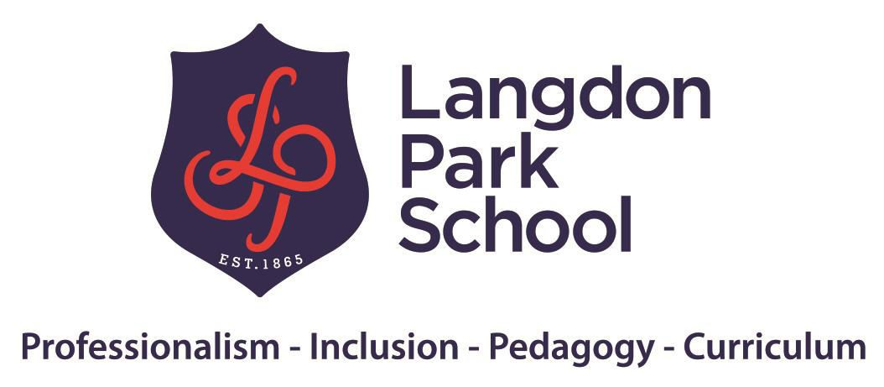

Accessibility Plan

Approved by:
Date:
Last reviewed on:
November 2021
Next review due by: November 2022

Accessibility Plan

Langdon Park’s School is a Rights Respecting and Inclusive School.

The United Nations Convention on the Rights of the Child (UNCRC) Article 23 (children with a disability):

A child with a disability has the right to live a full and decent life with dignity and, as far as possible, independence and to play an active part in the community. Governments must do all they can to support disabled children and their families.

Contents
- Aims 2
- Legislation and guidance 3
- Action plan 5
- Monitoring arrangements 9
- Links with other policies 9

1. Aims

Schools are required under the Equality Act 2010 to have an accessibility plan. The purpose of the plan is to:
Increase the extent to which disabled pupils can participate in the curriculum

Improve the physical environment of the school to enable disabled pupils to take better advantage of education, benefits, facilities and services provided
Improve the availability of accessible information to disabled pupils

Our school aims to treat all its pupils fairly and with respect. This involves providing access and opportunities for all pupils without discrimination of any kind.

At Langdon Park School, we actively promote a culture of mutual respect and tolerance, democracy, the rule of law, freedom and equal opportunities. These British values permeate throughout the school curriculum and all that we offer our students, ensuring they support in the development of the whole child, into a confident, independent individual that positively contributes to the wider community.
The plan will be made available online on the school website, and paper copies are available upon request.
Our school is also committed to ensuring staff are trained in equality issues with reference to the Equality Act 2010, including understanding disability issues.

Accessibility Plan

The school supports any available partnerships to develop and implement the plan.

The three main objectives for accessibility planning from the London Borough of Tower Hamlets are:
- Increase the extent to which disabled students can participate in the curriculum

- Improve the physical environment of all schools for the purpose of increasing the extent to which

disabled students are able to take advantage of education and benefits, facilities or services provided
- Improve the availability of accessible information to disabled children and young people.

Our school’s complaints procedure covers the accessibility plan. If you have any concerns relating to accessibility in school, this procedure sets out the process for raising these concerns.
We have included a range of stakeholders in the development of this accessibility plan, including staff and governors of the school.

We have included a range of stakeholders in the development of this accessibility plan, including staff, governors, students and parents.

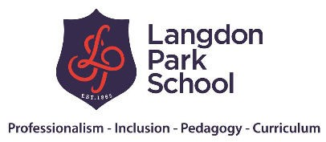Legislation and guidance

This document meets the requirements of schedule 10 of the Equality Act 2010 and the Department for Education (DfE) guidance for schools on the Equality Act 2010.

The Equality Act 2010 defines an individual as disabled if they have a physical or mental impairment that has a ‘substantial’ and ‘long-term’ adverse effect on their ability to undertake normal day to day activities.

Under the Special Educational Needs and Disability (SEND) Code of Practice, ‘long-term’ is defined as ‘a year or more’ and ‘substantial’ is defined as ‘more than minor or trivial’. The definition includes sensory impairments such as those affecting sight or hearing, and long-term health conditions such as asthma, diabetes, epilepsy and cancer.

Schools are required to make ‘reasonable adjustments’ for pupils with disabilities under the Equality Act 2010, to alleviate any substantial disadvantage that a disabled pupil faces in comparison with non-disabled pupils. This can include, for example, the provision of an auxiliary aid or adjustments to premises.

Action plan
This action plan sets out the aims of our accessibility plan in accordance with the Equality Act 2010.

AIM | CURRENT GOOD PRACTICE INCLUDE ESTABLISHED PRACTICE AND PRACTICE UNDER DEVELOPMENT | OBJECTIVES  STATE SHORT, MEDIUM AND LONG-TERM OBJECTIVES | ACTION TO BE TAKEN | PERSON RESONSIBLE | DATE TO COMPLETE ACTIONS BY | SUCCESS CRITERIA
Increase access to the curriculum for pupils with a disability | - Our school offers a differentiated curriculum for all pupils  - We use resources tailored to the needs of pupils who require support to access the curriculum  - Curriculum progress is tracked for all pupils, including those with a disability  - Targets are set effectively and are appropriate for pupils with additional needs  - The curriculum is reviewed to ensure it meets the needs of all pupils. | All students at Langdon Park School will have access to a curriculum which is meaningful and impactful for their future long-term goals.  All students at Langdon Park School will receive suitable qualifications for the courses they study.  All students Langdon Park School will have progress regularly tracked through summative assessment, and bespoke testing where needed | Continue the use and implementation of the QET guideline.  Review existing processes for curriculum design, qualifications and tracking for our students with complex needs to ensure fit for purpose  Book Scrutiny and Learning Walks  Check the students’ views through the SEND Lens Group | Teaching and Learning SLT member  SENCO | Ongoing | All students fully access the curriculum provided.  Structured conversations as appropriate take place with parents/Carers and students.  Additional resources/aids/scaffolds are provided for key students to enable them to access learning.  All students will make good progress, as confirmed by observations, formal assessment and monitoring.  All students can fully access exams and statutory assessments.

AIM | CURRENT GOOD PRACTICE INCLUDE ESTABLISHED PRACTICE AND PRACTICE UNDER DEVELOPMENT | OBJECTIVES  STATE SHORT, MEDIUM AND LONG-TERM OBJECTIVES | ACTION TO BE TAKEN | PERSON RESONSIBLE | DATE TO COMPLETE ACTIONS BY | SUCCESS CRITERIA
Improve and maintain access to the physical environment | The environment is adapted to the needs of pupils as required. This includes:  The presence of Evac Chairs  - Lifts in all blocks A-E  - Corridor width  Within regulation width throughout school and suitable for wheelchair users  - There is one designated disabled parking bay  - The school has 2 Disabled toilets and changing facilities  - Some of the library shelves at wheelchair- accessible height | All blocks are easily accessible to wheelchair users. There is a lift in every block.  There are three evac chairs for blocks B, C and D however, these have not been fitted  All students with SEND use these classrooms as they are suitable for 1-1, small group sessions or who whole class teaching.  Consider regulations whenever making alterations to the school site. | Discuss with SLT/Business Manager for the implementation and fitting of evac chairs.  Staff have already received training and the equipment has been purchased.  No perceived access difficulties. This will be kept under review. | Business Manager  School’s  Librarian | Autumn 2021  N/A | Everyone feels safe and can gain access safely to the school grounds. All visitors feel welcome.  The school buildings are fully accessible and easily accessible by all staff, student, parents/carers and visitors.

AIM | CURRENT GOOD PRACTICE INCLUDE ESTABLISHED PRACTICE AND PRACTICE UNDER DEVELOPMENT | OBJECTIVES  STATE SHORT, MEDIUM AND LONG-TERM OBJECTIVES | ACTION TO BE TAKEN | PERSON RESONSIBLE | DATE TO COMPLETE ACTIONS BY | SUCCESS CRITERIA
Improve the delivery of information to pupils with a disability | Our school uses a range of communication methods to ensure information is accessible. This includes:  - Signs or labels on doors  - Large print resources  - Pictorial or symbolic representations  - Posters with large print (The 4bes) | Door labes are too small. Make door signs and signage readable and clear to all.  Sensory room awaiting to be equipped  Not every room has a clock | All door labels to be reviewed in the coming year  The business manager to inquire about the sensory room installation | Business Manager | Spring 2022  Feb 2022  Summer 2022 | The learning environment is accessible to students, staff and visitors with visual impairments
School Website is accessible to students with SEND | Website is available to all. Alternative versions of information need to be signposted and made available. | Make the website compliant with best practice | Audit of website and prompt update. | System Compliance Manager | Summer 2021 | Website information is accessible to internal and external users

Monitoring arrangements

This document will be reviewed every 3 years, but may be reviewed and updated more frequently if necessary.
It will be approved by The Governing Body

Links with other policies

This accessibility plan is linked to the following policies and documents:

Risk assessment policy Health and safety policy
Equality information and objectives (public sector equality duty) statement for publication Special educational needs (SEN) information report
Supporting pupils with medical conditions policy

